JAY  Email Id: jay.189556@2freemail.com  Mobile no. +971503718643 | 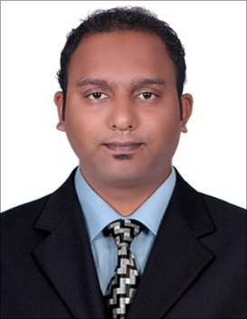
Personal Information:
Nationality : Indian
Marital Status : Married
Date of Birth : 15/06/1987
Language Know : English, Hindi, Marathi, Gujarati
Visa Status : Tourist visa
Work Experience:
- In Prism Mills LTD in Navsari.(From 26th January 2012 to 15th January 2018).
- In Maruti Suzuki Auto Vista Mobiles Limited in Mumbai. (From 10th June 2011 to 31st Dec 2011)
- In Maruti Suzuki Kataria Auto Mobiles Limited in Gujarat.( From 1st June 2010 to 31st March 2011)

Worked As:
- In Prism Mills LTD working as an Office Assistant.
- In Maruti Suzuki Auto Vista Mobiles Limited as a Sales Executive.
- In Maruti Suzuki Kataria Auto Mobiles Limited as a Sales Executive.
Work Profile:
- Worked as an Office Assistant in Prism Mills LTD profile as below mention:
- Maintain the employees Attendants sheet.
- Purchasing the tools &equipment’s for maintenance Department.
- Watched all departments & employees are working or not.
- Hiring, training and developing new employees.
- Handling Purches department and cash as well as filing and billing of equipment.
- Worked as a Sales Executive for in Maruti Suzuki Kataria Auto Mobiles Limited Work Profile as Below mention:
- Giving an explanation about the car features and make the customer satisfactory.
- Excellent Interpersonal, Communication & customer services skills.
- Handling Individual as well as corporate clients.
- Worked as a Sales Executive for in Maruti Suzuki Auto Vista Mobiles Limited Work Profile as Below mention:
- Giving an explanation about the car features and make the customer satisfactory.
- Excellent Interpersonal, Communication & customer services skills.
- Handling Individual as well as corporate clients.

EDUCATION & QUALIFICATION
- S.S.C: J.D.T high school Maharashtra board with 52.13% during the year 2005-2006.
- H.S.C: D.T.S.S collage Maharashtra board with 50.83% during the year 2007-2008.
- S.Y.B. Com Completed from D.T.S.S Collage during the year 2009-2010.

COMPUTER SKILL

- Operating System: MS-Dos, Windows 98 , 2000 & XP
- Application: MS-Word & Excel.
- Other: Email & Internet.

Hereby,

I promise that, all the above information is true and I am ready to work in your company according to your company’s rules and regulations, and I promise that, I will try my level best for the success of the company.

Date:
(Jay)

