Mrs. Farhanas –
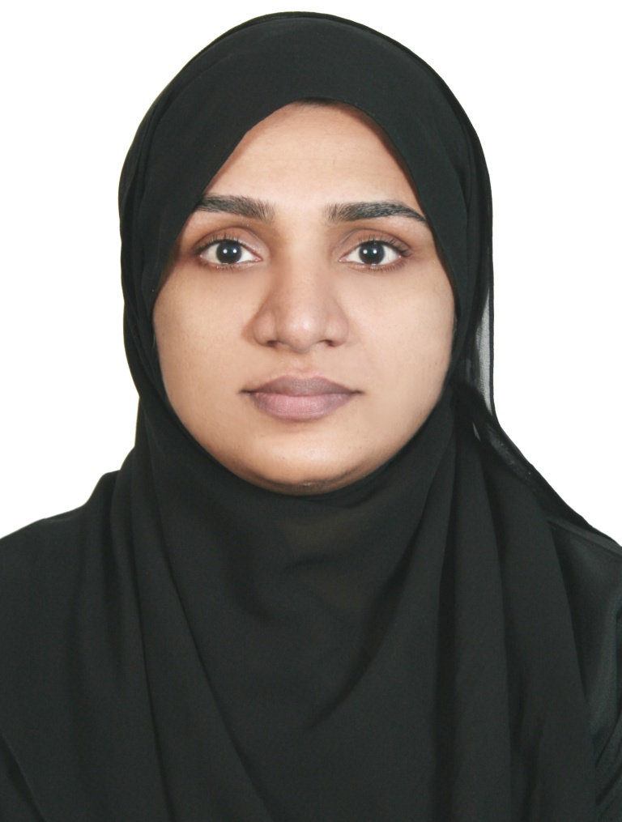
B Sc Medical Biochemistry
MOH Evaluation : Medical Laboratory Technologist-Clinical Biochemistry
DHA Evaluation : Medical Laboratory Technologist-Clinical Biochemistry

Email:farhanazt. 189687@2freemail.com
MEDICAL BIOCHEMIST
Quality-focused medical lab technician with excellent clinical skills gained through hands-on experience within one of the largest health services providers in India. Perform most of the biochemistry laboratory tests and procedures with expedience, attention to detail and optimum quality.
Professional Experience
Over 5 years of experience professional, in various areas of medical laboratory Services. Offering outstanding presentation, communication and cross-cultural team management skills. Highly energetic and results-oriented person with an excellent entrepreneurial attitude, consistently motivating others towards success.
Technical & Soft Skills
Hands on experience on the following
- AU680 Beckman Coulter
- Abbott Architect 1000 sr - Immuno analyser

Adaptability - Maintain professional and technical knowledge by reviewing professional publications, establishing personal networks, participating in professional societies.
Excellent Communication - Calmly explaining with internal and external customers
Team work &Collaboration - Effectively work as part of a team across the organization to achieve a common goal.
Critical observation - Analyse and interpret data rather than handing spreadsheet summary reports to superior.

Work History Total of 5 years and 9 months
Super Specialty Lab, Calicut, India
Lab Technician (Biochemistry), July 13 to Aug 2016
Lab Technician (Biochemistry), Aug 11 to Dec 2012

- Perform all the routine biochemistry tests such as
- Lipid
- Liver Function Test
- Enzymes
- Cardiac Function Test
- Renal and hormones
- Refer problems and unusual results to appropriate parties and document all the corrective action procedures undertaken in the laboratory.
- Assist physicians in the diagnosis and treatment of illnesses, injuries and medical conditions by providing test reports.
- consulting with pathologists; reporting results according to protocols mandated by the hospital and public health department
- Keeping records, preparing and updating written reports and Procedure manual
Ashirvad Hospital, Kannur, India
Biochemist, March ‘00 to April ‘01
- Performed lab analyses to provide data for diagnosis, treatment and prevention of disease.​
- Stringently followed lab protocols, sanitation standards and testing procedures.
- Maintain medical laboratory supplies inventory by checking stock to determine inventory level; anticipating needed supplies; placing and expediting orders for supplies; verifying receipt of supplies
Education & Certification
Bachelor of Science, Medical Biochemistry, 1996 to 2000 (4 years)
Centre for Paramedical Sciences,
Calicut University | Calicut, India
(Under Faculty of Medicine)
- Graduated with honors (2nd Rank)
Certificates License & Membership
- Ministry of Health License (Evaluated as Medical Biochemistry Technologist-Clinical Biochemistry)
- Dubai Health Authority (Evaluated as Medical Biochemistry Technologist-Clinical Biochemistry)
- Kerala Lab Technicians –(Membership)
- Certified Office Administrator, Nadia Institute, Abu Dhabi, UAE (Certification)
Conference and Seminar
Subject Organizer Date
Diabetes & Endocrine Forum Imperial College of London Diabetes Center, UAE 13-Mar-17
Best of AACC Middle East 2017 Al Borg Medical Laboratories 24-Mar-17
Diabetes and Endocrine Forum Imperial College of London Diabetes Center, UAE 03-Apr-17
Other Personal Details
Nationality Indian
Sex Female
Marital Status Married
Visa Status UAE Residence (House Wife)

