Nikhil
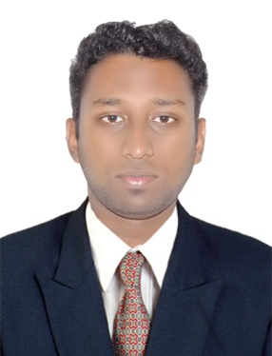
Nikhil.190397@2freemail.com

Career Objective:

Seeking a position to utilize my skills and abilities in Operations / Finance & Accounts / Sales sector that offers professional growth while being resourceful, innovative and flexible and to contribute gainfully towards the profitability by continuously keeping updated myself with the current trends in the industry and helping the industry towards perfection.

Educational Qualification:

Examination | Discipline/  Specialization | School/college | Board/  University | Year of Passing | Percentage
B.Com | Finance & marketing | M.E.S. First Grade College | Bangalore university | 2010 | 60%
PUC | Computer Science | Krupanidhi P U College | Karnataka P U College | 2007 | 50%
SSLC | Common | Narmada Memorial School | State Board Karnataka | 2005 | 78%

Computer Skills:

Operating Systems : Windows OS, Linux OS
Languages : C
Web Technologies : HTML
Application : MS-Office

Personal Skills:

- Hard working & Good team player.
- Good oral and written communication skill.

Experience:

- Worked at MY INTERNET SERVICES as Internet Operator for 15 months.
- Complete servicing of PC & Laptops for software/hardware issues.
- Sales of PC equipments and System assembly as per the customer’s requirement.
- Helping customer to serve the Internet
- Maintaining accounts of the shop

- Worked in HGSL for EarthLink International process for eight months.
- Direct interaction with customers & clients to check supportability of DSL feature on the voice line.
- Complete case taken care till the internet connection is setup for the customer who applied for the package.
- Resolving Internet connectivity issues after the installation.
- Handled monthly bill generation for different states of USA.

- Worked in DELL International for Dell Financial Services (Operations & Finance) supporting leasing process for US corporate companies from 29th November 2010 till 29 April 2012 (17 months).
- Generation of reports for operations for LE (Large Enterprise), SMB (Small & Medium Business) & CSMB (Consumer’s)
- Control of order release as per the procedure.
- Preparation of Schedules and follow up with customer (SMB) till the schedule is booked.
- Resolve dispute for the returned equipments
- Resolve funding issues on the contracts with incorrect tax calculation.
- Achievement: Awarded best performer of the month & also for a Quarter.

- Worked for EROS in Accounts & Credit control department from 21st March till September in Dubai.
- Handling complete accounts for EEEC (Eros Engineering Equipment Co.)
- Reconciliation of cash and cheque deposits for EEEC & Eros Electricals.
- Warranty generation / Invoice generation & submission / job listing information report / current AC job status updating.
- Cost & Estimation of the AC projects in ACBG Department.
- Follow up with customers for payment as per the terms & conditions.

Personal Details

Date of Birth : 04/02/1990

Nationality : Indian

Hobbies : Computer Games, Watching Movies and Long Driving.

Languages Known : English, Hindi, Kannada and Malayalam.

