Personal Profile
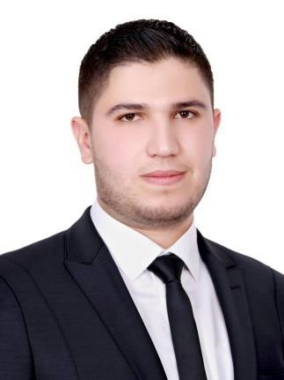
Ahmed

Date of birth Nationality Address Marital status Email
: 20.Jun.1993
: Jordanian
: Jordan, Irbid
: Single
: ahmed.192402@2freemail.com

Summary

- BSc. in electrical engineering with excellent degree.
- 2 years professional experience as quality control engineer in cable industry.
- Professional in low voltage cables (constructions, tests,… etc.) and good knowledge in medium voltage cables.
- Good knowledge in cable international standards, calibration, machine design, power systems.
- Excellent interpersonal and communication abilities, thrives in high pressure and challenging environments.
- Enjoys being part a team, as well as managing, motivating and training a productive team.

Work Experience

United Cable Industries Company
"UCIC Cables" Aug.2015 - present "2 years"

Quality Control Engineer
- Control manufacturing process according to international standard (IEC, BS, TUV, ASTM and ISO 9001).
- Professional experience in electrical and mechanical tests of cables to control raw materials, manufacturing process and finished cables, some of these tests (High Voltage test, resistances of conductors and insulations, materials tensile and elongation)
- Professional in inspection and repairing process to control nonconformity products
- Professional experience in calibration for all instruments used in cable industries.
- Statistical process control (SPC).

Jordan Petroleum Refinery Company "JOPETROL"

May.2015 - Jul.2015
- Electrical Engineer Trainee
- Good Knowledge in power generation and distribution system.
- Good Knowledge in transformers, motors and generators repairing.
- Good Knowledge in power generation stations work and controlling.

"3 months" - Good Knowledge in calibration works for counters and balances.

Education

Hashemite University

Sep.2011 - Jul.2015
  - BSc. in Electrical Engineering with excellent degree (3.50/4.00).
- Good information in power systems, communication systems, machines and micro grids.

- Graduation Project:
"GPS and GSM based vibration alarm system for visual impairment" with A+ evaluation

Irbid Secondary School • High School "Tawjihi" with 94.8% in scientific stream.

Jul.2011

Languages

Arabic English

Native.
Professional writing, listening and speaking.

Software and Programming

- Microsoft Office, Professional.
- AutoCAD, Professional.
- SketchUP, Beginner.
- C++, Very Good.

- Mat lab, Very Good. • Assembly Language, Very Good.
- PVsyst, Beginner.

