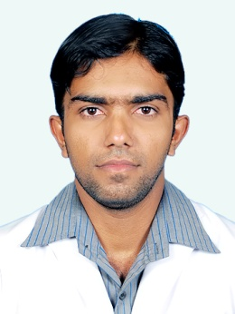 | Gulfjobseeker.com CV No: 1173252  Mobile +971505905010 / +971504753686  To get contact details of this candidates  Submit request through Feedback Link  http://www.gulfjobseeker.com/feedback/submit_fb.php

Profession
PHARMACIST
Career Objective

To pursue a career suiting my caliber and secure a challenging position where I can effectively contribute my knowledge and skills for the benefit of the company.

License

DHA License (Dubai Health Authority).

Professional Experience

August 2011 to August 2013:
SUPRIYA HOSPITAL, kerala ,India. Worked as a pharmacist.
Currently Working at Plasant Pharma, Tirur, Kerala, India
- Worked as a pharmacist.
- Drugs dispensing , purchasing and storage etc.
- Patient counseling.
- Provide clinical support to physician and patients.
- Managed order entry and prescription verification.
- Managed control substance inventory.
- Maintaining of records for restricted drugs.
- Maintaining sufficient stock as per market requirements.
- Having good and friendly relationship with customers and homely relationship with colleagues.

Education Qualification

- Bachelor of Pharmacy : (B.Pharm) Dr.M.G.R Medical University, India

- Higher Secondary Course: Kerala state secondary board of Education, India

Computer Skills

- Operating Systems: Windows 7, Windows XP.
- MS Office (Word, Excel, Power point).
- Internet.
- Computer application in pharmacy.
- Computerized Pharmacy Accounting

Languages Known

English, Hindi, Malayalam, Tamil
and Basic knowledge of Arabic.

Personal Skills

- Hard working, optimistic and dedicated individual.
- Honest, dependable and excellent interpersonal skills.
- Possesses leadership skills, enthusiastic and assertive.
- Making the buyers and patients feel well with pleasing nature and good communication skills.
- Work well under pressure, flexible and quick learner.
- Conscientious, with ability to maintain high standards of work under pressure.
- Collaborative, energetic, proactive and fair.
- Can demonstrate a high degree of initiative, and self-motivation.
- Enjoy the challenge of busy and demanding work environment
- Ready to deliver the task on a given time-line.

Personal Information
Date of Birth : 23/10/1988
Sex : Male
Marital Status : Single
Nationality : Indian

