Bishoy
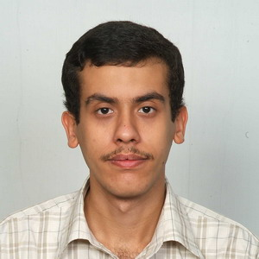
Bishoy.195652@2freemail.com
Personal Data:

- Birth date: 17/7/1984.
- Marital Status: Single.
- Military Service: Exempted.
- Religion: Coptic Orthodox.

Qualifications:
- Graduate of the IGCSE year 2000
- Bachelor of Medicine and Surgery of Ain Shams University, Dec 2007 Batch.
- One year of internship in Ain Shams University Hospitals.
- 4 years of experience in primary health care units of Samadoun and Ashmoun Menoufia Egypt.

Experiences:
- Had an undergraduate training course as an observer in Oasis Hospital Al-Ain for 3 weeks in 12 Dec 2006.
- Participated in the Second National Congress on Infections and Allied Conditions, Towards Safe Prescriptions and Iatrogenic Disorders and the Third National Congress on Patient Education 25-30 May 2008.
- Attended a postgraduate training course on Emergency in Obstetrics and Gynecology at the National Institute Cairo Egypt 30 May-1 June 2009.
- Participated in the Third National Congress on Advance Life Support, Emergencies and Critical Care and First Aid Medicine 23-25 July 2008.

Part time jobs Previously Held at in 2008-2013:
- St. Mary Hospital Matariya Cairo (local resident).
- Dar El Shefa Hospitals at Ain Shams and El Khosous Cairo (local resident).
- St. Mark Hospital Shoubra Cairo (local resident and pediatric incubators) .
- St. George Hospital El Herafeyeen Cairo (local resident).
- Greek Hospital Cairo (pediatric and incubators).
- El Sanabel Hospital Hadayek El Kobba Cairo (pediatric and incubators).
- Al Mahaba Hospital Gezeret Badran Cairo (pediatric and incubators).

Languages:
- Arabic: Mother tongue.
- English: Very good.

Computer Skills:
- Hospital related software for clinical auditing and registration.
- Microsoft Word, Excel and Powerpoint.

