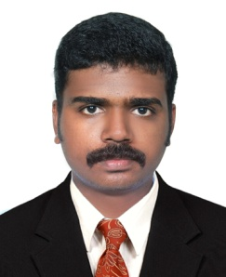
CURRICULUM VITAE

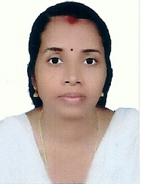
Gulfjobseeker.com CV No: 1174098
Mobile +971505905010 / +971504753686

To get contact details of this candidates
Submit request through Feedback Link
http://www.gulfjobseeker.com/feedback/submit_fb.php

OBJECTIVE:

A responsible and experienced 7 years of experience and having DHA License seeking for a position in a hospital were my skills, knowledge and experience can be utilize and nurture.

EDUCATION QUALIFICATIONS

Graduation : Diploma in Nursing, affiliated to J.Eashwari Bai Memorial School Of Nursing, Chikalguda, Secunderabad (2002-2005)

Pre-Graduation: 12th Exam, affiliated to Kerala State Board -from K.P.M.H.S.S Cheriya Vellinallor, Kollam, India (March 2002)

PROFESSIONAL REGISTRATION

Secunderabad State Nursing Council Register

Kerala Nurses and Midwives Council Register

PROFESSIONAL LICENSE

Dubai Health Authority License-

PROFESSIONAL EXPERIENCE

From | To | Year of Experience | Name of the Hospital | Post Held | Department
08th September 2005 | 12th  April 2008 | 3 Years | .  Ph: 040 - 669224444 WOCKHARDT.  (Kamineni Wockhardt Hospital), Hyderabad, India | Staff Nurse | I.C.C.U,  MEDICAL,  SURGICAL
17th  July  2008 | 10th  October 2009 | 1 Year  And  3 Months | ROYAL HOSPITAL.  Kollam, India.  Ph: 0474 - 2593555 | Staff Nurse | CASUALTY,  ICU
November 2009 | September 2013 | 3Year  And  10 Months | N.J HOSPITAL.  Kollam, India.  Ph: 9895288121 | Staff Nurse | MEDICAL

FUNCTIONAL RESPONSIBILITIES

- Admission.
- Receive the Patient, self introduction and inform Doctors.
- Check the weight, height, vitals, orientation of room and IV
- Calculation, drug administration.
- Giving general nursing care for maintaining personal hygiene and infection control.
- Teach and guide to junior nursing assistants and other auxiliary personal.
- Co-ordinate the team.
- Collect Blood samples.
- Proper Documentation.
- Assist the physician during the procedure.
- Recording Admission, Discharge, transfer in, transfer out and death of patients.

TYPE OF CASES

- Rta
- Copd
- Myocardial Infarction
- Malaria
- Dengue
- Emergency Cases
- Appendicities
- D.M
- Fractures
- Ceribral Oedema
- Rhd

TYPE OF CASES

- Rta
- Copd
- Myocardial Infarction
- Malaria
- Dengue
- Emergency Cases
- Appendicities
- D.M
- Fractures
- Ceribral Oedema
- Rhd
PERSONAL ATTRIBUTES
SKILLS
- Have good English-language skills both verbal and written.
- Capable of working under pressure.
- I have the ability to work as part of a team, to work under pressure and cope with stressful situations.

COMPUTER SKILLS
OS : Windows, XP, Vista, Windows 7
Others: Microsoft Office, Tools and usage of Internet Explorer.

HOBBIES

- Reading
- Internet browsing
- Listening to the music

PERSONAL INFORMATION

Date of Birth : 30-05-1984
Sex : Female
Nationality : Indian
Marital Status : Married
Religion & Caste : Hindu, Ezhava.
Languages Known : English, Malayalam And Hindi.

DECLARATION

I hereby declare that all the statements mentioned above are true to the best of my knowledge. I undertake to produce all my original certificates at the time of appearing in the selection test / interview.

