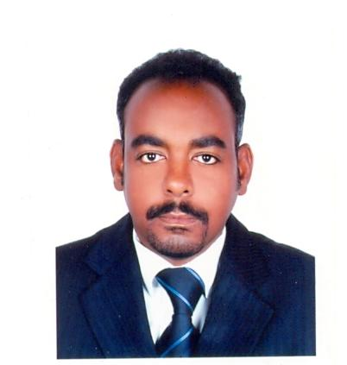

MUNTASIR
Email: muntasir.196752@2freemail.com

Personal Details :
Nationality | : | Sudanese
Sex | : | Mile
Date of birth | : | 25/03/1976
Address | : | Abu Dhabi
Marital Status | : | Married
Religion | : | Muslim

Educational Qualification :
- Diploma of Mechanical Engineering From
Sudan University for Science & Technology.
1/ Computer (Microsoft Office & Internet)_ (Muslim Aid –Sudan –UK). (Sudan)
2/Experience Certificate_ (Public Security Work shop).(Sudan)
3/ OSHA Construction _ Safe Way (Safety &Security Consultancy L.L.C).(U.A.E)
4/ Basic Fire Fighting Training _ Safe Way (Safety &Security Consultancy
L.L.C).(U.A.E)
5/ Basic First – Aid Training _ Safe Way (Safety &Security Consultancy L.L.C).(U.A.E)
6/ Basic Security Course _Group 4 Securicor (G4S).(U.A.E)
7/ Experience Certificate _ (ADNOC Distribution). (U.A.E)

Language Skills :
- Arabic
- English
WORK EXPERIENCE :

Office Assistant in Income Tax Office-1998-1999(Sudan), position- Office Assistant
-Public Security Work shop-1999-2000(Sudan), position-Mechanical Technician
-Group 4 Securicor-2003-2008(U.A.E), position- Patrolling supervisor
-Concorde-Corodex Group-2008 -2009(U.A.E), position-Project Coordinator
-MADAR International School -2009-2010 (U.A.E)Position- Transportation Manager.
-Star Security Services – 2012 - Till now(U.A.E),position-Supervisor
Skills :

- The ability to create good relationships with others.
- Learning anything fast.
- Respect Time
- Improvisation fast and Memorize.
- Working under Pressure, Working full time without rest.
- Computer (Microsoft Office & Internet)
- Driving License (2007) / U.A.E

I’m very interested to join your esteemed organization if given me a chance to serve your kind control; I assure you that I will discharging my duties to the best of my

