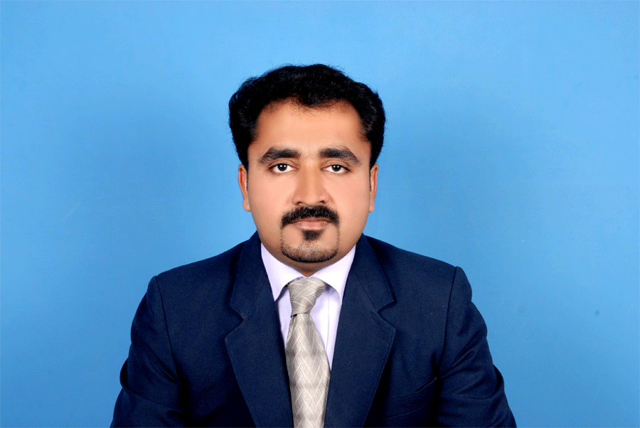
SREEKUMARAN . moh&dhA
Dubai, UAE 5527
Sreekumaran.197767@2freemail.com

Bachelor of pharmacy, M B A in hospital and pharmaceutical management.
Professional Summary.
- Pharmacist with demonstrated versatility in adapting to ever-increasing complexity in the healthcare industry. Committed to providing quality pharmaceutical care as an essential link in disease management. Contributed in MMU policy making, FMEA and Hospital KPI programs by worked as a Chapter Champion. Three time Participated in MMU tracer activity with JCI auditors.
Skills.
- Excellent Hospital and retail pharmacy procedure knowledge.
- Accurate pharmaceutical calculations.
- IV dilution of high alert medications.
- Prescription drug labeling
- Medication Inventory Management including Narcotics CDA and CDB drugs.
- Pharmacy law knowledge.
- Insurance billing expert.
- Prescription drug interaction assessment.
- Committed to quality assurance.
- Excellent knowledge in online insurance procedures.
- Motivated self-starter
- Sage Accpac ERP,HIMS,yasasii,MS Office (Word, Excel, PowerPoint, Access),BLS
WORK EXPERIENCE
Senior pharmacist (Prime hospital). (Presently)
- Attending physician’s call and providing drug related information’s.
- Dispensing of medication to the outpatient after appropriateness review of prescriptions.
- In patient medication monitoring to maintain JCI standard.
- Compiling Near misses, ADR, Medication error and KPI data’s and submitting periodically to the quality department as well as the Pharmacy and therapeutic committee.
- MMU chapter champion in Quality Improvement and Patient safety committee.
- Coordinating Pharmacy training and CME programs.
- High alert medication auditing.
- Maintaining CDA and CDB drugs and reports to Moh.
- Acting narcotic registrar in absence of narcotic pharmacist
- Prepared floor stock medication list in coordination with physicians and nursing heads.
- Make sure the availability of emergency medications in the hospital.
- Member in new Hospital Information system Development committee.
- Participating in policy making and orientation programs. Performing daily management and supervising all aspects of pharmacy operations on absence of manager.
Senior Pharmacist-(Belhoul speciality hospital) 02/2012-02/2014.
- Reviewed and interpreted prescription.
- Issuance of medication to in patient after reconciliation.
- IV preparation of high alert medications.
- Preparation of syrups which are rarely available in the market like Tamiflu, Ciprofrofloxacine etc.
- Attended physician’s call and provided drug related information’s.
- Managed cash and credit card sales.
- Dealt with more than thirty insurance companies.
- Played an active role in quality maintaining programs like FOCUS PDCA and FMEA
- Developed and implemented drug-inventory management system and thereby reduce waste and back orders.
- Maintained inventory of CDA and CDB drugs and reports to Moh.
- Arranging medications from suppliers or other institutions in an emergency situation.
Pharmacist -08/2005 to 10/2011 - Ministry of health Sulthanate of Oman.
Worked with a three hundred bedded regional hospital of Sultanate.As an ancillary staff in fulfilling more than 2000 prescriptions weekly (99% of Arab patients). Consult with physicians and patients with regard to medication dosage, drug interactions, medical equipment, disease management and potential side effects of prescription and OTC medications. Prepared quarterly intend of medication and surgical items in accordance with consumption. Maintained the inventory of narcotic and psychotropic drugs. Actively participated in H1N1 influenza eradication programs.
Pharmacist- Mathery Medical Mission hospital, Kerala, India. (11/ 2002 to 12/2004).
50 bedded hospital. Performed daily management of pharmacy. Supervised all aspects of operation in absence of in charge pharmacist. Provided drug related information to the patient doctors and all hospital staffs.
Registrations
- Registered Pharmacist in D H A (DHA-P-0042725)
- Registered Pharmacist in M O H of UAE (Register No: 3344)
- Registered in Kerala State pharmacy council(Register No: 22122)
Education.
- MBA in Hospital and Pharmaceutical management. Jan 2016(National Institute of business management-India)
- Bachelor of pharmacy (B. Pharm), October 2002- M.G.R Medical University, Tamilnadu, India. (It is the second largest Health Sciences University in India).
- Diploma in pharmacy (D Pharm), April 1998.
A.M college of Pharmacy - recognized by the Pharmacy Council of India (PCI), All India Council of Technical Education (AICTE) and Board of Medical Education, Kerala state.

PERSONAL DETAILS
Sex -Male
Maritalstatus -Married
Date of birth -3rd feb-1977
Nationality -Indian
Languages known -English, Malayalam, Tamil, Hindi, and Arabic.
Driving license-UAE, Sultanate of Oman and India
References: Available on request

