EDGARDO

Email Add.: edgardo.198148@2freemail.com

Profile:
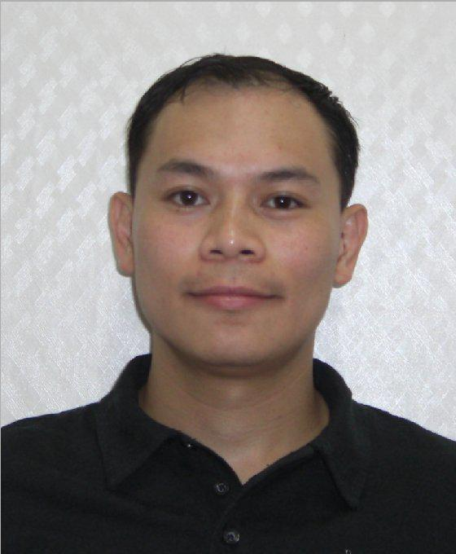

A qualified person with ability to work independently, experienced working with people at all levels of the organization, a team leader who is able to meet company expectations in highly professional manner, possesses good communication skills, have excellent technical skills, familiar in using Microsoft office suite, Outlook, a well trained in operating, repair and maintenance of different manufacturing machines, and experienced in customer related assistance and coordination.

Educational Attainment:
Electrical Engineering Technology (EET)

Technological University of the Philippines (Graduate)
WORK EXPERIENCE:

Food & Events Coordinator/ Attendant/ Waiter
Jack & Jenn Restaurant & Catering Services

Oct 2012 – Nov 2013
Las Pinas City, Philippines

Key Tasks:

- Responsible for coordinating events, including planning menus, booking musicians, hiring bartenders, others ensuring events runs smoothly.
- Help customers to plan and calculate budgets
- Sample food and select dishes for menus and suggest to client
- Schedule speakers, vendors, and participants

- Manage correspondence and invitations
- Record and keep inventories of display materials, projectors, computers
- Assist hiring of staff when needed
- Back up staff/waiters during the event, while spearheading the event.
- Prepare and submit necessary reports

Customer Service Assistant

March 2012 – Oct 2012
S&R Supermarket Department Store / Warehouse

Muntinlupa City, Philippines

Key Tasks:
- Assist and direct customers inside the Store/Warehouse
- Assist Cashiers and customers with items bought
- Re-stock Shelves/ Remove nearly expiry products

- Conducts Inventory /Provide report
- Attend trainings as required

Mixer Operator (Laser printer toner)

Oct. 05, 2011- Jan 20, 2012
CIT (Creative Imaging Technology Co., Ltd)

Wolmi Dong, Gongju City, Chungchengnam Do, Korea
(Manufacturer of Colored Laser Printer Toner)

Key Tasks:
- Conduct proper measurements of chemicals needed for the production of laser toners

- Ensures On time mixing of chemicals
- Conduct preventive maintenance of mixing machines and testers.
- Ensures quality and quantitative amount of laser toner needed for the shift.

PCB Etching / Cleansing Operator

Aug. 19, 2009 – Jul 06, 2011
JTech
Danwon-gu, Ansan City, Gyeonggi-Do, South Korea

(Printed Circuit Board design)

Key Tasks:

- Prepare machines, equipment and materials needed for the production printed circuit boards.
- Operate conveyor machines and other equipments in PCB cleansing area.
- Responsible for feeding PCB card to be cleans in cleansing area.
- Responsible for cleaning of silk screens and other equipment used by production.
- Conduct preventive maintenance on all conveyor machines.

- Transport and receives PCB card to be etch in the etching area.

Machine Operator (Printing/Cutting Dept.)

Nov. 29, 2005- June 29, 2009
Myeongil C&B

Incheon, Gwangyeok City, Gyeyang-gu, Jakjeon dong, South Korea (Manufacturer of Pulp paper and Corrugated Box Product)

Key Tasks:
- Prepare corrugated box sheets to be use in printing and cutting machines.

- Prepare and set up machines and equipment needed in production of corrugated box to be printed and cut.

- Responsible for operating of printing/cutting machines.
- Responsible for feeding of corrugated box sheets to be cut in cutting area.
- Conduct preventive maintenance of printing/cutting and strap machines.
- Ensures quality and quantity of finished products.

- Responsible for filling of finished product to be transported in a stock area.

Failure Analysis Quality Assurance Technician (3.5”, 2.5” & 1.8” PCBA, QA Dept.) cum Maintenance Test Technician (3.5”, 2.5” & 1.8” PCBA, Production Dept.)

April 1, 2003 – Oct. 21, 2005
Hitachi Global Storage Technologies Philippines Corp.
Special Export Processing Zone, Laguna Technopark, Binan, Laguna, Philippines (Manufacturer of 3.5”, 2.5” & 1.8” Hard Disk Drive)

Key Tasks: (FAQA Tech)
- Perform QA confirmation test to determine the validity of functional failures
- Assist FA engineers in performing some simple / routine FA job

- Perform periodic calibration and preventive maintenance on QA instruments / equipment or testers.
- Coordinating and preparing for the QA software release.
- Performing QA testers’ conversion

Key Tasks: (Maintenance Tech)

- Perform line support for all function circuit tester in line with testing of PCBA by responding to trouble reported by operators.

- Perform tester’s uptime conditioning by trouble shooting, repair analysis and on time action implementation.
- Conduct preventive maintenance for all FCT jigs and other test line equipment.

- Monitor and control of Hard Disk Drives (HDD) and Hard Disk Assembly (HDA) used by the production, Includes NG verification, and data gathering through summary usage and consumption.

- Conduct ESD grounding and control, by daily checking of grounds and ground monitors at the start of the shift.
- Control and handles equipment and tools at the test area.

- Monitoring and control of spare parts and other equipments used by the production through daily, weekly and monthly inventory.

- Perform IDE board trouble shooting and recovery.
- Conduct evaluation, base on jig performance.

Maintenance Test Technician (2.5” PCBA, Production Department)

June 26, 2002 – Mar. 31, 2003
ODAWARA Customs Manufacturing System Co. Ltd.
Hitachi Computer Products (Asia) Corp,
Special Export Processing Zone, Laguna Technopark, Binan, Laguna, Philippines (Manufacturer of 1.8”, 2.5” and 3.5” PCBA Card)

Key Tasks:

- Perform sustaining work on all Function Circuit tester and jigs used by entire production from cell, debug and QA stations.

- Responsible for line support for the production of PCBA by responding to trouble report of operators.

- Perform FCT model conversion and set up, using installation of new programs in support for ongoing production.
- Conduct preventive maintenance for all FCT machines and test line equipment.
- Conduct ESD grounding and control, by daily checking of grounds and ground monitors.
- Control and handles equipment and tools at the test area.

- Conduct initial checking of Hard Disk Drives and Hard Disk Assembly endorsed by warehouse to be store and use for the production.
- Conduct HDD recovery thru data adjusts.
- Monitoring and control of Hard Disk Drives and Hard Disk Assembly used by the production.
- Monitoring and control of spare parts and other equipments used by production.

Test Technician (Production Engineering Department)

July 19, 2002 – Jan 31, 2000
NEC Computer Storage Philippines, Inc

Laguna Technopark, Biñan, Lagun
(Manufacturer of Hard Disk Drive-HDD)

Key Tasks: (Test Technician)
- Performs trouble shooting and repair of V3 Testers and other equipment.

- Conduct preventive maintenance for all test line equipment
- Continuous line support for the production of HDD by responding to trouble report of operators
- Perform assembly and set up of DMA 100 tester to be release to line.
- Performs calibration, monitoring and periodic check of equipments
- Ensures implementation of Manufacturing Process Instruction to be observed at the area.

Trainings & Seminars

•

•

•

•

•

•

•

•

Courtesy & Food Safety, November 2012, BF Las Pinas City, Philippines
Korean Language and Korean Culture Seminars, Nov 29, 2005 to November 30, 2005, Incheon, Gyeongi-do, South Korea

Pre Departure Orientation Seminar (PDOS), for Employment Permit System in Korea, Conducted by DOLE and OWWA,, Oct. 19, 2005 to November 5, 2005, POEA Building Mandaluyong City Philippines Occupational Safety and Health (OSH), Oct. 19, 2005 to November 5, 2005, Diliman Q.C. Philippines

Korean Language and Korean Culture Seminars, Oct. 19, 2005 to November 5, 2005, TESDA Taguig City, Philippines

Operator’s Orientation and Basic Technical Training, Odawara CMS, SEPZ Laguna Philippines Inventory Management Seminar, Nov. 2000, NEC-CSPI, SEPZ Laguna Philippines
ISO 14001, July 2000, NEC Computer Storage Phils. Inc. , SEPZ Laguna Philippines

On The Job Training (OJT) ROHM Electronics Phils. Inc., Nov. 3, 1997 to April 3, 1998, Carmona Cavite Philippines

PERSONAL DATA

Civil Status: Single
Citizenship: Filipino
Languages or dialect spoken: Tagalog & English
Visa Status: Tourist Visa
Person to contact in case of Emergency: Normita Abanil (sister)

