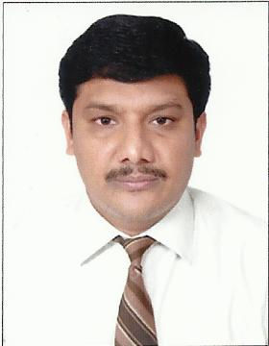 **CURRICULUM VITAE**

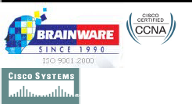

**MOHAMED   
  
E-Mail:** [**Mohamed-198822@gulfjobseeker.com**](mailto:Mohamed-198822@gulfjobseeker.com)

**Objective:**

To be a part of your ever-growing industry and to create innovative solutions that are different but those that have professional flair and are applicable in a real world scenario. To be a member of a team where I will be able use my creativity and be able to further enhance my knowledge.

To prove my Qualification, Skills, Computer knowledge and to transform them to Professional Experience and to work in a challenging environment.

## EXPERIENCE

Worked as a **IT Support Engineer** in **Tech Limited from** Jan- 2011 to Feb- 2014.

**Responsibilities**

* Configuration & Troubleshooting of MS Outlook.
* Maintains network performance by performing network monitoring and analysis, and performance tuning, troubleshooting network problems for LAN, WAN.
* Implemented and managed IP Addressing, configured TCP/IP addressing on a server.
* Solving day to day hardware & software related problem.
* Configuring and Managing of ADS, GPO, DNS, DHCP &WSUS in secure with Group Policy Management.
* Creating and Managing User Accounts using Active Directory and Secure with Group Policy Management.
* Configuring and Managing of IIS & Exchange Server
* Managing Backup Process Local and server.

## EXPERIENCE

Worked as a **Desktop Support Engineer** in **Al Zahra Hospital Pvt, UAE** from Jul-2007 to Jan-2011.

**Responsibilities**

* Hardware Assembling and Troubleshooting.
* Troubleshooting normal TCP/IP connectivity problems in Windows.
* Installation of Windows Operating System – Win XP/2003/07/08
* Every month doing the patching Activity System updates.
* Assigning the file and folder level permissions as per the user requirement.
* Provided thorough support and problem resolution for end users.
* Remained up-to-date on the latest technologies and solutions applicable to company products.
* Configuring, managing and providing support for print servers.
* Installation of OS for Client machines and Troubleshooting through Remote Access.
* Analyze Problems & escalate to appropriate Levels.
* Managed call flow and responded to technical support needs of customers.
* Created cases and claims for damaged, lost or displaced packages.
* Managing and maintaining the V-Cons and Projectors.

## EXPERIENCE

Worked as a **IT Administrator** in **Capital International Group, UAE** from Mar-2014 to May-2014.

* Installing the Windows Software’s, Network Printers, Scanners, & VoIP phone Avaya, Nortel standard software’s etc
* Maintaining the Printers, Desktop, Laptop, Scanner etc. for the user will not suffering any problem with that Hardware’s.
* Installation, Integration, Configuration, and proper support of Active Directories based on Windows Server.
* TCP/IP configuration and administration of IIS for Intranet.
* Installing operating systems and configuring the peripherals, components and drivers.
* Responsible for installing, maintaining and supporting computer communication network (LAN & WAN).
* Installing, maintaining and Biometric Access Control.
* Managing and maintaining the V-Cons and Projectors.
* Managing Local and server Backup Process.

## Technical Knowledge:

* **CCNA** Certified in **Netscope networking Pvt LLC**
* knowledge in AD,DHCP and router, switch and wireless.
* Knowledge in Operating Systems of Windows-XP, Vista & Windows 7.
* Having excellent working knowledge in **MS–Office** and other specified packages.

## EDUCATIONAL QUALIFICATION

* **B.E** (Information Technology) – March 2001– March 2005

**A.V.C College of Engineering - Mayiladuthurai.**

(Affiliated by Bharathidasan University, Trichy)

* **Diploma** (Electrical & Electronics Engg) – April 1998– June 2001

**A.V.C.C Polytechnic - Mayiladuthurai.**

(Affiliated by Affiliated to Dote, Tamil Nadu, India)

## PERSONAL DETAILS:

Father Name : Packeer Mohamed. A

Gender : Male

Date of Birth : 26/08/1978

Nationality : Indian

Marital status : Married

Language Known : English, Tamil.