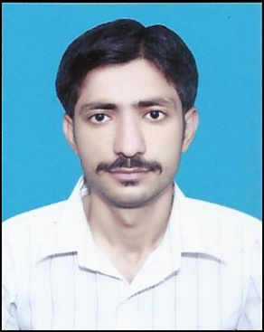
CURRICULAM VITAE

SOHAIL
SOHAIL.198964@2freemail.com
PAKISTAN

APPLICATION FOR : ASSISTANT ACCOUNTANT

Carrier Objective:
Looking forward for an organization that offers a challenging, learning environment to work and scope for individuals’ organizations’ development, which offers attractive prospects for long term development and career growth.

Educational Qualification:
- Matric
- Intermediate
- Bachelor of Commerce (B.COM)

Work Experience:
- Presently working as a ASSISTANT ACCOUNTANT in ACCOUNTS DEPARTMENT with ENGRO FOODS LIMITED SAHIWAL at Pakistan since last 1 year.

Job Responsibilities:
- Monthly management account preparation.
- Production of profit and loss.
- To complete and maintain sales invoice and reports.
- Accruals and prepayments.
- Preparation of the account pack for review.
- Bank reconciliation, posting and balancing.
- Weekly wages, petty cash and other journal posting.
- Daily bank receipt postings.
- Year budget preparation And Year end audit analysis.
- Reports on debtors and creditors.
Visit Visa Details:
Date of entry: 16th January 2014
Date of exit: 15th February 2014
Personal Details:
Date of birth : 11 / 09 / 1990
Gender : Male
Nationality : Pakistani
Marital Status : Single
Religion : Islam
Date of Expiry : 17 / 12 / 2022
Languages Known : English, Hindi, Punjabi & Urdu.

