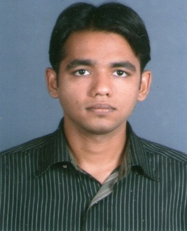  Manzar  Manzar.201465@2freemail.com  Certification  Microsoft Certified Professional. (Managing and maintaining a Microsoft windows server 2003 environment  OTHER CERTIFICATION  Hardware Troubleshooting and CCNA Course in CMS Institute in 2009 to 2010.  Address For Communication:  Near Al-Mujarrah Park,  Sharjah Rolla. | CURRICULAM VITAE  Objective:  To build successful career that will provide both intellectual and financial rewards, through a process continuously adding value to work place, as well as myself through constant up gradation of knowledge in my chosen field, with the full emphasis on development of potential abilities.  Professional Experience  Storekeeper  TAMIMI GLOBAL CO. (04APR12- 22MAR13) SAUDI ARABIA ,KSA  Responsibilities:  - Receiving Material.  - Arranging Materials.  - Preservation of the Material.  - Recording bin cards.  - Issue of Material.  - Issuing Purchasing Requisition.  - Daily Cost Record.  - Monthly Inventory.  Computer Operator  CITY COMPUTER & PERIPHERALS (24JAN11- 15SEP11) GOA,INDIA  Responsibilities:  - Sales Record.  - Stock Maintain.  - Purchase Order.  - Quotation Mails.  - Data Backup.  - Installation of Operating System.  - Maintenance of Computer.  Computer Hardware Engineer  DIGInet ,MAINTENANCE DEPT (1stOCT09 to 20JAN11) GOA,INDIA  Responsibilities  - Troubleshooting.  - Maintenance of computer hardware.  - Software related issues.  - Recovery process.  - Configure system backup procedures.
Personal Data:  Date of Birth: 13/03/1989  Sex: Male  Nationality: Indian  Marital Status: Single  Joining time  Within short notice  Languages Known  - English.  - Hindi.  - Urdu  - Konkani  Visa-Status  Visit Visa (Till 17OCT2013) | Educational Summary  Bachelor of Computer Application (B.C.A)  G.V.M’s G.GPoy Raiturcar College of Commerce & Economics  University-GOA, INDIA  June 2006 to October 2009  - Majoring in Peripheral Fault Finding and Assembling.  - Higher Secondary qualified through Goa Board majoring in Electronics Technology.  Strength  - Positive and aggressive attitude towards work and conditions given at any stage of career.  - Fast Learner and consistent in Meeting deadlines.  - Willingness to take additional responsibilities.

