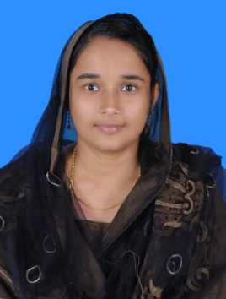

CURRICULUM VITAE

MUMTHAS
DEIRA. E-mail: mumthas.21183@2freemail.com
DUBAI

Objective:

To obtain a challenging position where in my skills and ideas will be focused to the best interest of the organization enabling its dynamic growth and progress.

Work Experience

Data Entry cum Office Assistant

Presently working as a Data Entry Operator cum Office Assistant in Arabian Automobile Association in Dubai.

Office Clerk

Duties
- Maintaining the students and teachers attendance for the purpose of providing accurate information for the district educational authorities
- Maintaining the inventory of office stationery for ensuring the availability of the items.
- Responds to inquiries of staff, the public, parents and/or students for the purpose of providing information and/or direction as may be required.

Primary Teacher
Worked as a teacher in Kerala , Govt .Upper Primary School
Vengara ,Kerala, India .

Accounts Assistant
Worked as Accounts Assistant in a Textile trading company at Malappuram, Kerala, India
Duties:
- Receiving daily cash from the counter and Depositing in the bank on a daily basis
- Journalizing the purchase invoices and making payment to the suppliers.
- Bank reconciliation.
- Preparing Salary of the staff
- Assisting in the quarterly inventory verification in the showroom.
- Assisting the senior accountant for the quarterly and yearly closing of accounts and in the preparation of Balance sheet.

Educational Qualification:

- S. S. L. C. from Board of Public Examination Govt of Kerala.
- Pre-Degree Course from Calicut University, Kerala.(Commerce, Accountancy, Correspondence)
- B.A. Arabic from Calicut University, Kerala.
- B.Ed. From Calicut University, Kerala.
- Diploma in Computer Financial Accounting (DCFA)

I T Qualification

- Tally
- Microsoft Word
- Microsoft Excel
- Power point
- Internet and Email

Personal Profile:

Date of Birth : 31/05/1977
Status : Married
Sex : Female
Nationality : Indian
Visa status : Husband visa
Religion : Muslim
Language : English, Malayalam

I hereby declare that all the statement mentioned above are true and benefited to the best of my knowledge and belief .Thank you for your consider action

