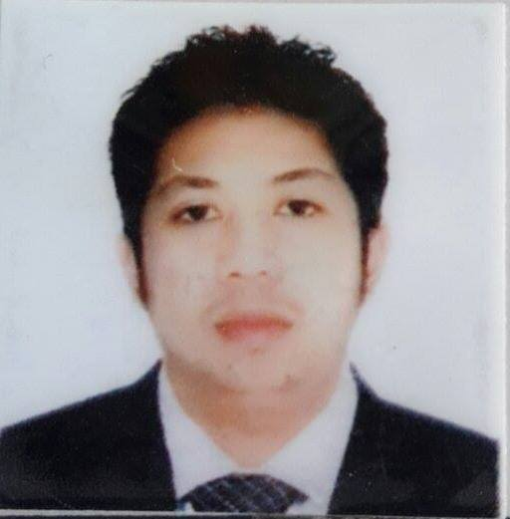
Mark
Mark.21941@2freemail.com

Career Objective
To secure a position in a professional work environment that gives an opportunity to grow and will enable me to apply my knowledge and skills effectively and efficiently for the company’s success.
Career History:

1. Salesman/Supervisor
Matrivino General Merchandiser - Philippines
Oil Refinery
December 10, 2015 - January 15, 2016

2. Customer Service Associates / Salesperson
Boutique 99 Perfume - Dubai UAE
October 28, 2013 to November 26, 2015
Duties:
- Ensuring that all customers receive excellent service through direct salesmanship, and prompt and courteous service.
- Assisting customers with questions, needs and purchases.
- Cultivating successful relationships with retail customers.
- Completing each transaction in a quick and efficient manner.
- Cleaning shelves, counters, and tables.
- Greeting each customer that comes into the store in a warm manner.
- Identifying customer requirements.
- Preparing merchandise for display.
- Assisting customers with purchase decisions.
- Assisting in physical inventory counts.
- Implementing all visual merchandising standards.
- Setting up merchandise on the sales floor.
- Making sure that customers receive receipts on all purchases.
- Helping customers try on or fit merchandise.
- Watching out for loss prevention through leakage and theft.

3. Lifeguard / Receptionst
Carlton Tower Hotel 4* - Dubai UAE
April 08, 2012 up to September 19, 2013

4. Lifeguard / Rescuer
Golden Tulip Ras Al Khaimah 5*-
October 04, 2011 up to present

5. Lifeguard / Health Club Officer in Charge
Emirates Concorde Hotel & Residence 4*
Deira Dubai, U.A.E
June 2008 up to September 2011
Duties:
- Train staffs according to set departmental standards and policies and procedures and informs superior on performance.
- Supervise assigned areas of the day to day operation of the health club.
- Inspects relevant areas and supervises the activities to fitness Coordinator and masseurs in order to increase the satisfaction of the guest.
- Enforces guest satisfaction through high staff morale and impeccable service
- Performs related duties and special projects as assigned.
- Reports unusual behaviors/activities in all areas of health club
- Keeps daily log book and enters relevant information in hand-over log for the next shift
- Offers assistance and helps all the guests and the health club staff too
- Reports and hands over lost and found.
- Attends health club meetings and trainings and acts on special events.

6. Lifeguard / Health Club Attendant
Emirates Concorde Hotel & Residence 4*
Deira, Dubai, U.A.E.
July 2007 to June 2008
Duties:
- Preventing injuries by minimizing or eliminating hazardous situations or behaviors.
- Enforcing facility rules and regulations and educating patrons about them.
- Recognizing and responding quickly and effectively to all emergencies.
- Administering first aid and cardiopulmonary resuscitation (CPR) or using automated
brillator (AED) in an emergency.
- Informing other lifeguards, facility staff and management when more help or equipment
is needed

7. Emirates Concorde Hotel and Residence 4*
Deira Dubai, UAE
January 2006 - June 2007
Duties:
- Maintain the cleanliness and orderliness of the kitchen.
- Assist in the kitchen in food preparation.
- Store food in designated areas.
- Check and prepare the ingredients needed to cook.

8. Kitchen Helper(Trainee)-Main Kitchen
Le Meridien Hotel
Al Garhoud Dubai UAE
November – December 2005

9. Salesman/Customer Service Representative
S.M (Shoe mart)
Batangas City, Philippines
January 10, 2003 – September 30, 2005
Duties:
- Respond promptly to customer inquiries
- Handle and resolve customer complaint
- Perform customer verification
- Process orders, form, application request
- Provide detailed information on services and products to customers
- Recommend service and product options to meet customer needs
- Demonstrate product if needed
- Direct request and unsolved issue to the designated source
- Follow-up customer service.

10. Service Crew - Kitchen Department
Jollibee Food Corporation
Batangas City, Philippines
July 2003 – December 2004

11.Waiter
Batangas Country Club
Convention Hotel Resort
Batangas City, Philippines
June 5, 2001 – December 5, 2002

Educational Background:
Lyceum of Batangas
Associate in Hotel and Restaurant Management
Batangas City, Philippines
1998 – 2000
Seminars / Trainings
1. Denan Aquatic Center Sports Services
(American Red Cross)
August 2010
- Lifeguard Training
- Basic First Aid
- CPR and AED (Automated External Defibrillator)

2. Denan Aquatic Center Sports Services
(American Red Cross)
July 2007
- Lifeguard Training
- Basic First Aid
- CPR and AED (Automated External Defibrillator)

3. Admiral Maritime Training Institute of the Phils. Inc.
2nd floor. Mezzanine, PCI Bank building Plaza, Sta. Cruz, Manila, Philippines
June 14 – 27, 2001

Basic Safety Course:
- Personal Survival Techniques
- Fire Prevention and Fire Fighting
- Elementary First Aid
- Personal Safety and Social Responsibility

Declaration:
For the best of my knowledge the information mentioned above is true.

