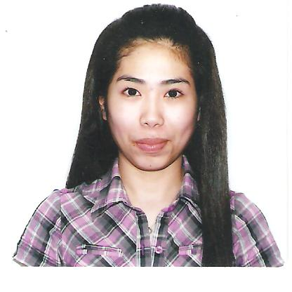
Araceli
Araceli.2755@2freemail.com
CAREER OBJECTIVE
Seeking a position where I can utilize my skills and abilities, enhance my knowledge and capabilities.

EDUCATIONAL BACKGROUND
COLLEGE: Polytechnic University of the Philippines
Sto.Tomas Extension
Sto.Tomas,Batangas
Bachelor of Science in Computer Science
2001-2003
Secondary:Manuel S. Enverga University Foundation
Candelaria Incorporated
Candelaria, Quezon
1996-2000
Primary:Malakimpook Elementary School
Malakimpook SanPascual,Batangas
1990-1996

JOB EXPERIENCE

Dec. 4, 2013-Dec. 31, 2014:Medical Records Officer
Hospital
Philippines

- Manage patient’s data
- Maintaining and securing patient’s medical records
- Ensure all the information contained in the patient’s record is complete and accurate

April 2010-August 2010: PT Cashier
Waltermart Supermarket
Tanauan,Batangasphilippines

- Receive and disburse money.
- Involved in processing credit or debit card transactions.
- Compute and record totals of transactions.

April 2006-March 2009: Film Inspector
Manufacturing Section 9 Electrysta Department
Nitto Denko Corporation
Hiroshima, japan

- Inspectioning foreign objects in the material that are visible to the eye that causes poor quality of the film while on process.
- Assisting new employees to familiarize them to the work area and to the work itself.

Feb.2005-Feb. 2006: Production Operator
Panasonic Communications Corporation of the Phillippines
Carmelray Industrial Park II
Laguna, Philippines

- Checking the appearance of the ODD(Optical Disk Drive) in the assembly department.
- Performing the audio check of the drive(ODD).

June- October 2003: Production Operator
PilipinasKyohritsu Incorporated
Lipa, Batangas Philippines

- Bundling wires to its specific number before passing it to the next process.

PERSONAL INFORMATION

Age : 31 years old
Date of Birth : June 22,1983
Nationality : Filipino
Sex : Female
Civil Status : Single
Visa Status:Tourist Visa
Residence Location : Dubai, UAE

