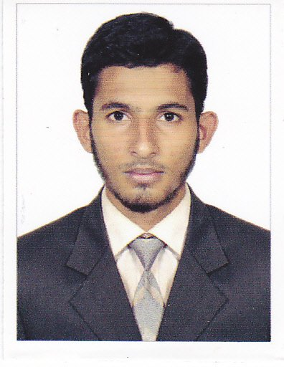
Curriculum Vitae

WAHID
WAHID.202982@2freemail.com

OBJECTIVE : Locking to join a progressive organization that has the need for
Arch. Draughtsman and offers opportunity for advancement
EXPERINCE :
- Preparing presentation Drawings in Auto CAD & 3DS MAX
- Preparing Drawings for Municipality approval
- Preparing working /shop Drawings
- Preparing flooring pattern in Auto CAD & 3DS MAX
- Preparing Detail Drawings
- Detail of different parts of sections
- Swimming pool Detail
- Bath and kitchen Detail
- Boundary Wall Detail
- Roof Finishing Detail
- Reception and Bath Counter Detail
- Preparing Door and window schedule &detail
- Preparing Landscape detail
- Preparing Cutting list & Quantity for Order Marble/ Ceramic
- Preparing As Built Drawing
- Co-Ordinary of Architectural drawing with structural & Service Drawing

EMPLOYMENT HISTORY
21st Feb. ‘2012 TO till date
Name of employer : MORGAN CONCOLTANTS, MUMBAI
Project Name : 22 Floor Storied Building At Behind The Bazaar
Client/Site: Paradise Enterprise, Mumbai
Duration: September 2011 till date
Designation: Municipal Drawing
Position : Arch. Draughtsman
Nature of job : Architectural Building Drawing
- Preparing Building drawings of plan , section & Elevation from tender drawings
- Preparing building drawing for Granit Floor pattern with detail of fixation, Skirting and wall cladding.
- Preparing building drawings for all type of staircases with finishing detail, Handrail fixation detail skirting & coping detail.
- Preparing detail of Toilet s , wash Rooms and janitors
- Preparing pilaster detail drawing.

- Co-ordination
- I have a good experience and talent in co-ordination.
- Coordinating architectural building drawings with tender drawings , stretcher and other service building drawing as well as with the site engineers &foreman and expose the problems &confliction.
- Coordinating with the Granite suppliers, replying for their inquiries and providing detail & information as they required.
QULIFICATION DETAIL
- SSC(Higher Secondary School Maharashtra Board 2008-09)
- Architectural Draftsman-2 Years Certificate Course (M.H Saboo Siddik Polytechnic 2009-11)
- Diploma in Auto Cad and 3DS Max (Cad Center (Dadar), Mumbai 2011.)
COMUTER EXPOSURE
Operating system : Windows XP, Windows 7 &vista
Drafting Software : Auto CAD ver.2007 to 2010
MS –Office : MS-word, MS-Excel, MS- Access,
MS- Power point, MS-Paint
Computer Language : Visual Basic

LAGUAGES
English : Good
Urdu : Excellent
Marathi : Excellent
Hindi : Native Lang
PERSONAL DETAIL
Birth date : 30/07/1991
Nationality : Indian
Religion : Muslim
Marital Status : Single
Gender : Male
Declaration
I hereby declare that all the information furnished above are true and correct to the best of my knowledge and belief

