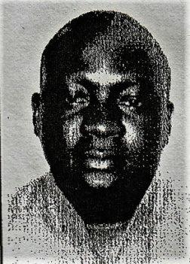
Security Guard Resume

PERSONAL DETAILS
NAME : James

EMAIL : james.204089@2freemail.com

PERSONAL INFORMATION
Ssenyonga james who is committed to complying to the highest work place standards in terms of attendance, health and safety, and conduct towards the public. James has a comprehensive working knowledge of all Security Guard orders and duties, and is physically fit enough to be able to walk around for long periods, stoop, kneel, push, pull and grasp things. In my previous role i was regularly exposed to hot and cold weather conditions, smoke, loud noise, and bright lights. Right now i wants to join an ambitious company that is looking to recruit a Security Guard who has the motivation needed to ensure the highest levels of safety and security.

WORK EXPERIENCE

SECURITY GUARD

Askar security company 2012 – 2016.

Locations were Sheraton hotel kampala , mukwano shopping center kampala

Responsible for impeding criminal activity and ensuring the safety of the company, its employees and assets.

Also involved in interacting with a variety of persons including clients, visitors and the general public.

Duties:

• Providing assistance and guidance to managers, visitors and gene
ral staff.

• Contacting the police, authorities and other emergency services when necessary.

• Checking badges of employees and visitors.

• Responding to emergencies.
• Reporting all incidents, accidents or medical emergencies.

• Monitoring and patrolling business areas on a consistent basis.

• Performing any light maintenance work that may be required.

• Responding to emergencies.

Currently working in Transguard group as a cleaner from 2016
Locations global village for 6months and now Emirates flight cater
Ing

ACADEMIC QUALIFICATIONS

2000 - Uganda certificate of Education

2002 – Advanced certificate of Education

2006 - Advanced certificate in computer repair and maintaince

2010 - Diploma in information technology

2017 – SIRA Security certificate

HOBBIES:

Playing chess
Reading books

