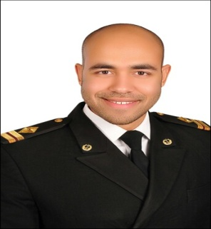
Deif
Address:, Cairo, Egypt

Gender : Male  Birth Date :14.04.1991  Nationality :Egyptian  Marital Status: Single | Email deif.206026@2freemail.com  Military Service : Exempted

Career Objectives:
Seeking for a job in a reputable company where my academic background & interpersonal skills are used and developed.
Education & Qualifications:
- B.Sc. Of Marine Engineering: Arab Academy for Science, Technology & Maritime Transport. ( Feb. 2015 ) - Alexandria, Egypt
- School: New Ramses College.
- High School: Menese International Schools. ( American Diploma SAT 1 & SAT 2 )
Training & work Skills:
- Marine Engineer at Kuwait Oil Tanker Company. “KOTC” (KUWAIT) 30 April 16 –17 Aug. 17
- Engine Cadet on AIDA IV Sea Training and Supply Ship. Feb. 2012 – Aug. 2012
- Arab Shipbuilding and Repair Yard Company. “ASRY” ( BAHRAIN) Sept.2014
- Arab Petroleum Pipelines Company. “ SUMED” ( Sidi Kerir Terminal ) July 2014
Special Courses Attended STCW – 95 & Certificates:
- 3rd Marine Engineer Officer.  - Advanced Fire Prevention and Fire Fighting.  - Proficiency in Survival Crafts and Rescue Boats.  - Personal Safety and Social Responsibilities.  - Medical First Aid.  - Security awareness training for seafarers with designated duties.  - Proficiency in Personal Survival Techniques.  - Basic Training for Liquefied Gas Tanker Cargo Operations.  - Basic Training for Oil & Chemical Tanker Cargo Operations.  - Prevention and Combating of Marine Pollution.  - Marlins English Language Test for SEAFARERS. ( Test result is 81% )  - IT Cambridge Diploma. | Valid till 30/04/2020 Exp. Date 06/05/2020  Exp. Date 06/05/2020  Exp. Date 11/05/2020  Exp. Date 13/05/2020  Exp. Date 17/05/2020  Exp. Date 25/05/2020  Exp. Date 23/12/2020  Exp. Date 20/01/2021
Computer Skills:
- Excellent Usage of MS Windows 7 & MS Office 2010 (Word, Excel, PowerPoint, Windows, IT, Access, excellent at using Internet Explorer & search engine.)
Language Skills:
- Arabic : Mother Tongue
- English : Fluent (written & spoken)
- French : Fair
Interpersonal Skills & Hobbies:
- Diplomatic person with good negotiation, co-operative & excellent presentation skills.
- Excellent Communication Skills, work problem solving & Able to handle problems.
- Ambitious, Positive, Self - motivated, Respect work, willing to Learn, Can work under pressure, Easily adapted & Organized.
- Able to reflect a Good image of the Company.
- I was Football player at Egyptian National team & Egyptian Sport Clubs.

All references are available upon request.

