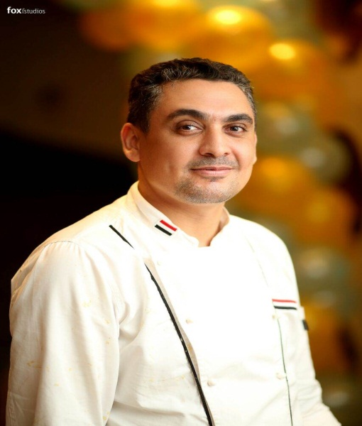
Personal Data

Elantary
Current Location : Egypt
Nationality : Egyptian
Date of Birth : 30 Jan 1980
Civil Status : Married
Languages Spoken : Arabic, English
Height/Weight : 180cm; 78kg
Email : elantary.206027@2freemail.com com

Work Experience

Le doux Damietta Egypt October 2014 till now
Executive chef

- Hiring and managing individuals on the kitchen staff team
- Organization for the operation
- Cost calculations and budget forecasting for 6 months
- Creative menu planning using seasonal ingredients
- Over seeing a large number of catering events both private and corporate

Grandcafe Bermuda united states

Executive Sous chef March 2014 till October 2014 www.grandcafe.co

- Reopen five stars restaurants & open new 3 branch
- Organize the kitchen
- Over seeing a large number of catering events both private and corporate
- Cost calculations and budget forecasting for 6 months
- Creative menu planning using seasonal ingredients
- Hiring and managing individuals on the kitchen staff team
- Train the team haccap system
- Dealing with our suppliers on daily basis , keeping up with the latest available products

Rotana coral beach montazah, sharm elsheikh, Egypt
Executive Sous chef Oct 2012 till March 2014 www.rotana.com

- Cost calculations and budget forecasting for 6 months
- Creative menu planning using seasonal ingredients
- Hiring and managing individuals on the kitchen staff team
- Train the team haccap system
- Dealing with our suppliers on daily basis , keeping up with the latest available products
- Organize the menu for festival arts sharm elsheikh 2013

Melia company, sharm elsheikh, Egypt
Sous chef Feb2012 – Oct 2012
www.melia.com

- Organize new menu for alacart & buffet
- Cost calculations and budget forecasting for 6 months
- Responsible for the Italian kitchen & 3 area alacart
- Train the team haccap system
- Replace the executive chef in his vacation

Amwaj blue beach abu soma hurghada , Egypt
Sous chef Dec 2010 – Feb 2012

www.amwaj.com

- Organize new menu for alacart & buffet
- Cost calculations and budget forecasting for 6 months
- Responsible for the Main kitchen & 2 area alacart
- Train the team haccap system
- Replace the executive chef in his vacation

Moevenpick royal lily, Luxor Aswan, Egypt
Executive chef June 2007 – Nov 2010

www.moevenpick.com

- Opening five stars hotel cruise and follow the Moevenpick standard
- Organize the kitchen and menus with Moevenpick standard
- Handle all the pepper work
- Cost calculations and budget forecasting for 6 months
- Creative menu planning using seasonal ingredients
- Hiring and managing individuals on the kitchen staff team
- Train the team haccap system
- Dealing with our suppliers on daily basis , keeping up with the latest available products

Coral beach Tiran Rotana, sharm elsheikh, Egypt
Chief D, parti April 2006 – June 2007
www.rotana.com

- Charge in main hot kitchen
- Improve the quality of food
- Replace the Sous chef in his vacation
- Responsible of tow alacart area

Iberotel lamaya & samaya , marsa alam , Egypt
Chief D,parti Jan 2005 – April 2006

www.iberotel.com

- Charge in main hot kitchen in tow hotel ( lamaya & samaya ) 532 family room
- Improve the quality of food for the Italian kitchen & oriental
- Replace the Sous chef in his vacation
- Responsible of tow alacart area
- Handle all the document for Cristal audit

Sonesta st. Georg, Luxor, Egypt
Chief D, parti August 2004 – Jan 2005

www.sonesta.com

- Charge in main hot kitchen & Italian
- Over seeing a large number of catering events both private and corporate
- Replace the Italian Sous chef in his vacation
- Responsible catering & banquet

The Ritz Carlton, sharm elsheikh, Egypt
1st commies Oct 2002 – August 2004

www.ritacarlton.com

- My duties work under chief D,parti in main restaurant ( café kitchen )
- Replace chief D,parti in his vacation
- Give helps to the waves kitchen (pool kitchen )
- Training in the Italian kitchen
- Alacart area in the cafe kitchen is my responsible

Golden five city hotels, Hurghada , Egypt
2nd commies Jan 2000 – Jan 2001
1st commies Jan 2001 _ Oct 2002

- Replace the demi chief in his vacation
- Working in paradise building

EDUCATION

1999 HOTEL SCHOOL FIVE YEARS TUR Sinai south Sinai

Trainings:

- Leader ship
- Preservation of food
- Safety food
- First aid
- Fire training
- Breakage
- Recipes file
- Fire Precaution
- Computer skills
- Menu Planning
- Kitchen equipment
- Hygiene Training
- Time management
- On job training
- Essential management techniques
- Haccap training
- Haccap management
- Hiis training food safety
- Telephone etiquette

Special awarded

- Thanks litter from hotel manager in golden 5 city
- Ritz Carlton, 2003 employee five stars
- Iberotel lamaya marsa alam 2005 the best employee
- December 2005. ISSO 14001 Certificate in Iberotel Marsa Alam
- Grand opening Iberotel lamaya marsa alam
- Opening Moevenpick Royal Lily
- Opening Amwaj blue beach & resort
- Tow thanks letters from Amwaj blue beach
- Thanks letter from festival arts Sharm elsheikh
- Opening grandcafe Bermuda
- Thanks letter from grancafe Bermuda
- Opening four branch chain restaurants Ledoux

Systems

Microsoft Office (Word, Excel, PowerPoint), martial control, fedilo

Interests

Swimming, music, ping pong.

