 |  | Accountant |  |  | FARVEES
 | Targeting assignments in Finance &
 | Accounts with a leading organization of
 | repute preferably in Manufacturing
 | /Construction/Contracting/General |  |  |  |  | Email: farvees-206494@2freemail.com
 | Trading/Food & Beverages / Oil & Gas / |  |  |  |  | VISIT VISA : Valid till 20 DEC
 | FMCG/Financial Services/Facility
 |  | Management etc.
 | A C A D E M I C D E T A I L S |  |  |  |  | O B J E C T I V E
 | • M.B.A | (Finance/Marketing)from
 | Sathyabama University, Tamilnadu in |  |  |  | I have completed Masters in Business Administration
 | 2013. |  |  |  | (MBA) Finance and Marketing. I wish to grab a position in
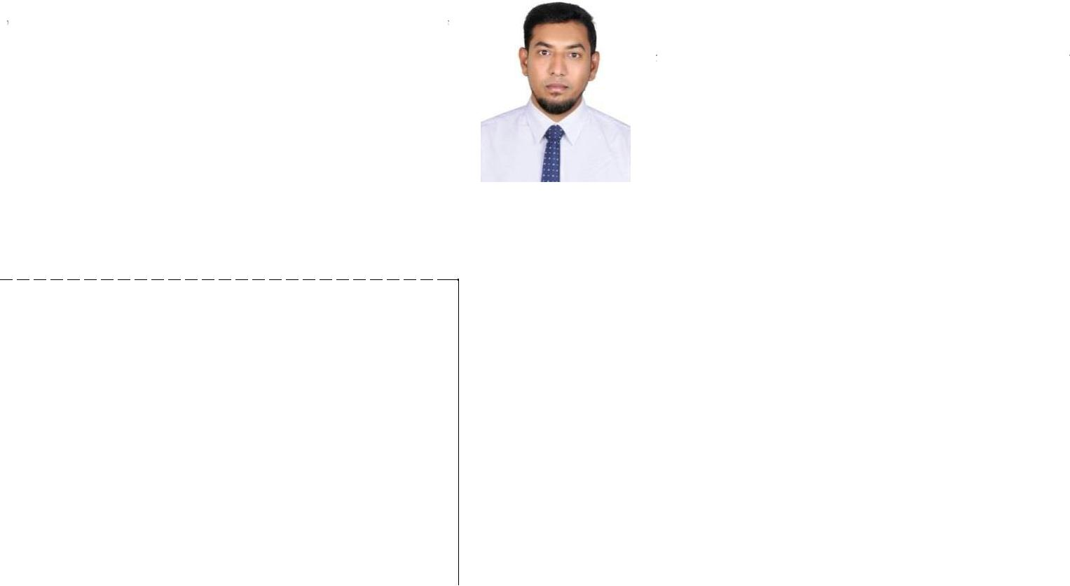

- ^{B.com (general) from The New} the Business Administration / Business Development College Madras University, Tamilnadu industry that offers an opportunity to make a powerful
 |  | in 2011. |  | contribution to organizational objective through continuous
 |  | IT S K I L L S
 |  |  |  | developments of professional skills.
 | • Tally ERP 9( Full version)
 | • | MS Office
 | • | Hardware & Networking
 |  |  |  | K EY S K I L L S
 | - Financial Planning & Control |  | - Costing |  | - Customer Services
 | - Accounting Operations |  | - Receivables & Payables |  | -Integrity
 | - Liaison & Coordination |  | - Reporting & Documentation |  | - Team Player
 | - Accounts Management |  | - Self - Motivation |  | - Quick learner
 | - Communicational skills |  | - Leadership quality |  | - Analytical ability

O R G A N I Z A T I O N A L E X P E R I E N C E

Accountant - Purchaser – (Dec 2013 – Feb 2019)

Responsibilities;

Prepares asset, liability, and capital account entries by compiling and analyzing account information. 
Documents financial transactions by entering account information.  Recommends financial actions by analyzing accounting options. 
Summarizes current financial status by collecting information; preparing balance sheet, profit and loss statement, and other reports. 
Substantiates financial transactions by auditing documents. 
Maintains accounting controls by preparing and recommending policies and procedures. 
Guides accounting clerical staff by coordinating activities and answering questions. 
Reconciles financial discrepancies by collecting and analyzing account information. 

Secures financial information by completing data base backups. 
Ensure all inventory and stock management systems are maintained accurately, within the agreed parameters and in a timely manner 

- Responsibility for purchasing and the “in-stock” levels within the agreed inventory parameters. 
Purchase inventory within the agreed budgets. 
Immediately alert the Retail Manager and Financial Manager when a budget is exceeded. 

Maintain a process for returns. Manage a defined area in the storeroom for returns/credits. This area will include out of dates, damaged and un-saleable goods. 

Maintain harmonious working relationship with Suppliers/Vendors within the buying parameters set by the business. 
Oversee and assume responsibility for the POS system and the Electronic Ordering Systems. 
Observe the correct buying protocols. 
Observe correct stock receiving protocols. 
Complete all necessary stock takes. 
Have a working knowledge of Tally ERP ensure accurate stock management. 
Consistently deliver customer service in accordance with our customer service standards. 
Implement Promotions accurately and in the required time frames. 
Attend training(s) as directed. 
Maintain good working relationships with your Manager and your peers. 
Comply with all aspects of the Standard Operating Procedures manual. 
Other work as directed by the Retail Manager/Business Owner. 

Purchasing Job Duties:

Verifies purchase requisitions by comparing items requested to master list; clarifying unclear items; recommending alternatives. 
Forwards available inventory items by verifying stock; scheduling delivery.  Prepares purchase orders by verifying specifications and price; obtaining recommendations from suppliers for substitute items; obtaining approval from requisitioning department. 
Obtains purchased items by forwarding orders to suppliers; monitoring and expediting orders. 
Verifies receipt of items by comparing items received to items ordered; resolves shipments in error with suppliers. 
Authorizes payment for purchases by forwarding receiving documentation.  Keeps information accessible by sorting and filing documents. 
Provides purchasing planning and control information by collecting, analyzing, and summarizing data and trends. 
Updates job knowledge by participating in educational opportunities.  Accomplishes purchasing and organization mission by completing related results as needed

Assistant Accountant in India (Chennai) (May 2013 –Oct

2013)

The role is hugely instrumental in helping the finance team make decisions about what will ultimately improve business performance.

Supporting the senior accountant and wider finance team 
Collaborating with these teams to work on various accounting projects 
Performing reconciliations of accounts 
Processing payments and invoices accurately and within expected time periods  Verifying financial statements, ledgers and accounts and making corrections where appropriate 
Preparing profit and loss accounts sheets 
Preparing VAT return 
Preparing the yearly budget 
Taking minutes in meetings and other administrative duties 

S U M M E R INTERNSHIP -

Project Title

: A Study on Inventory Management.

Project Description : This project is to study the inventory management

techniques followed in Dural Trims & Profiles Pvt Ltd. They found the variance between standard and actual material cost and to categorize the inventory based on usage and value. Finally to
find out the optimum level of inventory to be ordered at a point of time.

- N T E R E S T

Sports – Cricket, Football and Volleyball, Music and Driving

 | P E R S O N A L P R O F I L E
Date of Birth: | 22nd June 1990
Nationality: | Indian
Gender | Male
Passport: | Expiry Date: 11/01/2021
Visa Status | Visit Visa Valid Till 20 Dec 2019.
Languages Known: | English, Hindi, Tamil, and Malayalam.
Driving License: | U.A.E valid License Expired 2026
 | D E C L A R A T I O N

I hereby declare that all the information mentioned above is true to the best of my knowledge. I will make it my earnest endeavor to discharge competently and carefully the duties you may be pleased to entrust with me.

Date FARVEES

