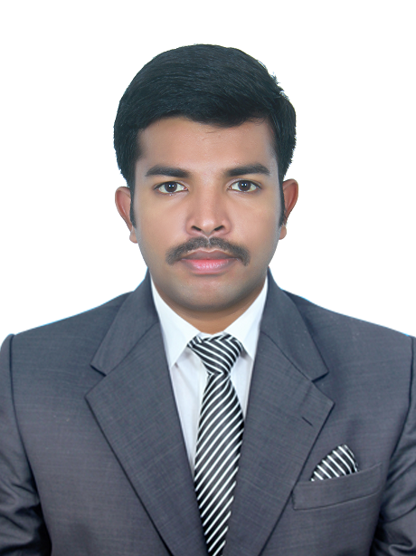 |   CV No: 1240380  Mobile: +971505905010 / +971504753686  To get contact details of this candidate,  Fill Free Job Posting Form and email to corporate AT gulfjobseekers.com  http://www.gulfjobseeker.com/Free_Job_Posting_Form.doc  Career Objective.  To obtain an accounting position where I will be able to contribute my skill, knowledge and experience to a company that will give me an opportunity to develop my career.  Personal Profile:  Academic Qualifications  - PG-MBA Finance  - UG-BBA  - +2 Commerce  - SSLC  Netw
  Date of Birth | : | 31st May 1990
  Sex | : | Male
  Marital Status | : | Single
  Religion | : | Hindu, Thiyya
  Nationality | : | Indian
  Language Known | : | English, Hindi, Malayalam
  Board | : | Bharathiar University ,Coimbatore
  Percentage | : | 58%
  Year | : | 2012
  Board | : | University of Calicut - Calicut
  Percentage | : | 60%
  Year | : | 2010
  Institution | : | JNMGHSS Puduppanam, Vatakara
  Board | : | Board of HSE, Kerala Govt.
  Percentage | : | 70%
  Year | : | 2007
  Institution | : | JNMGHSS Puduppanam, Vatakara
  Board | : | Board of Public Examination, Kerala Govt.
  Percentage | : | 73%
  Year | : | 2005

Work Experience:

One Year experience as an Audit Assistant under CA. Calicut (Kerala) from 15-10-2012 to 24-10-2013.

- Conducting Tax Audit of the proprietary, partnership concern.

- Preparation & filing of e-TDS, Income tax Returns.

- Preparation of Audit Report.

- Finalization of Accounts.

- Knowledge of TDS.

- Independently handled tax audits of entities of various sizes up to finalization.

- Handled the assignment of statutory audits as a part of team member up to the finalization stage.

- Independent handling of Annual return filing for company.

Other Skills
- Tally
- MS Office
- NCFM

Strength
- Smart Worker
- Co-Operative
- Optimistic

Hobbies
- Fishing
- Internet Browsing
- Listening to Music

Declaration

I, hereby declare that the above mentioned are true to the best of my knowledge and belief.

