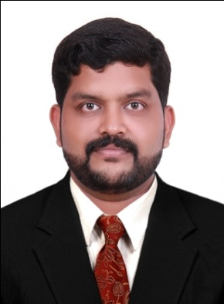
Nikhil
Dubai
Email: nikhil.206731@2freemail.com

CAREER OBJECTIVE
Intend to build a career with leading corporate of business environment with committed and dedicated people, which will help me to explore myself fully and realize my potential. Now looking to start a new challenging position to meet my competencies, capabilities, skills and education.
EMPLOYMENT HISTORY
COMPANY NAME | POSITION | DURATION
KALYAN Jewelers India pvt ltd  Thirunelveli, Tamilnadu | ACCOUNTS ASSISTANT | 2nd December, 2011 to 20th July 2013
KALYAN Motors pvt ltd  Thrissur, Kerala | SALES EXECUTIVE | 27thJuly, 2013 to 31st January 2014
Al Faisal Tyres Trading  Ajman, UAE | ACCOUNTS CUM SALES EXECUTIVE | 18thJune, 2014 to 18st June 2016
BASCO Foods (India) pvt. ltd | ACCOUNTS CUM SALES EXECUTIVE | 2nd August 2016 to 15th September 2017

PROFESSIONAL SUMMARY
- About 5 years’ Experience in the field of Accounts & Sales.
- Strong in Software like Tally ERP-9, MS Office and Peach Tree.
JOB REQUIREMENTS
- To carry out day to day transactions with Banks.
- Preparation of MIS reports.
- Issuing cheques.
- Entering and posting of vouchers, preparations of Goods Receipt Notes (GRN), Invoices, Purchase orders and manages Pay Roll.
- Proper follow-up for Receivables and reporting to management.
- Preparation of weekly Bank, Cash positions.
- Preparation of monthly schedules.
- Keeping a good relationship with customers.
- Providing the value of money & best follow-up service.
- Providing information & advice with accuracy, reliability & speed of service.
ACADEMIC PROFILE
- BBM from BHARATHIAR University, Coimbatore in May 2011
- Higher secondary Examination passed under HSE Board Govt. of Kerala in March 2008
- SSLC Examination passed under GED Department Govt. of Kerala in March 2006
COMPUTER CERTIFICATIONS
- Office suit Certification from IRS Computers and Communications Pvt ltd, Thrissur
In September 2012
- Tally ERP-9 and Peach Tree Certification from IRS Computers and Communications pvt ltd, Thrissur In October 2012
EXTRA CURRICULAR ACTIVITIES
- Won prizes for various cultural and literary programs.
- Event organizer for various cultural programs.
- Participation in social activities through different clubs.

PERSONAL SKILLS
- Ability to deal with people diplomatically.
- An optimistic minded personality.
- Good verbal and written communication skills.
- Willingness to learn.

PERSONAL PROFILE
Date of birth : 22nd June 1990
Nationality : Indian
Sex : Male
Marital Status : Single
Languages Known : English, Hindi, Tamil and Malayalam

DECLARATION
I hereby declare that the above written information is true to the best of my knowledge and belief.
Nikhil

