Curricullum Vitae
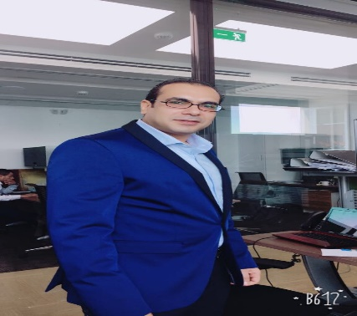

ibrahim

career Objective: To be on active part of Hospitality industry having career with growth and opportunity with F&B production that achieve the company goals ! Mission, vision, and values.

WORKING EXPERIENCE

Position

General Manager

AL ENNA Restaurant – Souq Waqif
Restaurant project Establishment
Layout and Drawing.
-Case study & planning.
-Vision & Mission. .
Opening contribution
Worked all the pre-opening tasks and preparations,
Sourced suppliers
Menu pricing / costing
SOP.

PREVIOUS EXPERIENCE IN food and beverage (16 YEAR)
- Worked as a Restaurant Manager in Teama Restaurant in Egypt seven years from 2001 to 2008 .
- Worked as a Restaurant Manager in Gad Restaurant in Egypt two years from 2008 to 2010 .
- Worked as a Catering Assistant Manager in Sofitel hotel Sharm El Sheikh in Egypt two years from 2010 to 2012.
- Worked as a Manager in Wrap it Restaurant Villaggio mall, Landmark mall, Gulf mall in Doha two years from October 2012 to November 2014 .
- Worked as a Restaurant Manager in German Doner Kebab Restaurant in the pearl-Doha for one year from January 2015 to February 2016.
- From February 2016 till Present Working as a General Manager in AL ENNA Restaurant – Doha - Souq Waqif.
CONTACT ME FOR
operation Manager, Brand Manager, Chain Manager, Area Manager and General Manager for Restaurant set up and run the operation.

Education
- : Bachelor of Commerce, Department Trade Business.

Personal Data
Date of Birth : 22/09/1979
Sex : Male
Nationality : Egyptian

Marital Status : Married
Email Address : ibrahim.207006@2freemail.com
NOC : Transferable
Driving license : Qatar valid driving license.

langauge :

- Arabic . Writing & Speaking, Fluent.
- English. Writing & Speaking, Fluent.
- Italian. Writing & Speaking, very Good

Strengths:
- Hard working.
- Confident.
- Punctual.
- Smart working.
- Family support.

PROFESSIONAL EXPERIENCE
- Manage according to the established operating standard with an objective to achieve maximum guest’s satisfaction.
- Managing a specified restaurant and hotels catering to the standards agreed by brand and a company.
- Running the day-to-day catering operations and services in restaurants, hotels and resorts.
- Ability to communicate at all levels with an effective communication.
- Achieving good quality within a budget and maintaining high standards of hygiene and customer satisfaction
- Ensure that high levels of customer service are maintained at all times.
- Monitoring the quality of the food and service and for making sure that their outlets perform well.
- Planning menus in consultation with chefs
- Able to Know how to build sales and profits, reading sales, follow sales, cost of goods sold and labor report to ensure they are meeting sales and profit goals.
- Able to achieve the company goals! Mission, vision, and values.
- Reviews and analyzes sales, compares them, finds reasons for increase or decrease and writes a report with an action plan on how to improve.
- Monitors daily sales performance and compare figures analysis
- Studies a LSM for each unit and elaborates a plan with a calendar
- Reviews all training records, ensures that all units have the proper training materials and plans an annual training calendar.
- Maintains and implement QSC (Quality Standard Check).
- Monitor QSC progress and set corrective actions and follows up on implementation.
- Makes sure complete commitment of the floor managers in approved recipes and there’s no changes are taking place.
- Monitors and follows up on food presentation and display.
- Follows up on guest complaints and collects feedbacks.
- Makes sure appropriate action and follow up guest satisfaction.
- Collects Guest Comment Cards and makes sure guests call back.
- Maintains adherence to company standards and policies always.
- Follows up and monitor monthly Food, Labor and Operating Costs.
- Controls wastes and costs.
- Follow up on monthly inventories and submit wastes analysis reports.
- Submits monthly and quarterly reports for sales performance.
- Ensures that all managers & team members are trained to the required standards, providing appropriate training & development plans for all and ensuring completion.
- Conducts appraisals for floor managers with regularly meeting with them to set common goals, and delegates key tasks to them to maximize their potentials.
- Follows up closely on team members’ performance and productivity.
- Sets ideal team members count Vs Actual and works on recruiting qualified team members with the HRD.
- Make sure managers commitment in applying company standards and rules.
- Follows up on floor managers schedule and approves on changes.
- Makes sure commitment of all team members in hygiene and grooming standards.
- Makes sure proper implementation of the team members in training
- Communicates with all related department and especially with the Development and Purchasing Managers.

Declaration
I hereby declare that the above mentioned information is correct up to my knowledge and I bear the responsibility for the correctness of the above mentioned particulars.

Ibrahim

