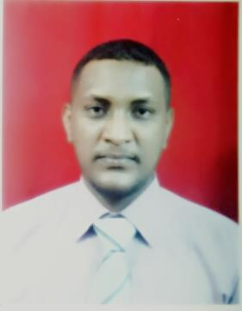
Name : Amro
Address : KSA-Riyadh
E-mail : amro.207245@2freemail.com
Nationality : Sudanese
D of B : 16/3/1985
Other : Transferable Visa

Qualifications.
Bachelor of Science in Information Technology and Management, Faculty of Computer Studies, National
University of Rabat, Sudan.
Experiences.
(December 2015 to December 2017)
I have been Working in The Contact Centers Company which is belong to STC Saudi Telecom Company, Where I worked in the Mobile Section Extension of Debts and mobile services and then I have been Transferred to The Residential Technical Sector for Telephone Lines and Internet Services As a Technical Support - English Language Section.
Technical Support For ADSL,VDSL,FTTH.
Excellent Knowledge – CRM Systems.
Systems Dealing With : ICMS, NETWORK ANALYZER, ALPEO , HDM.
Excellent Knowledge in BMS.
(April 2015 to September 2015)
I had been working for Abdul Rahman Al Shahri Trading and Contracting Est.Lamasat, an online sales And marketing website for accessories and luxuries in the job Administrator for The website and as a Warehouse Administrator. I also update and introduce products through the website and some office and Administrative works.
(May 2009 to September 2013)
• CCTV Operator in the control room of the security department of Petrodar Petroleum Operations
Company.
• Officer and administrative coordinator in pumping station No.5 # for the PDOC. And Supervising
for development works That’s belongs for The Department.
• Supervising of The General Services of Security Department at the port of oil exporting(Port Sudan).

(January 2007 to January 2009)
• I worked through this period as a warehouse Administrator for The Company and my main Responsibilities its was to Supervise, regulate and control the movement of The warehouse and other tasks.

