MILIND
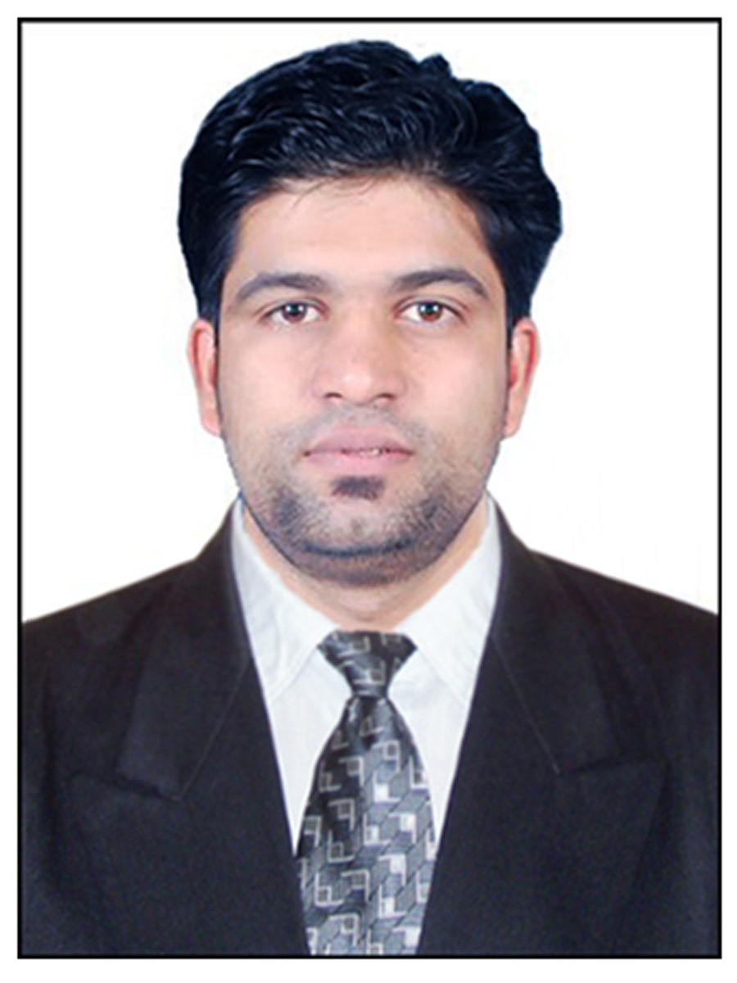
Dubai
E-mail: milind.207634@2frreemail.com

OBJECTIVES

To obtain a challenging and responsible position in professionally managed organization. I am looking forward to an opportunity, where I can integrate my personal skills with that of the workforce and contribute fast growth profile to the organization and also further improvement of my personal skills.

SUMMARY

- Over 9+ years of total professional experience in Hospitality Industry.
- Highly organized and efficient in fast-paced multitasking environment.
- Strong commitment, vision and leadership.
- Competent at managing responsibilities in a high volume atmosphere.
- Innovative in designing and carrying out projects.
- Effective working independently and as a cooperative team leader.
- Proficiency in Microsoft Word, Excel, Access, Power Point and outlook; Internet Explorer, My Micros & Chat to Survey (Net Promoter Score).
- Possessing the required enthusiasm, vision, drive and adaptability necessary to manage an organization.

Education

Completed Advance Diploma in Business Mgmt. (London, United Kingdom)

Completed NVQ level 7 Postgraduate Diploma in Hospitality Mgmt. (London, United Kingdom)

Diploma in Hospitality Mgmt. from Government Polytechnic from I.H.T.M (Nasik Maharashtra)

Front Office Management from Government Polytechnic from I.H.T.M (Nasik Maharashtra)

Work Experience

- Food and Beverage Restaurant Manager at Emirates Leisure, DSO (Premier inn Hotel DSO, Dubai, UAE (Nov 2013 to Until Now)

- Food and Beverage Team Leader at Emirates Leisure, PI DIP (Oct 2012 – Oct 2013)

- Food and Beverage Shift in-charge at Whitbread Company Premier Inn Hotel Heathrow Bath Road, London United Kingdom. (Nov 2007 to Aug 2012)

- Food and Beverage associate at Hilton Gatwick, United Kingdom. (3 months training)

- Food and Beverage associate at Fariyas 5star resort in Lonavala, India (3 months Training)

Work Summary

- To be the custodian of the ELR Brand’s, delivering exceptional standards of quality, service and product to our customers.
- Complete Profit & Loss responsibility and accountability for the outlet
- To manage and develop the team by delivering training where needed, administering performance appraisals and handling employee relations, in line with the growth expectations of the business.
- Develop sales and marketing initiatives with the Marketing Manager to maximize revenues through effective brand development, new product development and promotion of product range and brand identity.
- Review and communicate financial information to assist in proactive and timely decision making.
- Manage monthly stock-takes and review results and variances with relevant departments ensuring that in house control systems/ audit requirements are adhered to.
- Stay abreast of industry trends and communicates/incorporates information to assure the business remains current.
- Coach employees on performance matters and work to establish a supportive and team-oriented outlet.
- Ensure all kitchen and food and beverage operations are in compliance with all legislated health and licensing guidelines.
- Perform other duties as requested by the Line Manager
- Manage the performance of the service attendants – all Front of House employees during shifts in the absence of the Outlet Manager, which includes training on new menus, supporting busy outlets where necessary, attending to guest complaints and managing a smooth relationship with the kitchen to ensure that guest satisfaction is maximised at all times
- Being the first point of contact for the guests to ensure that guest complaints are dealt with the a consistent a fair manner & adherence to all company Cash handling Procedures
- Adhering to the closing procedure in line with the Company’s Policies and Procedures to minimise financial risk to the Company
- Assist in the development of new marketing initiatives including assist & oversee of social media requirements
- Perform other duties as requested by the Line Manager.
- Be the first point of contact for customers by receiving orders which entails internal checking with relevant departments and inputting of the details into the database to ensure that the customer order is accurate and complete and the products are delivered in a timely manner.
- Interact professionally and develop added value relationships with allocated customers, providing excellent and consistent customer service.
- Management of uplift and credit note process and pricing errors to ensure that errors are corrected accurately for recording purposes and correct invoicing.
- Implements policies and procedures under the guidance and direction of the general manager.
- Responsible for meeting all budget goals.
- Monitor budget to control expenses.
- Starting new games and incentive in team to get the business on top level, for ex (bingo, promotions, incentives, trainings).
- Develop at all-time ideas, methods to improve the revenue and generate needed guest awareness.
- Responsible for organizing the room service, brand standards, meetings trainings for staff.
- Coordinate with chef for the achievement of high quality standards and for maintenance of maximum level of profitability in the service and production of food.
- Provide required information needed by the accounts dept.
- Doing payroll for staff, tracking working hours according to business.
- Delivered high levels of service according to standards.
- Handled the day to day functioning of Restaurant & bar.
- In charge of maintaining inventories, maintenance & proper hygiene in the department.
• Provide required information needed by the accounts dept.
- Taking the orders for food & beverage in the restaurant and responsible for delivering high standards of customer service.
- Follow bar stock levels of glassware, utensils, alcohol, tobacco and linen at the bar.
- Assist my manager in stock take weekly.
- Check in and check out at reception.
- Food knowledge, training for room service, guest satisfaction, housekeeping, reception, bar & restaurants.
- Personality development training, banqueting halls, setups for the marriages and functions.
- Housekeeping, Reception, Accounts & Food and Beverage training.

ACHIEVEMENTS

- Worked as a Captain for Gala Dinner “Best of India” – 2006.
- Organized Tourism day with theme of “Gujarat Tourism” – 2006
- Always undertook Health Safety Measures in the whole F & B Management process.
- Employee of the Year two time in Food and Beverage Department. London Heathrow (UK).
- Completed Food and Hygiene PIC training Level 3. (Dubai)
- Completed Basic Food Hygiene Course 2013. (UK)
- Completed Train to Trainer Course 2014. (Dubai)
- Completed Fire Ward Training Course 2008-2014.(UK & Dubai)
- Win the Bacardi Mojito Competition Trip to Puerto Rico USA (Dubai)

Personal Information

Sex Male
Marital Status Married
Nationality Indian
Blood Group A+
Hobbies Cricket, Cooking, Acting & Football
Language Marathi, Fluent English, Hindi
DOB 9/11/1986

DECLARATION:

I hereby declare that the above furnished information is true to the best of my knowledge.

