CURRICULUM VITAE
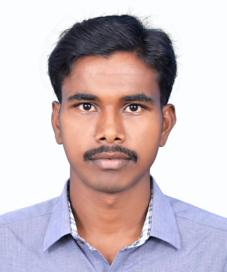

SUNDHARARAJAN
E-mail : SUNDHARARAJAN.208110@2freemail.com

Objective
To obtain an experienced level engineering position that will allow me to utilize my engineering knowledge, communication & leadership skills.
Profile
- Positive attitude with qualitative and quantitative abilities.
- A team player with strong inter-personal and communication skills.
Professional Experience

NTS InfoTech, Neyveli Tamilnadu. July 2016 To Aug 2017
Business Development Officer
Objective :
My job role is assist acquire new customers and sell additional products or services to existing ones, this means the role is a crucial one for any business with the ambition to expand or the necessity to diversify its clientele.

Eureka Forbes, Chennai India. May 2015 To April 2016
Territory Executive

Objective :
I have to sell security solution products and services to customers. work with customers to find what they want, create solutions and ensure a smooth sales process. then work to find new sales leads, through business directories, client referrals, etc.

Education

COURSE | INSTITUTION | UNIVERSITY/ BOARD | DURATION | MARKS  (CGPA/%)
B.E/CSE | Dr.Navalar Nedunchezhiyan  College of Engineering | Anna University | 2010 To 2014 | 74.60
H.S.C | Government . Hr.Sec.School, Kurinjipadi | State Board | 2009 To 2010 | 60.00
S.S.L.C | Government . Hr.Sec.School, Kurinjipadi | State Board | 2007 To 2008 | 65.10

Additional Qualification
- Have successfully completed java certification course at NIIT in Chennai

Project Experience

“Toward Secure Multikeyword Top-K Retrieval Over Encrypted Cloud Data”
Objective:

The project deals Secure multi-keyword based top-k retrieval over encrypted cloud data without information leakage is achieved .

Computer Skills
- HTML
- JAVA (Certified)
- MS Word,Excel

Awards And Commendations
- Attended an IN-PLANT TRAINING for 5 Days at HCL in Chennai.
- Participated an INDUSTRIAL VISIT regards Telecommunication at BSNL in Coonoor.
- Received an 'Certificate of Excellence ' for my Performance as Captain in 'NCC'

Personal Strength’s
- Self-motivated ,Hard working, Punctual and sincere
- Good leader as well as team player and optimistic.
- Adaptable to any environment.

Awards
- Attended An National Level Workshop On Services And Grid Computing For One Day At Dhanalakshmi Srinivasan Enginerring College In Perambalur.
- Participated In One Day Workshop On AJTHS At DR.NNCE In Cuddalore.

Languages Known
- English & Tamil : To Read, Write & Speak
Personal Profile
Date Of Birth : 15th April 1993
Gender : Male
Marital Status : Bachelor
Nationality : Indian
Visa : 3 Months Tourist Visa
Visa Expire : Nov 1 st 2017

Declaration
I hereby declare that above mentioned details are true to the best of my knowledge.

