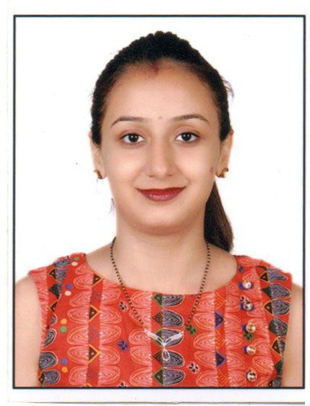
Neeta
Dubai, UAE
Email: neeta.208215@2freemail.com

Career Objective

- To Work in a dynamic environment that provides me a vide spectrum of experience and exposure. To bring a dynamic and versatile portfolio of skills at work place and to serve the organization.

Professional Experience:

Company Secretary Trainee at National Stock Exchange of India Limited (NSEIL)
(Jan 2014 - April 2015)

- Handled following work:

- Processing the applications for Listing of shares of companies listed on Other Stock Exchanges (including Regional stock exchanges) pursuant to direct listing on NSE.

- Processing Further issues applications namely :
- Preferential Allotment
- ESOP issue
- FCCB issue
- Bonus issue
- QIP

- Assisted in Quarterly Compliances under various clauses of Listing Agreement :
- Corporate Governance
- Share Holding Pattern
- Financial Results
- Annual Report

- Assisted in Monitoring of Share Holding Pattern, Analysis of Annual report w.r.t. Corporate Governance and Analysis of Auditor’s Qualifications provided with financial results.

- Dealt with disclosures under SEBI (Prohibition of Insider Trading) Regulation, 2015.

Extra Curriculum:

- Member of National Service Scheme in College

- Volunteered in arranging blood donation camp

- Attended the Seminar on Preferential Issue of shares, Insider Trading Regulation and on Listing Regulations organized by NSEIL

Educational Qualifications

- Professional Qualification

- Passed Executive Program of ICSI by scoring 303/600 in August 2012.

- Preliminary Qualifications

Qualification | Institute | Board / University | Percentage / Grade | Year of Passing
Bachelor of Commerce (B.com.) | CHM college | University Of Mumbai | 69. 14% | March 2011
Higher Secondary Certificate Examination | New era junior college | Maharashtra State Board | 76.17% | Feb. 2008
Secondary School Certificate Examination | Jhulelal Trust School | Maharashtra State Board | 57.20% | March 2006

Other Details:

- Languages Known: English, Hindi, Sindhi and Marathi
- Marital status: Married
- Date of Birth: 28 May, 1991
- Place of Birth: Agra, India
- Visa Status : 90 Days Tourist Visa

All references and attested certificates can be presented upon request

