RESUME

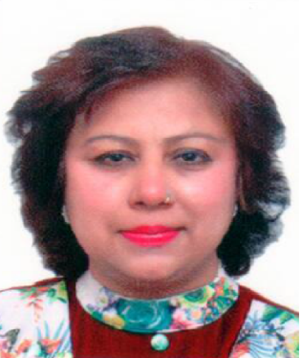
Name: Mrs. Anita

Qualification: M.A (English), M.A (Pol. Sci.), B.Ed., M.Ed.

Date of Birth: 27th January 1966

Experience as Teacher/Lecturer: 1988 to 1994 (Six years)

Experience as Principal: 1994 onwards (over twenty two years)

Special Remarks:

Founder Principal of C.B.S.E affiliated +2 School naming Lala Jagat Narain D.A.V Model School in Jalandhar City (India) since 1994. School started with few students with meagre infrastructure has now bloomed into a highly sought after school spread in a six acre plot with strength of over 1600 students having arts science and commerce faculties.

Award of School:

1. The School has won International School Award from British Council
2. The School has also won Green School Award from Centre of Science & Environment
3. National Painting Competition 2013-14 won by student, Deepak and was honoured by Sh. Pranb
Mukherjee, Hon’ble President of India
4. One of our school student, Pankaj Dhir, represented India in Taekwondo at Commonwealth Games
5. School skit team won 1st Prize in national level skit competition in New Delhi
6. School has always won many accolades in each of the District, State and National level competitions and
co-curricular activities

School Results:

School has consistently produced excellent results by producing highest QPI (average results) in Jalandhar District

Personal Achievements and Awards:

In the capacity of Principal I have been bestowed with the following Awards:

1. Outstanding Contribution in the Field of Education for Action Research Work – at International Conference held at Lucknow on 23rd, 24th December 2009
2. Special Award for Outstanding Work – by Sh. G.P. Chopra, President, DAV College Managing Committee, New Delhi
3. Award for Innovative Ideas in Teaching of English Grammar – by Dr. Kiran Bedi at Lucknow in 2015
4. Award of Excellent Performance in the Field of Education – by Sh. Balram Ji Das Tandon (Governor, Chhattisgarh) on 13th January 2016
5. Award for Work for Needy Women – by Children & Women Welfare Society, Punjab
6. Award for Teaching Excellence – by S. Chand Group (Publishers)
7. My Book on English Grammar was published in 2015

Experience as Resource Person:

I have been giving regularly many presentations on teaching of English, Life Skills, Education and on CCE in many Schools of DAV. At present I am working as Mentor of many Schools under CBSE curriculum.

Trainings Undergone:

1. I have attended Conference on Leadership Strategies at IIM Bengaluru in 2009
2. My contributions were recognised for heading many workshops at NASA in USA in 2008

Paper Presentation:

Many of my papers were published in CENBOSC Magazine of the CBSE besides its Annual Magazine with titles as under:
• Work Centered Education
• Achieving Academic Excellence
• Gender Sensitization in Schools
• Skill based Education and Vocational Education
• Collaborative Learning
• Improving Teachers’ Quality
• Transformation Pedagogy
• World Education Foundation
• Education Quality and Economic Growth

Special Skills:

I am a good writer and singer. All the script and items of the annual function of the school are written by me. I am a person with pleasing personality having good communication skills full of potentialities and capable of doing all good work as well as tech savvy.

Anita
Email: anita.208239@2freemail.com

