SALIQ | Saliq.208325@2freemail.com
Assistant Project manager

WHO I AM?

A resourceful, efficient and passionate project manager having experience in all aspects of project management in construction and fit-out business starting from the bid stage through to completion, including design review, procurement, resource management, technical, commercial and financial control as well as liaison with consultants, designers, suppliers, client representatives and regulatory authorities. A confident and credible individual with the kind of communication skills that inspire at all levels of business. A meticulous organizer, who possesses excellent team working skills and performs well under pressure. Having an active commitment to continuous improvement and quality standards always works hard to create a positive atmosphere that motivates others and builds team spirit for peak performance, as a driven individual who wants to progress, and now looking to join a company where internal succession is always given priority.

WHAT’S MY STORY?
EXPERIENCE
 | Project engineer | Mep engineer |  | Asst Project Manager
 | Ajk Hydroelectric board | Althara Contracting Dubai (ATC) |  | Althara Contracting Dubai (ATC)
 | June 2013 – April 2014 | April 2014– Jan 2016 |  | Since Jan 2016
2013 | 2014 | 2015 | 2016 | 2017 Still Working

EDUCATION

B.sc electrical engineering 2009-2013 Mirpur University of science and technology.

EXPERIENCE
Assistant project manager @ ATC Jan 2016-Present

Primarily responsible for establishing, monitoring, and executing project plans. In charge of delivering projects that improve client’s

business applications, infrastructure and processes, and doing this on time, on budget and to the highest standards. Also involved in building relationships with clients, and maintaining liaison with all the stakeholders throughout each project.

Duties

- Leading, motivating and managing a team in all aspects of estimating, planning and resource evaluation.

- Controlling the budget for each project, maintaining the agreed levels of expenditure.

- Maintaining proper documentation (general project plans, action items, timelines, call notes, etc.) on all projects.

- Managing and coordinating human resources department for hiring new staff and manpower for projects.

- Managing project funding and resources, negotiating project changes, and adjusting resources across multiple projects.

- Developing and managing KPIs to drive improvements and deliver performance.

- Setting and driving project timelines, ensuring all deliverables are met and completed on time.

- Coordinating work for and providing direction to staff to complete deliverables.

- Developing solutions and taking ownership of situations to ensure a projects success.

- Preparation of annual maintenance contracts, networking and identifying new perspective clients for new annual maintenance projects.
- Coordinating in development, reviewing of compliance documents and project implementation plans for new projects.

- Maintaining relationship with clients for future projects and selling of new solutions.

- Experienced in working with luxury hospitality groups for providing solutions and execute fit outs for their facilities including beach club facilities and high end fit outs for offices, soft plays, coffee shops and warehouses.

Mep engineer @ ATC April 2014- Jan 2016

Responsible for all the electrical, plumbing, drainage and HVAC work planning, execution for turnkey projects and also coordinating in submitting tenders for new projects.

Duties:

- Competent in all phases (Initiating, planning, execution and finishing) of Mep construction.

- Assigning technical staff, financial and logistical resources for the project.

- Bringing innovation and recognition methods in company to motivate team thus achieving desire results.

- Outsourcing different project activities by analyzing quotes, and quality from different subcontractors.

- Evaluate engineering proposals, shop drawings and design comments for sound electrical engineering practice, compliance with established safety and design criteria, and recommend approval.

- Review Mep drawings and provide technical guidance, also coordinating in preparation of as built drawings.

- Coordination with dewa, rta, etisalat and Dubai civil defense for drawing approvals and inspections till completion.

- Managing procurement of equipment ordered from various Equipment Makers as per approved specifications.

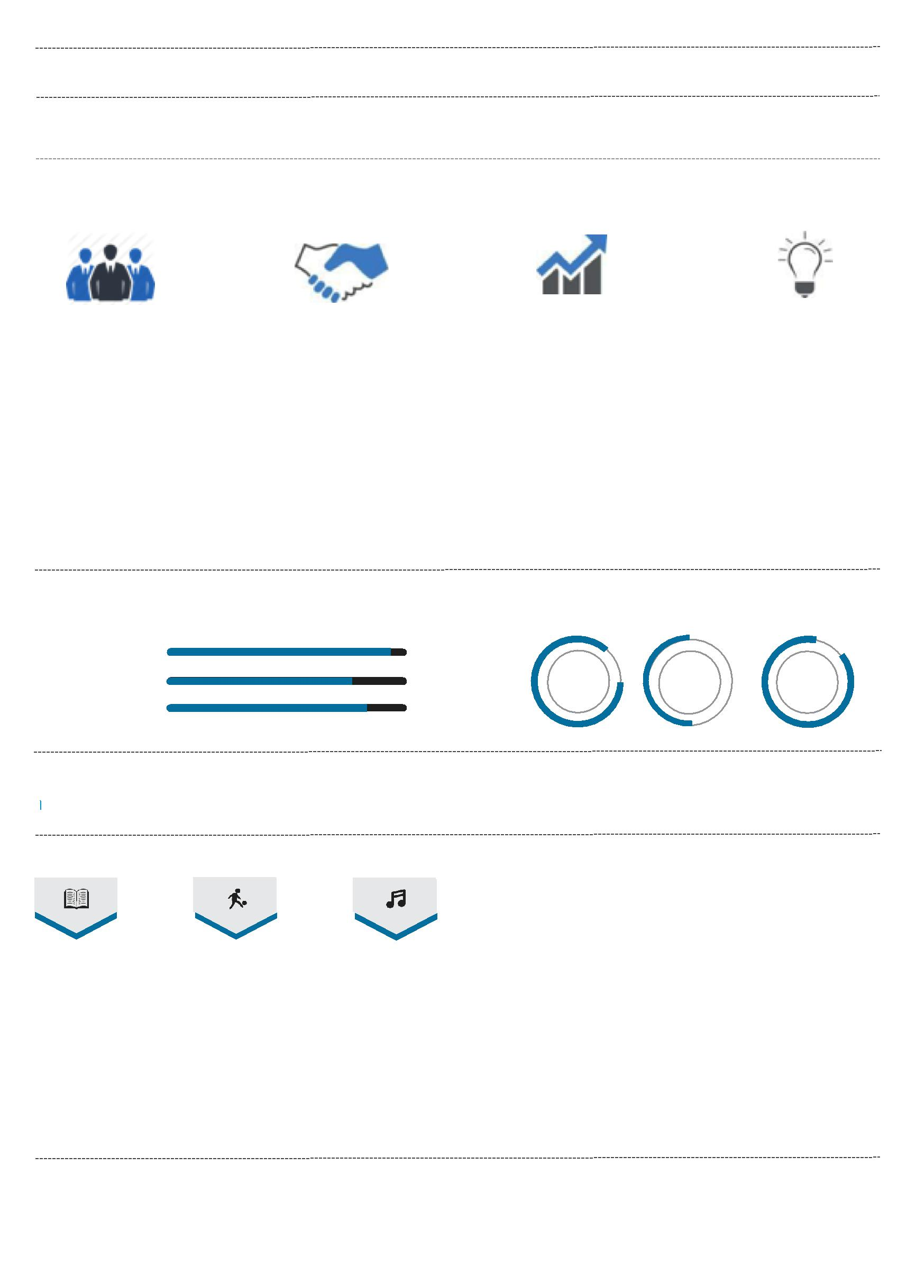
Project engineer @ AJK hydroelectric June 2013- April 2014

Work with project manager and distribution authority for planning and execution of 11kv/440v overhead distribution system from regional substation to a newly developed community.

STRENGTHS

Leadership Negotiation Dynamic Smart

Visionary | Strong closing skills | Entrepreneurial flair | Lateral thinking
Result oriented | Influencing skills | Revenue growth | Commercial judgment
Role model | Building relationship | High energy level | Analysis data
Motivator | Account management | People management | Innovative
Passionate | Selling creatively | Business planning | Business sense
Strategist | Up selling | Writing reports

LANGUAGES
COMPETENCES

Communications | 95%
Project management | 75% | English | Arabic | Urdu
Teamwork | 80%

OPERATING SYSTEM & SOFTWARES

AutoCAD Visio MS Project AutoCAD Windows OS

INTERESTS

Learning Squash Music

PERSONAL INFORMATION

Nationality: Pakistani

Visa Status: Employment UAE.

Marital status: Married.

Mac OS

COURSES AND CERTIFICATIONS

- Dubai municipality building control system CRM.
- Project Management Professional (PMP) Seminar - 35 Contact Hours.

- Microsoft project management.

- Advance management training.

- Financial Accounting.

- Team management and development.

- NEBOSH international H&S training.

- Business communication course.

