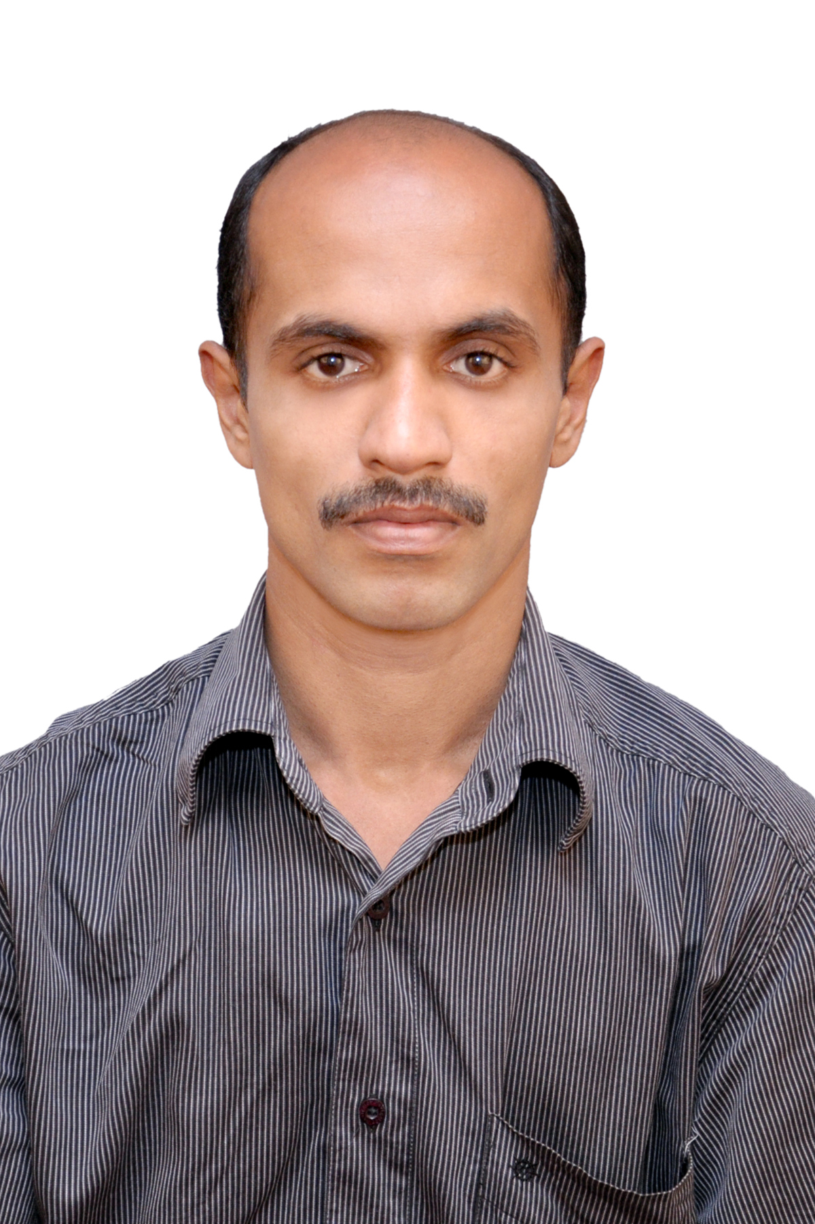


CV No: 1249992
Mobile: +971505905010 / +971504753686

To get contact details of this candidate,
Fill Free Job Posting Form and email to corporate AT gulfjobseekers.com

http://www.gulfjobseeker.com/Free_Job_Posting_Form.doc

To seek a challenging profile in Accounting/Finance/Auditing field, which will provide a ground for continuous learning, upgrade knowledge and augmentation of skill sets, and translate this learning and skill sets in to benefits to the organization.

Objective

- Always eager to study and learn new amendments in the Industry
- Strong desire to work and learn in new areas of the Accounts Industry

Educational Qualifications

Examination | Board of Exam | Year of Passing | Percentage of Mark
SSLC | Kerala Board of Public  Examinations | 1998 | 41
Pre-Degree | M.G. University | 2000 | 53
B.Com | M.G. University | 2003 | 69

Computer Knowledge
- Knowledge in accounting software like ERP, Tally, QAD and Private software FIN used in CA firm and Santham.
- Knowledge in MS Office

My Skills

(Nature of Business: Finalization of Accounts of Individuals, Proprietorship Business, Partnership Firms, Companies& Charitable Institutions)
- Handling Internal and Final Audit of Trading Firms and Companies
- Preparation of Day Book, Ledger, Tax Returns and VAT Returns
- Checking Firms & Companies Vouchers to reduce the Mistakes and Malpractices
- Have sound knowledge in Tax Areas - Sales, Service tax, TDS and ESI and PF
- Took responsibility of Overall General Ledger and in total control of the Trial Balance of the Circle
- Have ensured timely reporting of the monthly P&L, Balance Sheet and the related schedules
- Actively engaged and involved in the works allotted.

- Finalization of books of accounts of works allotted.
- Computation of ESI & PF
- Vouching of bills and vouchers of relevant works allotted
- Internal audit of several firms
- Finalization of accounts of Trusts with 12A Registration
- Helps in the preparation of Audit Report

- Conducting regular Stock/Inventory Audits and Branch audits
- Knowledge in MIS
- Compliance Audit
- Documentation in branches
- Preparation & Finalization of the books of accounts of the charitable institutions & trusts like Hospitals, Schools, Colleges, Churches, Convents etc.,

Relevant Work Experience

I. Jose Kappen & Co. Chartered Accountants, Thodupuzha&Cochin, Kerala
I worked as an audit assistant for a period of three and half years from 2005 to 2008

II. CEMA Electric Lighting Products India (P) Ltd, Reg. Office Chennai, Tamilnadu.
I was working as an Internal Auditor of CEMA Electric Lighting Products India (P) Ltd, A SAROTOGA USA GROUP COMPANY at Corporate Office, Cochin for the period from 6th November 2008 to 5th October 2009.

III. LEE Builders, Contractors&Engineers, Cochin, Kerala

I was working as the Accounts Manager in Lee Builders for the period from 2nd November 2009 to 26th December 2010 and I engaged in the following works
- All accounts & tax related jobs on various contracts and projects of the company
- Finalization of the books of accounts of the entity.

III. Sunrise(Builders) Resort and Health Care Private Limited, Cochin

I worked as the Accounts Manager of Sunrise Resort and Health Care Private Limited for the period from 27th December 2010 to 31st March 2012 and I actively engaged in the following jobs.
- Maintenance of books of accounts.
- Computation of VAT and filing of quarterly and annual return
- Appear before the VAT and Income-tax assessment authorities to produce the books of accounts and other related documents.
- Computation of TDS and Service tax and filing the returns
- Preparation of cash flow, reconciliation statements of concerned bank accounts and creditors.
- All other accounts related works,
- Preparation of managerial reports& the presentation before the board of directors
- Finalization of books of accounts of the company
- Acting as the cashier of the company

IV. Al Hadeer Contracting L.L.C. Abu Dhabi, U.A.E

Presently working as an Accountant in Al Hadeer Contracting L.L.C. for the period from 10th April 2012. Currently I actively engaged in the following jobs

- Computation of Salary& wages of staff and make payment through W.P.S. as per UAE laws.
- Day to day accounting & maintenance of books of accounts of the company
- Preparation of invoices on monthly and project wise and the submission of the same before the Awarder on timely.
- Timely follow up and the collection of invoice raised & other receivables of the company
- Inventory management
- Preparation of reconciliation statements of Banks, Sundry Creditors, Sundry Debtors etc.,
- Preparation and submission of all necessary documents before our various banks
- Timely reporting of company’s operating result and financial position to the management
- All jobs related to the finalization & auditing of the books of accounts of the entity at the end

of accounting year

Interested area

Listening Music Travel/Sight seeing

Personal Details
Nationality : Indian
Sex : Male
Religion : Hindu
Marital Status : Single
Date of Birth : 25.02.1983
Status of Visa : Present contract expired

Abu Dhabi

