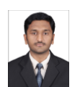 | SHABEER.208985@2freemail.com
SHABEER .  IT SUPPORT PROFESSIONAL  Versatile, high-energy professional with the distinction of presenting IT support, targeting assignments in IT Administrator/ System Administration  Location Preference: Gulf  Skill Set  Collaborator  Planner  Change Agent  Motivator |  | Career Summary  - Microsoft Certified System Administrator (MCSA) with 10 years of experience in IT Support  - Expertise in providing IT Support to across UAE, Qatar and Saudi Arabia Branches  - Supported and monitored the existing infrastructure, supervised preventative maintenance and backup as well as performed other regular support activities to ensure effectiveness  - Developed cost estimates and recommended systems development as well as upgradations to existing systems; evaluated infrastructure services equipment and software for purchase  - Led the management of hardware and software throughout the organization including servers, employee desktops/laptops, network / voice infrastructure, internal networks, peripherals, and wiring  - Good analytical and troubleshooting skills in Windows platform Analytical and quality-oriented professional with an eye for detail
Critical Strengths & Competencies

IT Support | IT Infrastructure Management | IT Administration
IT Maintenance | Microsoft Certified | System Administration
Updates | Back Up | Team Building & Leadership

Career Timeline
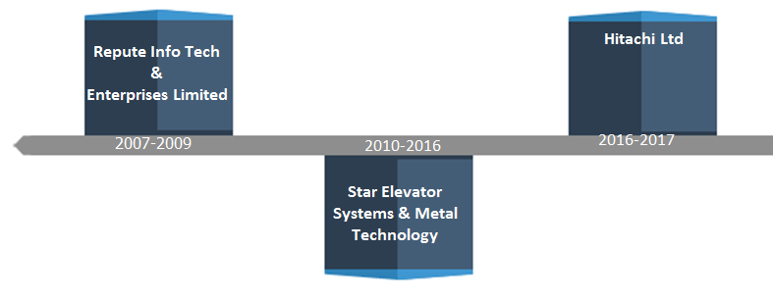
Professional Experience
Jul’16 – Sep’17 Hitachi Ltd., Dubai as IT Assistant

Key Result Areas:
- Monitoring all activities and supporting three divisions of Hitachi groups Hitachi Infrastructure Systems, Basra-Iraq
Project Office and HISTAR
- Led the design and documentation of infrastructure processes, procedures and standards along with the maintenance and preparation of system and software documentation
- Ensuring maintenance of 90 Laptops, 10 Desktops, 10 all in one Printers
- Developing LAN and WAN network for offices in Middle East
- Scheduling and Managing backup jobs
- Creating and Maintaining human database for Hitachi
- Providing Cisco VPN Support to connect intranet network
- Formulating all IT documentation for auditing purpose
- Sending procurement request to the concerned department
- Maintaining IT stock reports, spare and scrap details , Windows Update for all PC’s in Middle East and Symantec Antivirus update for all PC’s in Middle East
Highlights:
- Liaised with Singapore office to implement the policies for Middle East Office’s and HQ-IT from Japan to escalate various issues for Middle East Office’s and Maintaining Office 365 accounts
Feb’10-Jun’16 Star Elevator Systems & Metal Technology (ETA-Group) , Dubai as I.T. Support,
Key Result Areas:
- Provided IT support given to three divisions ETA Star Elevators, Central Procurement Department and Central Fleet Management Divisions
- Supervised all 20 Laptops, 60 Desktops, 5 all in one Printers and 2 Plotters
- Managed programming machines like Trump TruTops, Punching and Laser Machines
- Liaised with More than 180 users in SAP, ORBIT & Exchange E Mails
- Maintained 8 No of Windows Server, installing & maintaining Cisco IP Phones and Panasonic IP Phone
- Presented remote system support for systems from Abu Dhabi, Chennai and Qatar
- Developed users in AD & giving them appropriate rights
- Executed installation & monitoring trend micro & windows update server
- Created backup and restore data using NT Backup
- Supervised IT stock reports, spare and scrap details
Commenced career with Repute Info Tech & Enterprises Limited, Chennai as Systems Administrator from May’07-Nov’09
Key Result Areas
- Maintaining 10 Laptops, 30 Desktops, 7 all in one Printers, 1 Labelling Machine and 1 Plotter
- Troubleshooting of Desktop PC's and different Software Applications and Operating System
- Installation & Monitoring Symantec Endpoint & Windows update servers
- Creation of users in Active Directory & giving them appropriate rights
- Maintaining Inventory record of computer hardware & software
- Hardware assembly, troubleshooting & testing of PC’s
- Managing peripherals like disk drives, backup devices, Printers, Scanners
- Responsible for Installation, Configuration, Monitoring and Supporting Windows 2000 /2003 Domain Controllers, File Servers and Print Servers
- Configuring Wins, DNS, DHCP, IIS, ISA, RIS, RAS, VPN, FTP Servers and FSMO Roles in AD
- Files uploading and downloading by using File Transfer Protocol (FTP)
- Maintained Network Security Levels, Addressed Server Security issues and applied Security Patches and upgrades, regular maintenance of Servers, software and driver updates
- Installing and Configuration of desktop client with OS like Win XP, Windows 2000, and Windows 2003
- Configuring Microsoft Outlook for email users
Technical Skills
Server OS : Windows 2012, Windows 2010, Windows 2008, Windows 2003
Client OS : Windows 10, Windows 8.1, Windows 8, Windows 7, Vista and XP
Hardware’s: HP ProLiant, HP DX Series, IBM X Series, Dell Power Edge
Backup Tool : NT Backup, Symantec Archive and Symantec Backup Exec 2012
Package’s: Office 365, MS-Exchange 2007 / 2003, MS-Office Suite
Antivirus Tools : Trend Micro, Security Essentials and Symantec Endpoint Protection
PBX System : Cisco IP Phone, Panasonic IP Phone, Avaya and NIC
Firewall System : Microsoft ISA Server and Fort iGATE 80C
Networking Tools : Cisco Switches 2950 and Routers 2811, 2900
VPN: Cisco AnyConnect Secure Mobility Client and Symantec VIP Access

Certifications
- Microsoft Certified System Administrator (MCSA)
- Certified in Computer Hardware & Networking at Accel IT Academy
- Certified in CCNA at Rolla Institute, location

Education & Credentials
M.Sc. (Information Technology) from Annamalai University, Chidambaram
B.Sc. (Electronics & Communication) from The New College, Madras University, Chennai

Personal Details
Date of Birth: 30th June 1985
Languages Known: Tamil and English
Visa Status : Work Permit up to 30th September 2017

Declaration
I hereby declare that the above cited information is true to the best of my knowledge and belief, if given a chance, I can prove myself.

