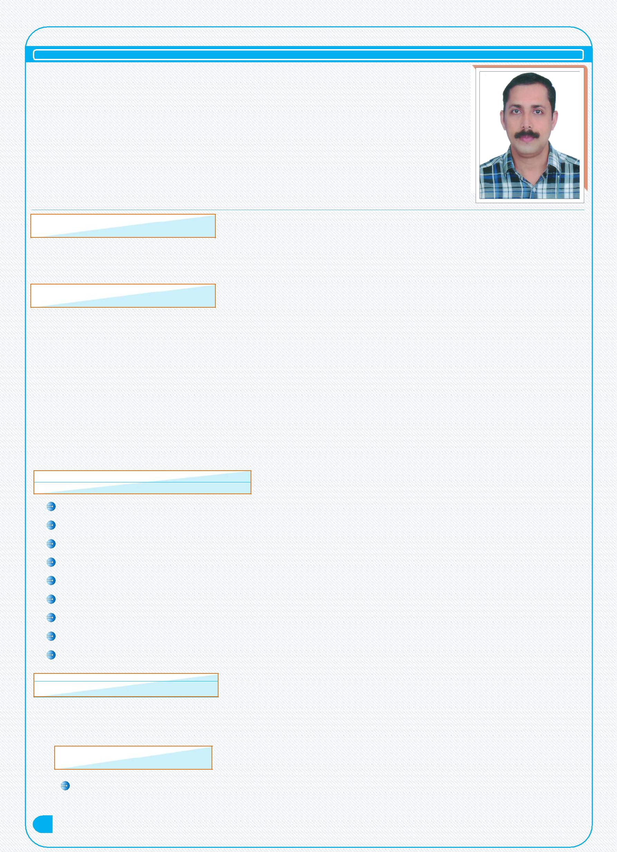
PRAJASH

Email: prajash.210727@2freemail.com

OBJECTIVES

Looking for an entry level position as an Accountant to develop my interpersonal and subjects skills along with giving some contribution in company's profit.

CAREER SUMMARY

Enthusiastic and accounting professional with over 5 years experience in UAE 12 years in native country in both public and private companies.

Experience of managing accounting functions, preparing financial reporting and month end close.

Experience of working with ERP systems.

Expert in interacting with other group companies or accounts purpose. Completer accounts, Payroll and other Statutory Accounts.

KEY RESPONSIBILITIES HANDLED

Enter posting of purchase, sales, payment, receipt collection & journal Voucher. Verification of bills & reconciliation of total turnover.

Bank, Debtors & Creditors Reconciliation.

Maintain cash transaction & petty cash book, preparing cash. Day to day cash and bank transactions.

Preparing outstanding list of Debtor & making payment follow-up. Reconciliation of Bank Statement at the end of month and stock statement. Maintain Salary Register in MS-Excel.

Experience in working with Excel spreadsheets.

TECHNICAL KNOWLEDGE

VitaeCurriculum

1

Computer operating -Windows 2OO7 ' XP' Windows 2OOO Accounting Packages-ERP & Tally 7.2

ACADEMIA

B.Com

Under Calicut University
Kerala, India

EMPLOYER

Still Working As an Accountant

Maintenance LLC on 2015 February onwards

Worked as Accounts Assistant in Barkath Al Madeena super market (Al -Ain) from

2010-2014

Worked as Accounts Assistant in Appolo Wines (lndia) from 2006-2010.

Worked as Accounts Assistant in Soubhagya Tiles (lndia) from 1998-2006.

PERSONAL DETAILS

Name | : | PRAJASH.K.P
Gender | : | Male
Nationality | : | Indian
Date of Birth | : | 26-04-1972
Marital Status | : | Married

LANGUAGES KNOWN

English

Hindi

Malayalam & Tamil

COMPUTER KNOWLEDGE

MS Office

Internet & E-mail

DECLARATION

I hereby declare that above mentioned details are true and correct and best of my knowledge.

PRAJASH

VitaeCurriculum

2

