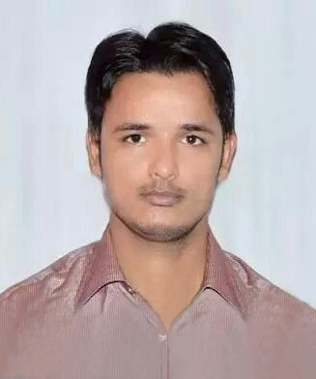
Zeeshan
Zeeshan.212025@2freemail.com

Career Objective

Seeking a challenging position in the organization where I can utilize my technical skills, strength to accomplish the organization’s business goals, in parallel improving the skills and abilities while working with seniors together.

Working Experience
Total experience: Approx 2 year
I was working with “Sherwood College of Engineering and Research and Technology” as a “Desktop Support Engineer” from 06/05/2014 to 31/07/2016.

Job Profile

- Expertise in Desktop Hardware Assembling and installation
- Providing Technical Assistance & support to approx. 250 users.
- Configuration & troubleshooting of E-mail clients (MS-Outlook 2000, 2003 & Outlook Express).
- Expertise in Microsoft Windows Operating System installation and administration
- Expertise in Microsoft Office and other standard application installation
- Expertise in troubleshooting on O.S., Applications and Hardware related problems.
- Expertise in troubleshooting of Network and internet issues
- Wireless network configuration and technical support
- Expertise in Desk jet and LaserJet Printers installation and troubleshooting
- Ability to maintain the hardware and software inventory.

Professional Qualification

- Advance Diploma in Computer Hardware & Network Engineering
From UPTEC Hazratganj Lucknow.

- CCNA (Cisco Certified Network Associate) From (UPTEC COMPUTER CONSULTANCY) Lucknow.

- CCNA Certified (640-802) Latest Track:-
640-802: Bridging/Switching, OSI Reference Model & Layered communication, Network Protocols, Routing, WAN Protocols, Network Managements, LAN Design & Cisco Basics and IOS & Network Basics.

- Microsoft Certified Solutions Associate (MCSA 2012) from SSDN Technologies New Delhi.

Academic Qualification
Qualification | Board / University | Year
Master of Art | Awadh University | 2013
Bachelor of Art | Awadh University | 2011
Intermediate | U.P Board | 2008
High School | U.P Board | 2006

Interpersonal Skills

- Excellent interpersonal and communication skills, both written and verbal
- Excellent analytical and procedural thinking skills
- Quick to grip new technologies and able to self-teach
- Motivated by solving problems and helping others

DECLARATION

I do hereby declare that the above information is correct up to my knowledge and I bear the responsibility for the correctness of the above mentioned particulars.

