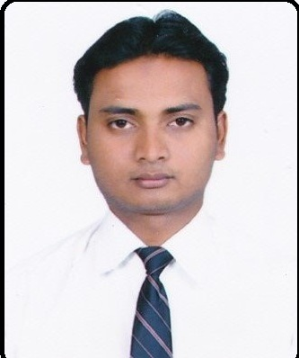  Personal Information :  Date of Birth : 03-07-1990  Gender : Male  Marital Status : Single  Nationality : Indian  Languages  Known : English, Hindi  Hobbies : Playing and  watching cricket | Gulfjobseeker.com CV No: 1273716  Mobile +971505905010 / +971504753686  To get contact details of this candidates  Submit request through Feedback Link  http://www.gulfjobseeker.com/feedback/submit_fb.php  CURRICULUM VITAE  Career Objective  To obtain challenges and responsible position in your organization where I contribute in the growth of the organization using my abilities and skills and further improving my personal and professional skills and As a professional, add value at every stage of life personally and for the Organization to strive for excellences .  And I want to be a part of an organization, where education, experience and Intellectual should be recognized, rewarded and appreciated.  Work Experience  - With Professor Dr. Nina David as Computer Accountant in Lucknow University for about 2 years (from 1 April 2009 to 31 March 2011)  - Worked at J.A. Arts ( Flex printing firm) as a  Part-time Accountant ( from 5th may 2012 to 20 May 2013 )  - Training and One year worked on Samay Solutions  As a Assistant Accountant and Busy Accounting Software trainer  Technical Skills  Having knowledge of computer application  In Business Environment comfortably working in the following area –  - Tally ERP  - MS Office ( Specially in excel )  - Taxation knowledge: -  - Income Tax, Tax Deducted at Source  - Value Added Tax & Central Sale Tax  - Service Tax  Academic Qualification  - High School (2007)  - Intermediate (10+2) (2009)  - Graduation (B.Com) From Lucknow University. (2012)  - MBA from IISE AICTE University (2014)  Others Technical Skills  - Good knowledge & operate to TALLY (All Version)  - Good knowledge of payroll  - Handling Bank & Cash entries and reconciliation  - Handling monthly tax payments and reconciliation.  - Intercompany Reconciliation.  - Co-ordination with other departments.  - Responsible for monthly closing reports and other MIS as per HOD’s requirements.  Declaration  I solemnly declare that the above information is true and correct to the best of my knowledge. I understand that if any information given above is found false/incorrect, my candidature is liable to be rejected.  Place : Dubai.  Date :

