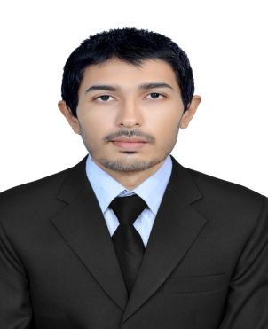
Resume

Gulfjobseeker.com CV No: 1293696
Mobile +971505905010 / +971504753686

To get contact details of this candidates
Submit request through Feedback Link
http://www.gulfjobseeker.com/feedback/submit_fb.php

OBJECTIVE
To seek challenging position with strong desire to make a substantial and positive impact towards the success of the organization and my own career growth.

WORK EXPERIENCE

- Accounts Officer in Khan Advertiser, Sargodha, Punjab, Pakistan (August 2012 – August 2013)
- Internship Trainee in National Bank of Pakistan, Punjab, Pakistan (September 2013 – February 2014)
- Sales Consultant in State Life Insurance Corporation, Pakistan (July 2011 - July 2012)

JOB DESCRIPTION

- Manage Accounts and prepare monthly and weekly financial report
- Overall day to day office management.
- Accounts opening, cash remittances and deposits, General Banking.
- Performing other related duties as required.
EDUCATIONAL QUALIFICATION

Master of Commerce – University of Sargodha, Pakistan

- Co-operate Finance, Investment, Accounting
Bachelor of Commerce – University of Punjab, Pakistan

- Advanced Financial Accounting, Cost Accounting, Auditing

Board of Intermediate & Secondary Education, Sargodha, Pakistan

- Commerce, Accounting

Board of Intermediate & Secondary Education, Sargodha, Pakistan

- Science
IT/ Computer Skills – National Computer College, Sargodha, Pakistan

- Diploma in Office Management
- Diploma in Computer Graphics
- MS Office, Tally, Typing
Languages known

- English, Urdu, Hindi, Punjabi
Interests

- Reading Newspaper & Books
- Internet Browsing, Cricket, Chess
PERSONAL INFORMATION

Date of Birth : 20/07/1988
Religion : Islam
Nationality : Pakistani
Gender : Male
Marital Status : Single
Visa Status : Visit visa (Expiry date: 20/05/2014)

DECLARATION

I hereby declare that the above information are true and correct to the best of my knowledge and belief

