2018-09 -

2018-11

2016-10 -

2018-08

2014-08 -

2016-10

Shamira Khan

Administrative Officer Cum HR

Administrative Officer Cum HR Plus Banking

To work with full determination and dedication to achieve organizational and personal goals. To work as Senior Administrative where 4 years’ of Dubai experience will be fully utilized in providing quality and efficient administrative support to the company’s activities, and ensuring its smooth running.

CURRICULAM VITAE

Branch Manager at Deva S Forex Beauro, kampala,Uganda Africa

- Currency exchange, buying and selling all major currencies. ... Handle day-to-day cash transactions involving receivables and payable and exchanging foreign currency. Attends to customer inquiries on foreign exchange rate, remittances, bill payments, credit card encashment, promotions and other services

- Monitoring of stock on hand, Monitoring of rate fluctuations in the market.

- Optimization of cash stock by disposing non moving currencies.

- Arrange for daily bank deposit of Money Gram, Western Union , T.T transfer and client money.

- Monitoring and training cashier on new currencies and fakes notes.

- Keeping track on rate fluctuations of market and according to that changing buying and selling rate of currencies.

- Doing Western union and Money-gram sending & receiving.

Gehna Jewellery Trading L.L.C

- Handling specific personal task such as processing and renewing visa of employee, and all legal documents i:e labour card, trade license expiry,Dubai Municipality,Chamber of Commerce,Traffic Dept. Police Alaram System.

- Drawing Offer letters and experience letters for Joiners and leavers

- Conducting Interviews and handling recruitment inquiries by telephone and email.

- Maintaining and updating staff attendance and employee records.

- Schedule meetings,book air tickets,hotel reservation for staff and clients.

- Resolve day today administration issue like preparing documents and coordinating with carrier services for customs clearance of import and export of shipment and preparing documentation for event and Exhibition.

- QC-post & pre- shipments, stock in-out reporting,Tagging display.

- Coordinating with social media team and creative agency.

- Bill Payments Of Du/Etisalat /Bank transfer

- Been a part of Sales promotion exhibition held in UAE and Oman.

Admin Cum Validator (TMQ channel Partner of Etisalat)

- Promotion of Elite products on behalf of Etisalat, via telephone from the database provided

- Make contact with the customer, process the customer’s application forms via email and

Personal Info
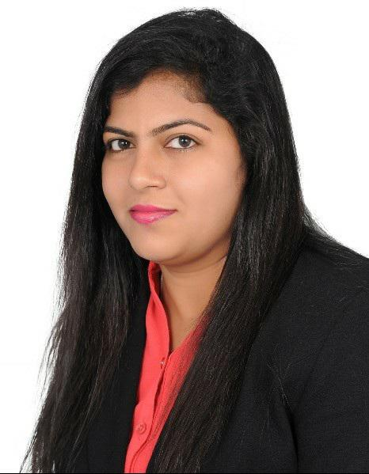

Address

Burdubai, Dubai UAE

Phone

00971525639326

E-mail

shamirakhn08@gmail.com

LinkedIn

www.linkedin.com/in/shamirakhn08

Technical Skills

Good in windows family,MS office: CRM,Outlook,Win gold,Herms,Excel.

advanced

Good in Communication,Customer Facing,Handling Sales team,Handling Cash, Preparing Accurate Reports & Administration Work.

2010-10 -

2014-04

2005 -

2006

2003 -

2005

2001 -

2003

- Coordinate with team members for collection of the same.

- Identifying potential customers

- Preparation of customer reports, facilitating distribution and necessary follow ups

- Answer customer queries about company and its products

- Setting up appointments, Filing, record keeping, data entry , other office tasks

- Entering Data into CRM.

- Getting approval for Business Case.

- Cordinating with Sales Executive by give them update on product and also guiding them when they are in field.

HDFC Bank LTD, GOA INDIA

- As a Personal Banker, my job was to ensure that all the documents for account opening are checked, formalities completed by the customer in my presence.

- Explain to the customer the various benefits of the Investment product available.

- To assist the customer to complete the documentation and application formalities.

- Opening new customer accounts with documents to ensure that the criteria is met as per the Banks requirement.

- Ensure that photograph submitted for the ID proof is clearly visible it should match with the photo on AOD

- Original identity and address proof documentation need to be personally seen, scrutinized and verified. And then the originals are verified, stamp is to be affixed, a written confirmation “that the customer has signed the document in my presence” need to be stated and signed.

- To maintain quality norms on depletion and for cheque bouncing cases.

- To achieve sales target of Bank.

- Correspondence and follow up with customers

- Preparing and updating customer documents

- Preparing an Excel sheet on status of customers on a weekly basis

Academic Credentials

Office Management Course

GOA India

B.A (Bachelor of Arts) From Govt.College, Goa ,India.

Shri Bhumika Higher Secondary

Intermediate from Goa Board with 60% marks

ST. John Of the Cross High School Goa India

SSC Board with 67% marks

