Riya
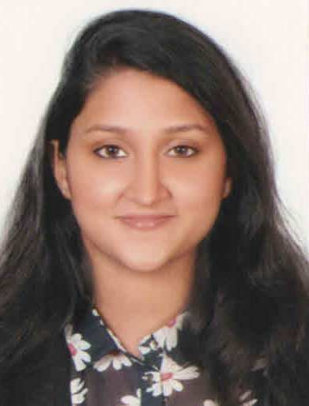
Email : -riya.219068@2freemail.com

Career Goal:
Currently seeking to secure a challenging development position that will enable me to contribute and add value to the organization while enhancing my skills and abilities, in an atmosphere where sincerity and perfection is encouraged and rewarded.
_________________________________________________________________
Education
- 2015: Graduated from Middlesex University, Dubai
- 2012: Pursued Bachelor Honor’s degree in International Tourism and Human Resource Management in Middlesex University, Dubai
- 2012: Completed 12 CBSE board: The Indian High School, Dubai
- 2010: Completed 10 CBSE board: The Indian High School, Dubai

Professional Experience:
1.Company: Microexcel Technologies LLC
Role: HR Recruiter June 2015 - June 2017
- Worked with the senior HR Manager on recruitment and planning.
- Made precise observations and corrections on data.
- Researched and classified the employment data to the system
- Made preparations of data sheet as required by HR management.
- Prepared the needed documents for new employees.
- Posting the requirements in Job Portals.
- Conduct screenings for potential candidates.
- Scheduling interviews with job candidates.
  - Gave assistance on the implementation of the programs for the development of Human Resource.
- Lama Tours
Role: HR Admin (Intern) November 2014 - December 2014
- Accountable for staff tracking and organization.
- Worked as an Administrator with the Recruiting Executive.
- Was in charge of training material supply and scheduling the training sessions.
- Completed different types of duties associated the HR tasks.
Additional Work Experience:
2012: Worked for Gulf Film Festival
2012: Worked in Kinokuniya bookshop, Dubai mall – Temporary.
2013: Volunteered for Summer Camp in St Mary’s Catholic Church.
2013: Was student representative in University.
2014: Worked for Dubai International Film Festival
2015: Worked for GITEX Technology Week – October (Microexcel)
2016: Worked for GITEX Technology Week.
2016: Worked for Big 5 event.
2016: Worked for Beauty World
2017: Worked for Intersect event.
2017: Worked for Arab Health event.
2017: Worked for Cabsat event.
2017: Worked for Arabian Travel Market event
2017: Worked for Cityscape event
2017: Worked for Hotel Show event
Key Skills:
- Imaginative thinking and eagerness to learn more from the industry.
- Capable to work independently as well as in a team.
- Ability to work under pressure.
Relevant Skills:
- Well versed with all aspects of Microsoft Office
- Excellent written and oral communication. Also obtain good presentation skills
- Resourceful and quick learner
- Internship provided me the opportunity of handling projects and course work which in turn enabled me to become multi- tasked.
Personal Profile
- Date of birth : 1st August 1994
- Nationality : Indian
- Visa Details : Fathers Sponsorship
- Driving License : U.A.E license holder
- Marital Status : Single
- Languages : Fluent in English, Hindi, Malayalam and basic
Arabic.
________________________________________________________________

References
References can be provided on request.

