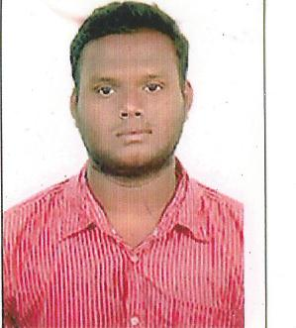

Hassan.219536@2freemail.com

Hassan

CAREER OBJECTIVE

Looking for an opportunity to present and prove my skills. A candidate with a challenging attitude to take the confidence of my superiors through the jobs given to me.

STRENGTH

- Systematic and structured working methods and ability to work on own initiative.
- Hardworking and responsible.
- Ability to cope and grow with expanding job responsibilities and duties
- Capable of working independently, under pressure and willing to accept changes
- Excellent inter-personal skills and pleasant personality.

ACADEMIC PROFILE

- BE- Aeronautical Engineering(Anna University 2012-2016)
- DIP(Diploma in Airport Management 2016 - 2017)
- +2 (Board of Higher Secondary Education Tamil Nadu)
- 10th (Board of Higher Secondary Education, Tamil Nadu)

PREVIOUS EXPERIENCE

- Worked as an System Data Entry Operator in Thanjavur, Tamil Nadu, India(Feb 2016 to Aug 2017)

COMPUTER SKILLS

- Operating System : Windows Vista 7,8, Windows XP, Windows 98
- IT Tools : MS Word, MS Excel, ,Auto cad, CATIA V5, Internet

LINGUISTIC ABILITIES

- To Read and Write : English, Arabic and Tamil
- To Speak : English, Hindi, Tamil and Malayalam

PERSONAL PROFILE

Name : Hassan
Sex : Male
Nationality : Indian
Gender : Male
Marital Status : Single

DECLARATION

I hereby declare that all the above information is true and correct as the best of my knowledge.

Sincerely

Hassan

