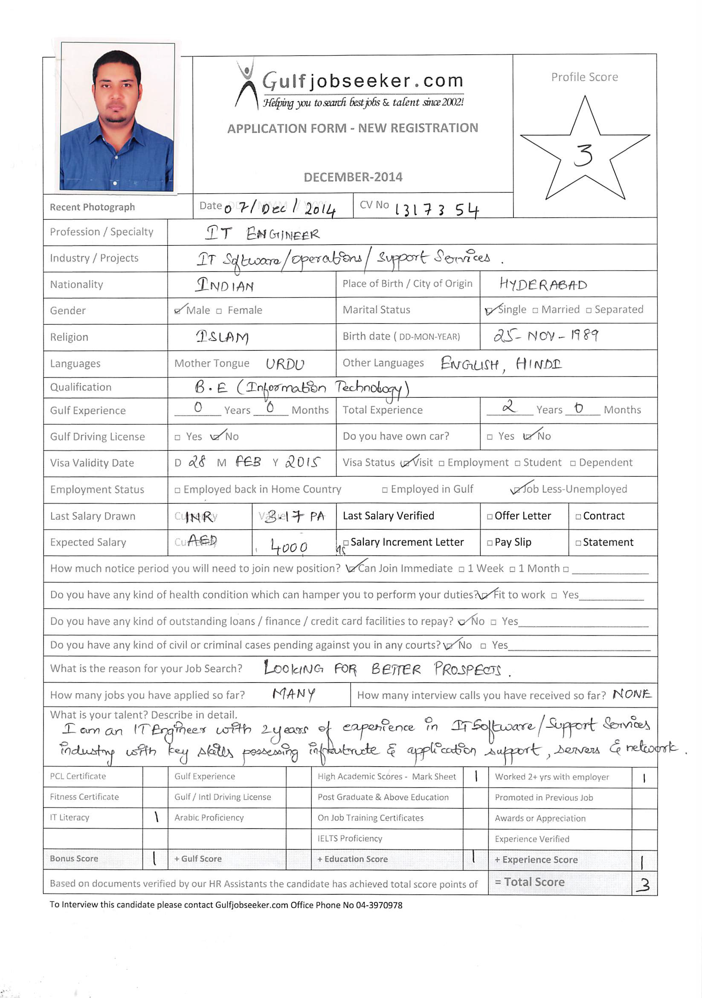

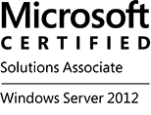
Career Objective

Enthusiastic and objective oriented individual seeking growth and satisfaction by being part of a large professional organization that will provide various challenging opportunities to realize my full potential and excel therein.

Technical Skill set

Programming Languages | : | C & C++, Java, HTML, PHP
Technical Tools | : | Web logic , BMC Remedy Application v8.0, Light House, IEX
Virtualization | : | VM Ware, Citrix XenApp, Hyper-V
Database | : | Oracle SQL, MySQL
Operating system | : | Windows (Vista/7/8), Linux
Servers | : | Windows Server 2003/2008 R2, Active Directory, Exchange Server 2007/2010
Desktop Applications | : | MS Office ( Word, PowerPoint, Excel, Outlook)
Networking | : | Routing & Switching, Cisco Routers/Switches, TCP/IP, DNS, DHCP

Work Experience

Service Support Engineer –(Aug 2012 – Aug 2014)

Roles & Responsibilities:

- Working in infrastructure &network support environment, troubleshooting issues, monitoring and managing servers for smooth operation of the business.
- Responsible for handling different accounts of the clients & stakeholders.
- Providing post deployment support for upgrades/changes/enhancements done on production (Live) Environment.
- Strong Linux/Oracle skills and very quick learner.
- Have taken the responsibility of deployment, raising change request and coordinating with the production team.
- Analyzing and investigating defects and faults, and tracing them till final resolution.
- Installing, configuring and monitoring routers, switches & WAP’s (devices such as Juniper SRX router, Juniper Net screen 5GT WAP, HP Procurve Switch, Cisco routers, High gain antennas).
- Time-efficient, systematic working methodology. Rapid adaptability to new problem-solving and new locations.
- Proficient, dynamic and result oriented team player with excellent analytical and interpersonal skills used to coordinate multi-disciplinary teams and clients and consistently motivated toward success and completion of projects.
- Prioritizes requests in accordance with agreed service level agreement (SLA).
- Within own area of knowledge; follows agreed procedures to investigate issues and other requests for support and determines appropriate actions to take.
- Interface with the 1st& 2nd line support and development team.
- Liaises with systems development staff or software suppliers on the development of system enhancements to overcome known problems or further fulfil user requirements.
- Provide support for application build and releases. User Problem Management: User interactions through phone/mail to get more details for a fault.
- Application Monitoring
- Provides correct responses to requests for support by means of for example: making modifications to system parameters, developing work-around or site-specific enhancements, reconfiguring systems, changing operating procedures, training users or operations staff, producing additional documentation, or escalating requests to systems development staff or software suppliers.
- Monitoring performance and resources on server
- Upgrading and deploying software's in case of any enhancement or core releases
- Provide support out of office hours, during weekends and during major release work to development and customer to help them resolve issues faced. Ensures all work is carried out and documented in accordance with required standards, methods and procedures.

Trainings& Certifications

- Microsoft Certified Solutions Associate – Windows Server 2012 (MCSA 2012)
- Completed training for ITIL v3 Foundation (On-Job Training)
- Completed training on CCNA
- Completed training on Advance Java for Project during bachelors.

Educational Qualification

B. E | Deccan College of Engineering & TechnologyOsmania University, Hyderabad | 74% | Jun-2011
Intermediate | Narayana Junior College  Board of Intermediate, Hyderabad | 89% | Apr-2007
SSC | Sujatha High School  Secondary School of Education, Hyderabad | 79% | Apr-2005

Personal Information

Date of Birth | : | 25-11-1989
Marital Status | : | Single
Nationality | : | Indian
Languages known | : | English, Hindi, Urdu
Visa Type | : | Visit Visa

