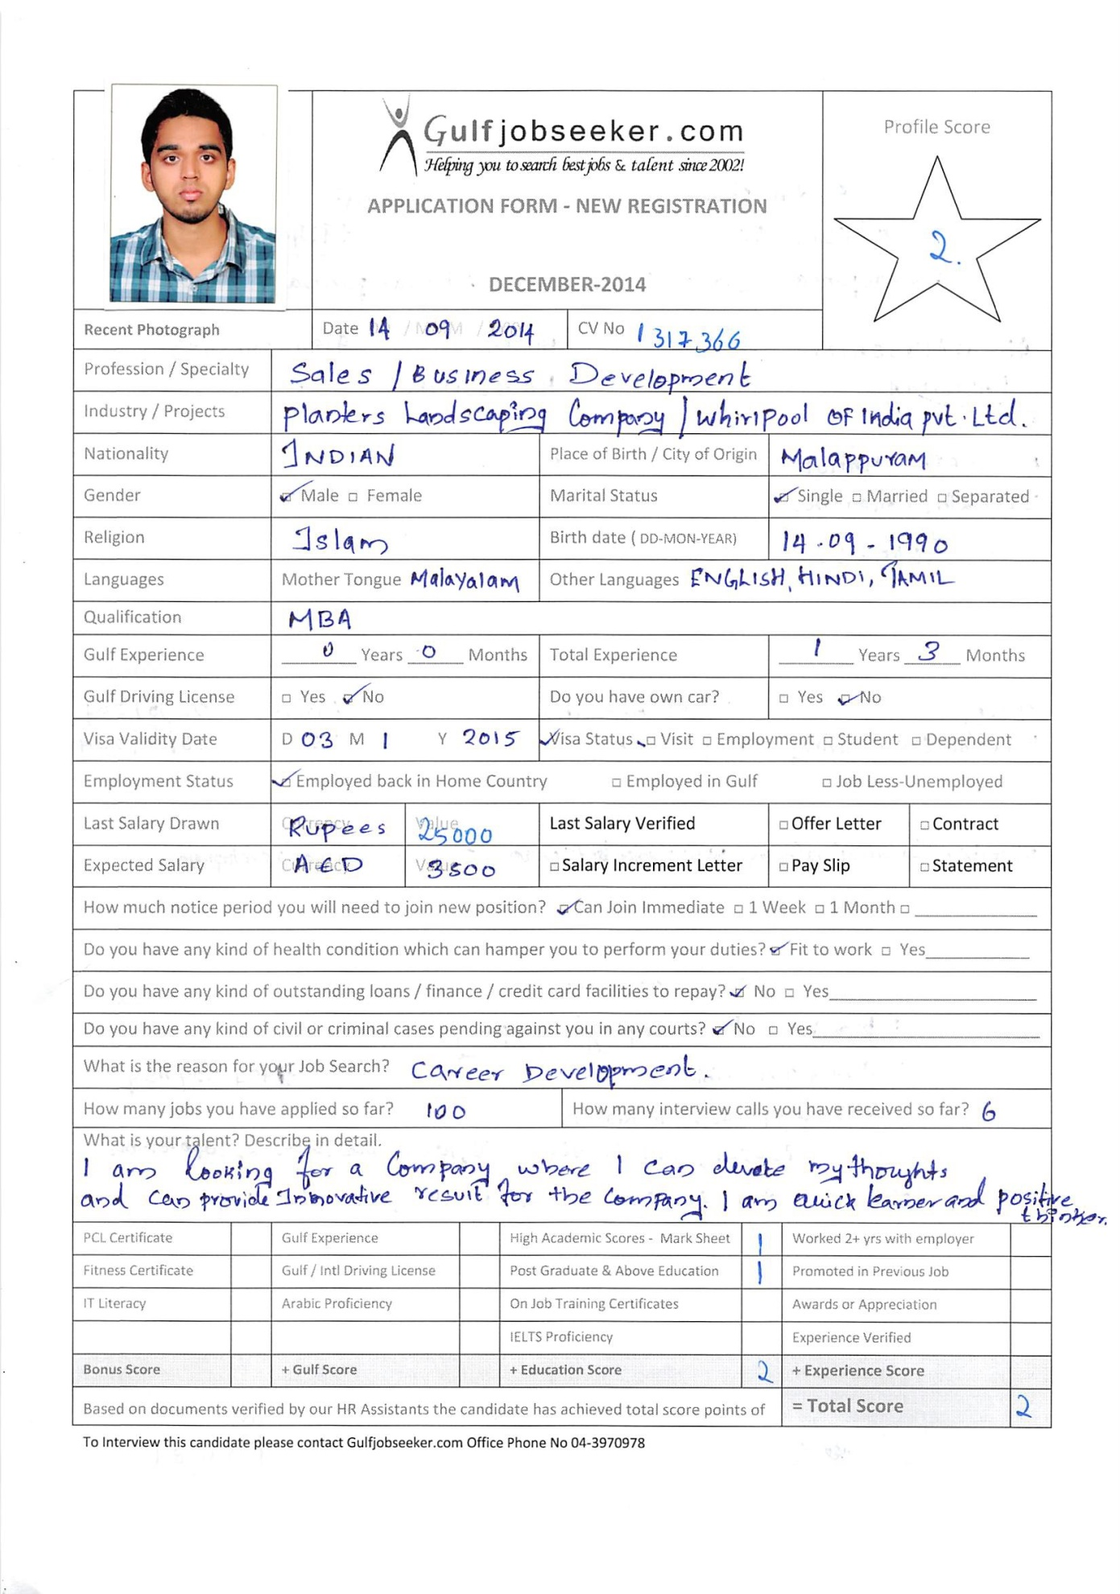

CAREER OBJECTIVE
I look forward to work for a company which gives me opportunity to devote my thoughts and can bring up innovative results. My own background and analytical interests have made me adaptable towards new conditions and work as a team player, which will ensure the growth of me and my company.
STRENGTH AND ACHIEVEMENTS

Positive thinking
Motivated, persuasive and goal orientated.
Good Communication skills
Adaptable and have a positive attitude towards change.
Flexible with working hours
Quick learner, Excellent team player and dedicated with an ability to grasp new ideas and concepts.
Sharing knowledge and encouraging development of others to achieve team goals.
Ability to come with new ideas and suggestion to team.
Able to work as part of wide and varied team

PROFESSIONAL EXPERIENCE

Job description

The Business Development Executive is responsible for providing excellent customer service, building positive business relationships and working with staff to ensure that any commitments are delivered within appropriate timeframes. The Business Development department is responsible for achieving targeted revenue, maximizing business opportunities and for the ongoing development and growth of company.

Duties

- Following up new business opportunities and setting up meetings.
- Planning and preparing presentations.
- Communicating new product developments to prospective clients

  - Overseeing the development of marketing literature Writing reports
  - Providing management with feedback

Responsibilities

- Managing and maintaining databases of potential clients
- Develop incentive and marketing programs for customers
- Conduct client presentations and negotiations
- Provide quotes on major projects and manage account transitions
- Identifying, researching and targeting new business prospects.
- Liaising with new and existing clients over the phone and meeting them face to face.
- Undertaking customer interactions with prospective as well as existing customers.
- Maintain strong relationships with key contacts in existing accounts and develop new accounts
- Developing strong working relationships with prospective new customers
- Knowledge of how to cleanse and maintain prospect and customer records on the database

EDUCATIONAL QUALIFICATION

Master Of Business Administration
Mahatma Gandhi University, Kottayam (2011-2013)

Bachelor of Business Administration
University of Calicut (2008-2011)

TECHNICAL SKILLS
  - Microsoft excel
  - Microsoft office , Internet
  - Microsoft power point presentation

PROJECT SUMMARY
- M.B.A(Project):Organization Study about “ WHIRLPOOL OF INDIA PRIVATE LIMITED”
- Completed a project report on “ Job satisfaction of employees in Miracle India Rubber Private Limited”.
- Done internship training at Whirlpool of India Private Limited Bangalore.

INTEREST AND HOBBIES
Listening to Music, Long Drive ,Jogging, Playing games.

DECLARATION
I the undersigned hereby declare that all the information furnished above is true to the best of my knowledge and belief.

