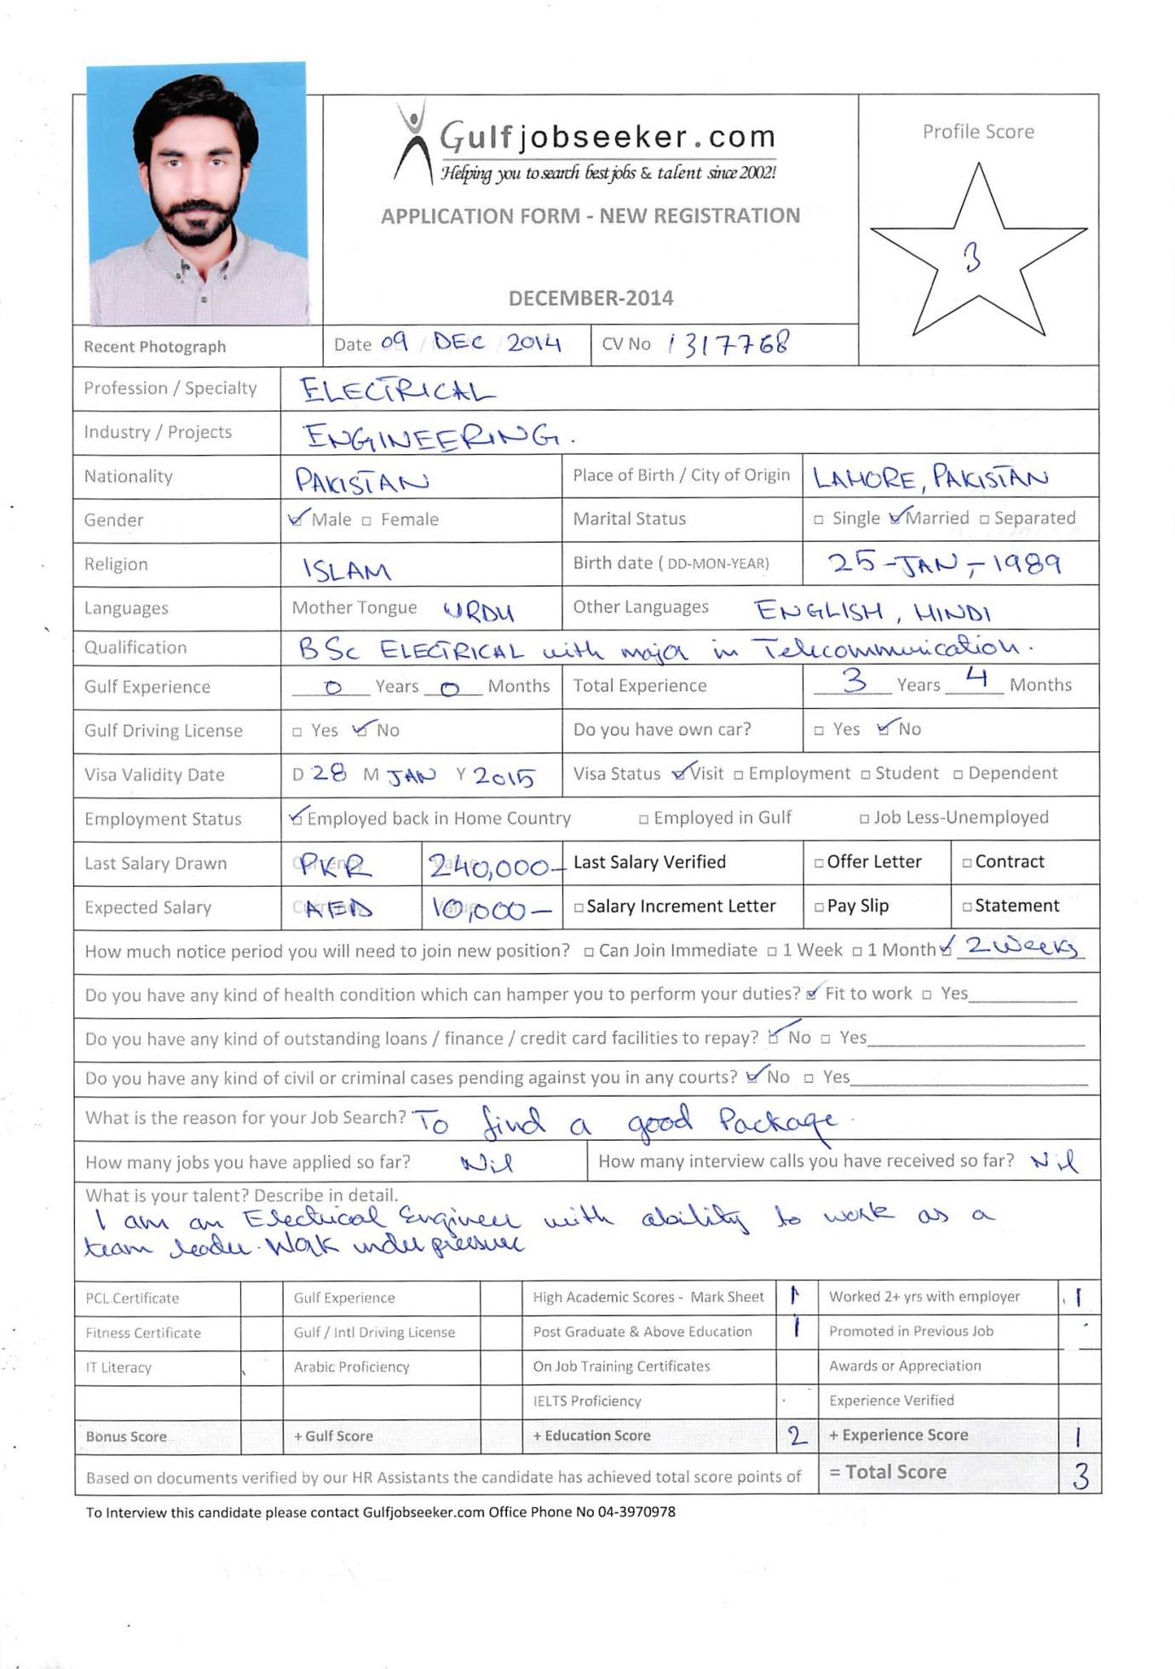

SUMMARY OF SKILLS

Telecommunications professional, seeking to contribute and grow with a dynamic, progressive and innovative organization.

STRENGTHS AND SPECIALTIES

Network Operations; working on HUAWEI SBCs with monitoring and error handling for the best available QoS, working on NEXTONE Soft Switch which include monitoring and technical support, working on PORTA server.Other specialties include Radio Frequency &Strategy Planning, System analysis, Networking, Wireless and Mobile communication.
Recognized as a team player and performer by my superiors.Consistently completing assignments on time.A troubleshooter, able to effectively and efficiently resolve issues and meet challenging goals and objectives.

EXPERIENCE

- Electronics Engineer Responsible for error handling and maintenance of Electronic equipment. February 2012 – Date
- Network Operations Engineer. Responsible for monitoring and technical support, in the Long Distance International (LDI) department, related June 2011 –January 2012 (8 months)
- Training at ZTE which included the up to date ZTE equipment. October 2010 - October 2010 (1 month)
- Internship with training latest equipment. June 2010 - August 2010 (3 months)

ACADEMIC PROJECTS

- Antenna Designing on HFSS.
- Radio Frequency Network planning for 2G, 3G using Gaia Planning Tool.
- Channel Modeling for 4G on MATLAB.
- Home Automation through GSM.

QUALIFICATION

- COMSATS Institute of Information Technology,Lahore
BSc, Electrical (Telecommunication) Engineering, 2007 - 2011
- Member Institute of Electrical and Electronics Engineers(IEEE) since 2010
- Member Pakistan Engineering Council (PEC)
- COMSATS Institute of Information Technology,Lahore
CCNA 2009– 2010

SKILLS AND ABILITIES

HUAWEI SBC, Nextone Switch, NSN Switch, Porta Server, MapInfo, Gaia Planning tool , Hfss Antenna Designing, ArcGis, Global mapper, MATLAB, C, C++, Java.

PERSONAL INFORMATION

Nationality: Pakistani
Date of birth: Jan, 1989

