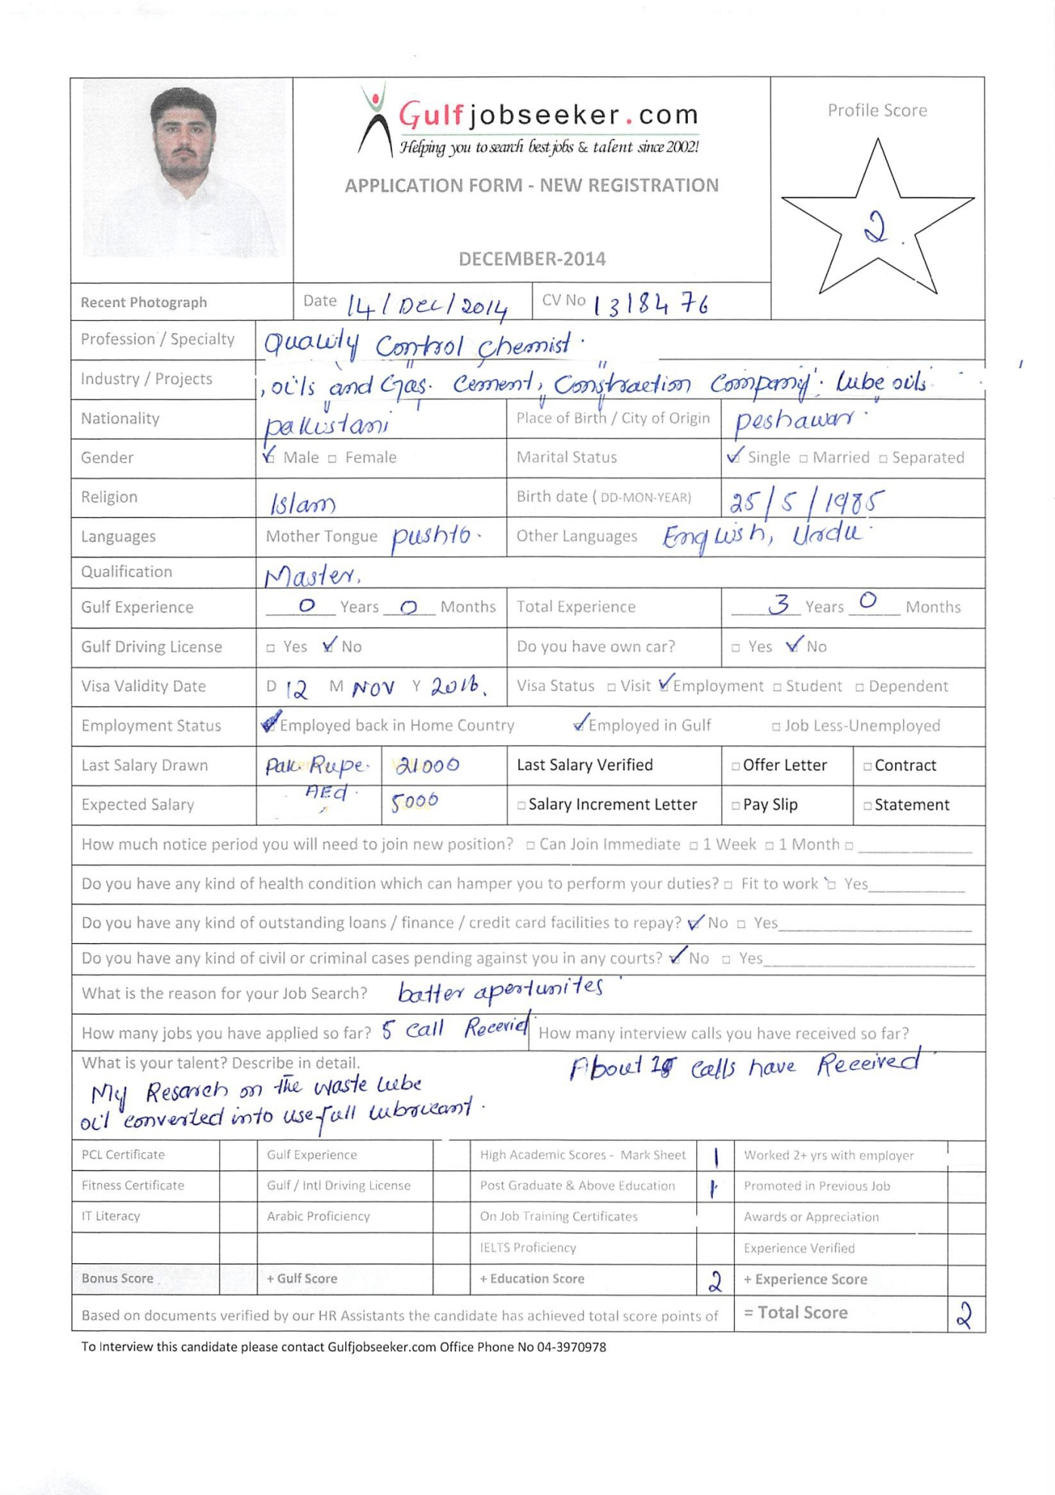
Gulfjobseeker CV No: 1318476
To interview this candidate call: 971505905010
Or email us back filled up Vacancy Form
http://www.gulfjobseeker.com/Free_Job_Posting_Form.doc

CARIER OBJECTIVE:-

To secure a challenging position to a professional reputed organization where I can effectively utilize my skill and experience to en have professional growth.

PERSONAL DETALIS:-
Nationality : Pakistan
Date of birth : 25/05/1985
Religion : Muslim
Gender : Male
Language Known : English, Urdu, Pashto, Arabic

EDUCATION QUALIFICATION:-

Certificate | Session | Division | Board/ Universty
S.S.C | 2002 | 1st | BISE Peshawar
F.Sc | 2005 | 1st | BISE Peshawar
B.Sc | 2008 | 2nd | University of Peshawar
M.Sc (Analytical Chemistry) | 2011 | Ist (3.07 cgpa) | A.W.K.U.Mardan

Strengths:
- Have strong interpersonal & Communication Skills
- Ability to work under Pressure
- Punctuality and time Management
- Ability to Convince and hard Work Person

Computer Skills :
- MS Office ( Word, Excel ,Power Point and Internet Browsing,)

Work EXPERINCE:-

 | Position | Period
 | Universty Student | 1year
 | Quality control | 2 year
cement qaulity control 1 year

DECLARATION:-
I certified that the above are true and correct to the best of my knowledge and ability. If given a chance to service you I assure you that I will execute may duties for the total stratification of my superior.

