Personal Data
Nationality: Indian
Sex: Male
Date of Birth: 30/12/1989
Place of birth: UAE
Religion: Islam
Marital Status: Single

Languages Proficiency:
English, Malayalam
Hindi & Arabic (partial)

Objective

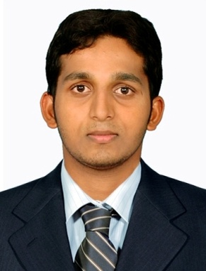
Intend to build a career with leading Co-operative hi-tech environment with committed and dedicated people, which will help me to expose myself fully realize my potential. Willing to work as key player in challenging and creative environment.
Key Strength

- Comprehensive solving abilities
- Organizing and managing capabilities
- Willingness to learn and update myself
- Positive attitude and team spirit
- Excellent Communication and presentation skills
- Dedicated, focused, enthusiastic and hard work
Employment History

CHARTERED ACCOUNTANCY FIRM
P.R SASIKUMAR FCA (CHARTERED ACCOUNTANT, Membership no:207816) Edappal,Kerala,679576, India
(An organization running as Accounts & Audit firm that undertakes Accounts and Audit works of various companies and submits reports, payment of taxes etc.)
Position - Accounts & Audit Assistant
Duration - from February 2012 - March 2014
Roles:
- Annual & Interim Accounts finalization (Preparation of; Profit & Loss Account, Balance sheet etc),
- Verification of day book, Ledger, Cash book, Bank book, Purchase bills, Sales register, debtors , creditors etc. of various firms,
- Preperation of Audit report by using : MS word, MS excel, Tally etc.
- Individual Tax Audit: Verification and checking of relevant Books of accounts; Preparing Profit& Loss Accounts; Balance Sheet; Computation of Tax Statement etc,
- Partnership Audit: Periodical Internal Audit; Verification and checking of Books of Accounts; Preparation of Final Accounts followed by Tax audit,
- Company Audit: Private Limited Company and Limited Company Audit,
- Audit of Semi – Government Companies like National Mineral Development Corporation,
- Institutional Audit: State Bank of India, Canara Bank etc.
Academic Profile:

- Master of Business Administration (MBA) - in 2014 from Bharathiar University
- Master of Commerce (M Com) - in 2012 from Madurai Kamaraj University
- CA Foundation (CPT) - in 2010 from ICAI
- Bachelor of Commerce (B Com) - in 2010 from Mahatma Gandhi University
- Higher Secondary (+2) - in 2007 from DHOHS School Edappal , Kerala
- SSLC (10 th) - in 2005 from MVM RHS School Valayamkulam, Kerala

Computer & Technical Skill:

- Diploma in Computerized Financial Accounting (DCFA) (Tally ERP-9, Peachtree)
- MS Office (Word,Excel,Powerpoint,Outlook,Access)
- CA ITT (Information Technology Training)
- CA Orientation Programme
- Graphic Designing
- Photoshop

DECLARATION
I hereby declare that the above mentioned details are true to the best of my knowledge and belief.

