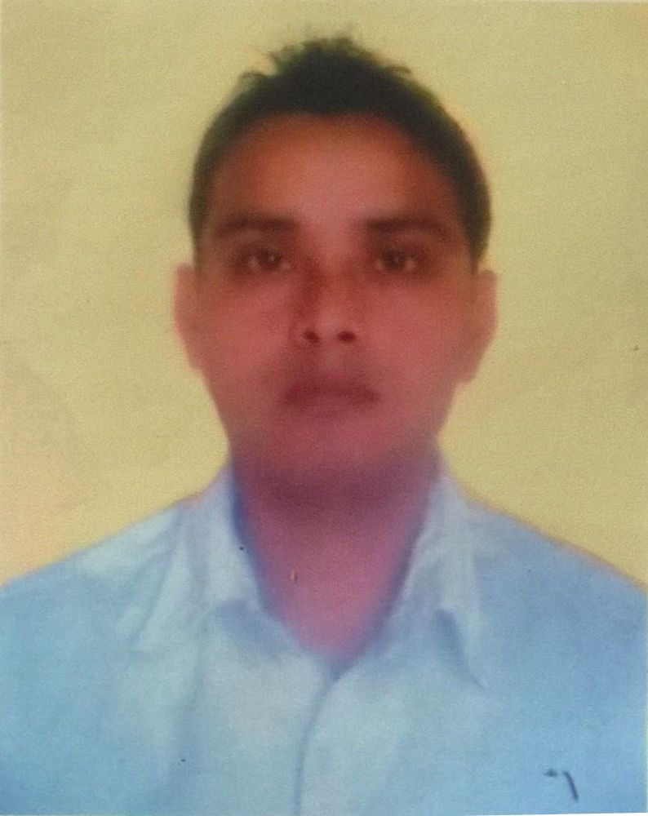
Curriculum - Vitae

Mr. BIKRAM Email:- bikram.23776@2freemail.com

Objective:-
Continuous growth and advancement in professional career
through hard and diligent work, knowledge and skill enrichments with the attitude for high commitment and applications of both the required and acquired learning right prospective.

Working Experience:-

- Working with THE CHEESE CAKE FACTORY Restaurant at MOE
& JBR DUBAI.
Working period: 24th JANUARY 2016 to till date.
Position:- Prep Kitchen

- Starting shift with checking 86’,Kill list items in the list.
- Fallow up the low call from the line.
- Manage the station and jump for help to other if required.
- Check the quality of the product like Sauces, Dressing etc. and immediate inform the CDP or Kitchen Manger if it is not as per standard.
- Handling the oven items.
- Responsible for checking for expiry items everyday.
- Responsible to fill the Cooling log after prepare the sauces soup to keep safe from contamination.
- Responsible to keep the area clean and tidy always.

. Worked as a sales executives for (NOKIA & MICROSOFT) Mobile at Siliguri Cell Tek, Siliguri
Working period: 1st JULY 2012 to 30th NOV 2015.

- Serving customers at the sales counter.
- Offering face to face advice to customers on the stores products.
- Maximizing store revenue by suggesting upgrades, insurance and add-ons to customers.
- Processing returns and refunds as required in line with company procedures.
- Occasionally being responsible for the stores security including being its key holder.
- Using the stock management system to log, check, locate and move stock both in and out of the store.
- Responsible for the daily management of the till in the absence of the senior members
- Ensuring that all areas are clean and adhere to the company’s clear floor policy and Health and Safety requirements
- Making sure that any item which is removed from a display column is replaced immediately after a sale.
- Handling customer complaints in a calm manner.
- Managing cash and payment systems in accordance with company procedures and policies.

- Worked as a sales executives for LAVA Mobile at Siliguri Cell Tek, Siliguri
Working period : 1st January 2011 to 30th June 2012.
- Assisted and encouraged customers in selecting and purchasing required products in a retail environment.
- Addressed customer’s needs – Advised and helped locate appropriate merchandise.
- Described product’s features/benefits and demonstrated usage/operation of products.
- Answered/addressed customers’ questions – Provides information concerning specifications, warranties, financing available, maintenance of merchandise and delivery options

- Worked as a sales executives for Fly Mobile at Siliguri Cell Tek , Siliguri for Nine months.
Working period : 1st May 2010 to 31st December 2011.

Job Profile:-

- Preparing Daily Sales, Daily Stock Report placing stock Order to the co. and verifying about the availability of products at that time.
- Intimating the seniors about any new Competition Handling all customers queries and Complaints.

- Worked as a senior Customer Care Executive for Reliance Telecom
LTD.
(Inbound / Outbound and Dealer Helpline).

Working period : 12th July 2007 to 31st March 2010.

Job Profile:-

- Handling all customer's Queries & complains, intimating the dealers about all day to day Schemes.

- Intimating the supervisor about the customer's problems and queries.

- Informing the supervisor about the latest developments and submitting them the day to day call details.

- Worked as a sales Executive for Three Years at HARSH ENTERPRISES.
Working period : 15th March 2005 to 30th June 2007.

Education:

- B.A PASSED( STREAM ARTS)
SURYA SEN MAHAVIDYALAYA

- H.S from W.B.H.S.E:-
(MARGARATE SISTER NIVIDITA ENG SCHOOL.)

- Matriculation from W.B.B.S.E
(MARGARATE SISTER NIVIDITA ENG SCHOOL.)

Personal Details:-
- Date of Birth : 2nd November 1984
- Gender : Male
- Marital Status : Married
- Religion : Hinduism
- Nationality : Indian
- Language Known : English, Hindi, Nepali,Bihari & Bengali
- Hobbies : Playing Football.
- V ISA : RESIDENCE VISA

Signature

