Eslam

E-Mail: eslam.23923@2freemail.com
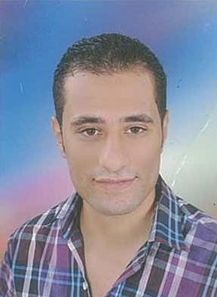
Personal Data:
-Date of Birth: 22/11/1988

- Place of Birth: Tanta, Egypt
- Nationality: Egyptian
- Gender: Male
- Religion: Muslim

Qualification: - 2014, Bachelor of Engineering, Electrical Power and Machines Department.

Experience: - had a certified training in Alstom company in A transportation field in metro line 2 project as an
Excellent trainee.
- had 1 year experience as a field & design engineer in low Voltage distribution and lighting using AutoCAD.

Professional Memberships:
- Member of Egyptian Engineering Syndicate.

Training Courses:
- Course in English Conversation.

Skills: - General knowledge of using computer.
  - Excellent in using English Language.
  - very good in using AutoCAD program.
  - very good in using E-tap program.

Personal Skills: - Ability to work under pressure.
  - Have the ability to handle with the problems efficiently.
  - Hard working and diligent.
  - Ability to communicate with the team works.

- have the Ability to learn new skills easily and quickly.
  - Attention to detail and high level of accuracy.

Interests and Hobbies:-Chess.

