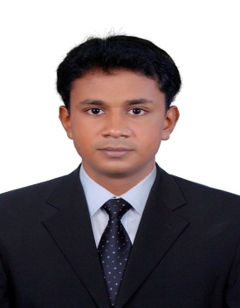

Gulfjobseeker CV No: 1333350
To interview this candidate call: 971505905010
Or email us back filled up Vacancy Form
http://www.gulfjobseeker.com/Free_Job_Posting_Form.doc

CAREER OBJECTIVE

To seek a challenging responsible position that offers me an opportunity to contribute to the success of organization in a substantial manner with my knowledge and ability.

SUMMARY

An enthusiastic, B-tech Software Engineering with 1 year of experience in programming, designing the code and validating, and all engineering related office works, Eager to learn new technologies.

JOB EXPERIENCE

Employer: Aptara Learning PVT Limited, Technopark, Trivandrum.
Duration: Almost 1 year(August 26,2013 to May 16,2014).
Designation: XML Operator.

EDUCATIONAL QUALIFICATION

Degree | University / Board | Institution /  School | Year of passing | Percentage %
B.Tech (Information Technology) | Anna University, Chennai | The Rajaas  Engineering College, Vadakkankulam. | 2012 | 62%
Diploma in JAVA | NIIT | NIIT, Trivandrum | 2012 | 59%

KEY SKILLS
Programming Languages : Java, . NET
Technologies : Html, Xml
Database : SQL
Software Packages : Microsoft Office, Photoshop

PROJECT DETAILS

Project #1(Main Project):

- Peer To Peer System For Livestreaming
Description - Reduce Time for the servers to Complete one Process.
Project Tools - JDK 1.6.Eclipse 3.3.
Duration - 3 Months

Project #2(Niit-project):
- OnLine Video Library
Description - Manage Videos in a Website.
Project Tools - Netbeans/Oracle 10g.
Duration - 2 Months.

ACHIEVEMENTS
- Participated in Workshop titled ‘Android the Future of IT Professionals’, conducted by ActivApps on 26th January 2013 at Trivandrum.
- Participated in Science And Engineering Exhibition at EXPO ’11, a National Level Exhibition held on 4th February 2011 at Rajas International Institute Of Technology For Women, Nagercoil.
- Created an Online Video Library using J2EE During the project time at NIIT
KEY STRENGTH

- Leadership skills, effective communication, coordination skills, optimistic & objective, performance oriented, systematic and organized.
- Dealing effectively with people at all levels within the organization.
- Ability to work well within and lead a site based team of mixed nationalities.
- Able to organize tasks and complete them with tenacity and thoroughness.
- Enthusiastic, reliable and responsible team player.
- Hard working, sincere, honest and diligent.
- Excellent command of spoken and written English.
- Knowledge of Microsoft Office applications like Word, PowerPoint and Excel.
- An enthusiasm for new challenges and stepping out of personal comfort zone.
- Ability to organize staff and prioritize works.
PERSONEL PROFILE:
DATE OF BIRTH : 28-10-1989
MARITAL STATUS : Single
NATIONALITY : Indian
VISA STATUS : Visit Visa
LANGUAGES :English, Malayalam and Tamil

