Curriculum Vitae
Objective:

- Seeking a challenging position in the field where I can use my talents and abilities.

- B.Tech in Computer Science and Engineering
Kerala University - 2009 – 2013. (Passed with 69.0%) {UKF College of Engineering and Technology}
- Higher Secondary Education:
CBSE – 2008 - 2009. (Passed with 65.0%) {Kendriya Vidyalaya Keltron Nagar}
- Secondary School Certificate:
CBSE – 2006 - 2007. (Passed with 61.8%) {Kendriya Vidyalaya Keltron Nagar}

- Strong verbal and written communication skills.
- Adapt to handle multiple activities and ability to remain calm under pressure.
- Strong understanding of Organizational structure and effective time management.
- Team handling/management capabilities and have the ability to work independently as well.
- Ability to work collaboratively as a team member and to maintain a strong service orientation

- Operating systems: Windows XP, Vista, Windows 7 and 8, Linux
- Languages: Basics of C, C++ and Java
- Application Software : MS OFFICE
- Database Management System – My – SQL Server

GIRISH
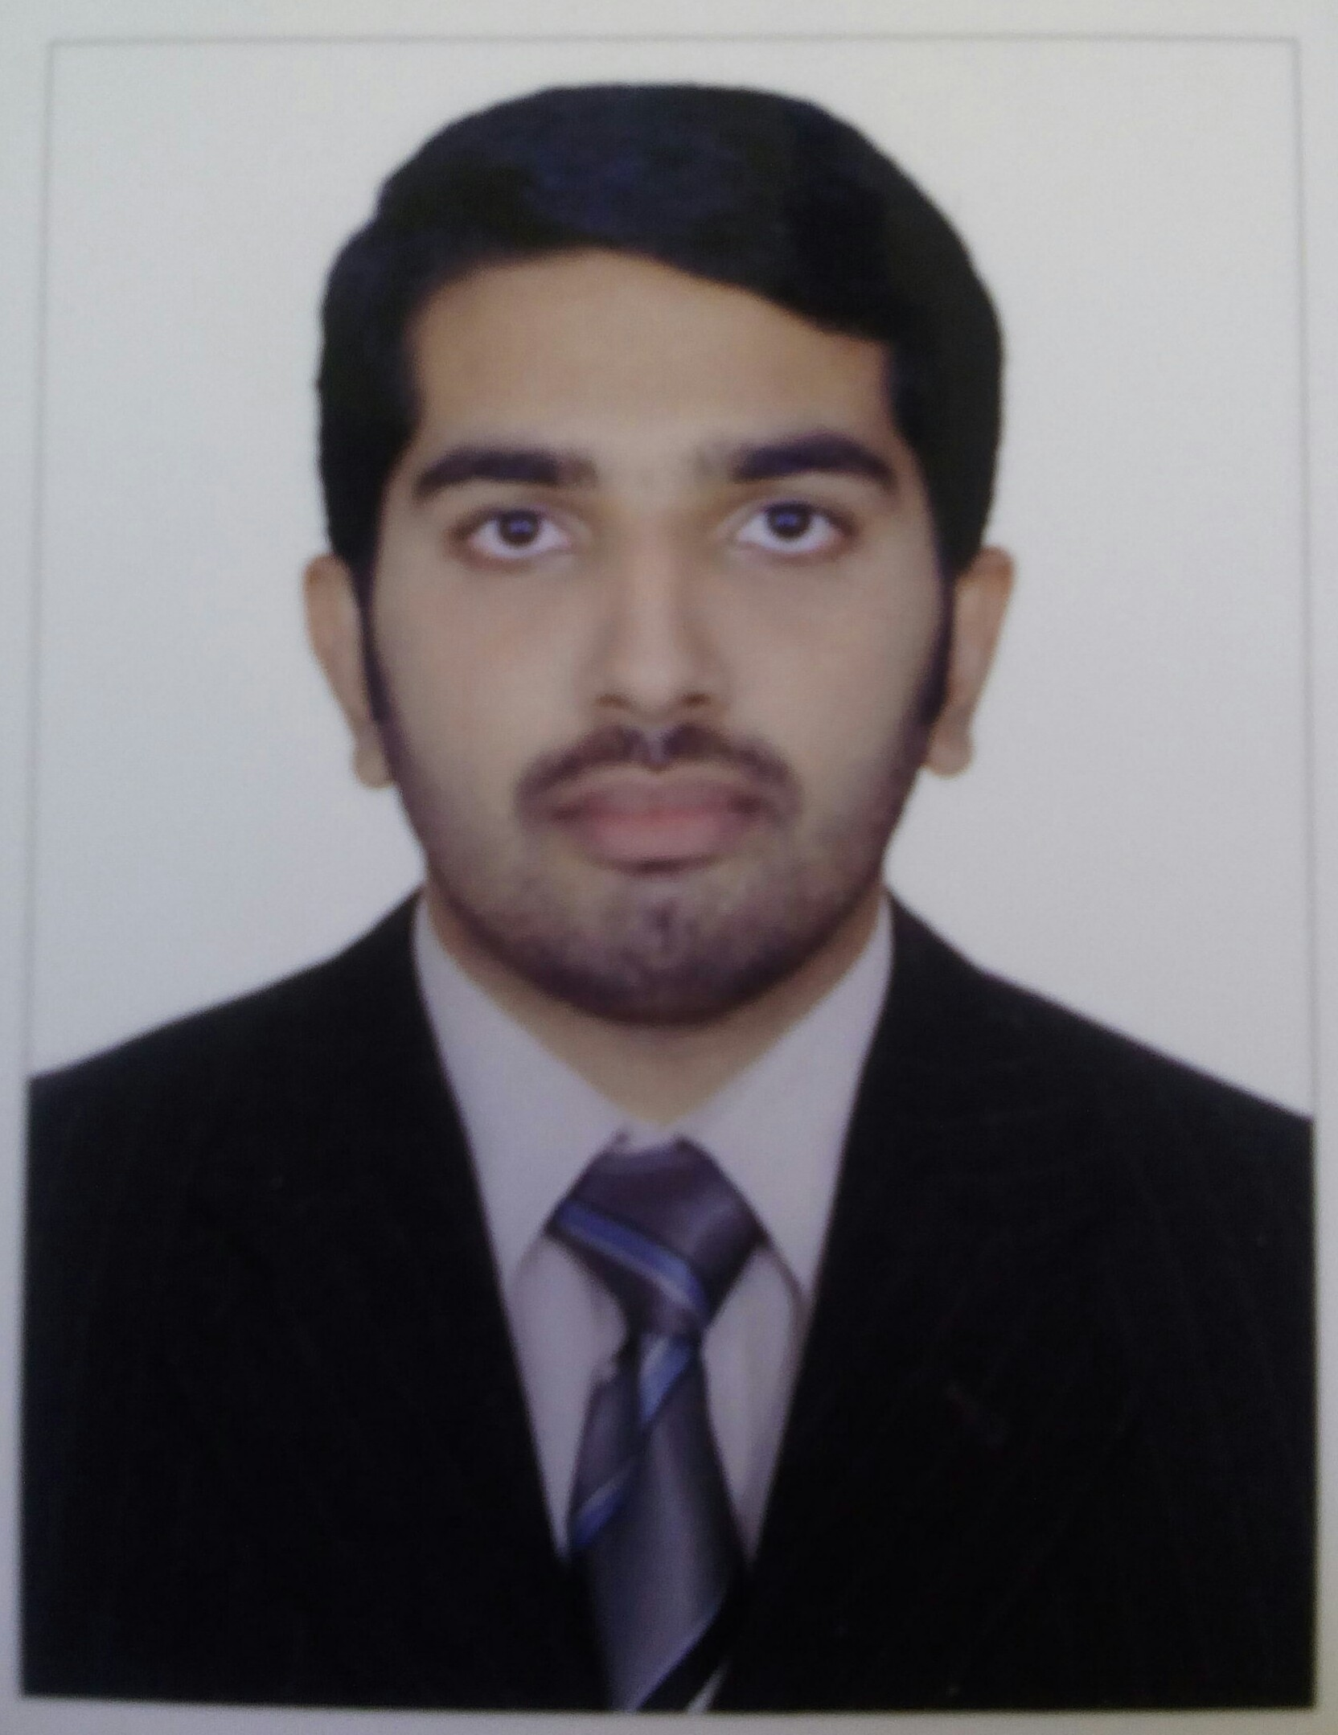
GIRISH.222350@2freemail.com
Personal Information:
Name : Girish
Girish.222350@2freemail.com
Mother’s Name : Rohini
Date of Birth : 01-08-1989

Address for Communication:
SHARJAH,
UAE

IT Skill Sets:
Educational Qualifications:
Skills & Abilities:
Work Experience:

- July 2013 – September 2013 - Worked as Java Developer at INENS Solutions, Cochin.
- November 11th 2013 – November 29th 2014: Worked as System Administrator at UKF College of Engineering and Technology, Parrippally, Kollam.
Key Responsibilities:

- Maintaining system
- Verify that peripherals are working properly
- Quickly arrange repair for hardware in occasion of hardware failure
- Monitor system performance
- Install software
- Create a backup
- Monitor network communication
- Update system as soon as new version of OS and application software comes out
- Implement the policies for the use of the computer system and network
- Setup security policies for users.
- Firewalls and intrusion detection systems
- Password and identity management
- Network services
- Create new users
- Resetting user passwords
- Lock/unlock user accounts
- Implementation and Functioning of ERP Software.

Achievements:

- CCNA
- JAVA BASICS
- ISO 9001:2008 Certified Internal Auditor
Professional Skills:

Routing protocols | RIP(V1 & V2), EIGRP(V4), OSPF (V2)
Routed Protocols | IPV4 & IPV6
Layer 2 Technologies | STP, RSTP, VLAN
Network Security | ACL, Distribute List, Route Map, Port security, FIREWALLS.
Network device platforms | Cisco Routers: 3700, 3600, 2800, 2600, 2500 Cisco Catalyst : 3500, 2950, 3600 Series. Tech-Route
Monitoring and Management | Cisco TFTP server
Windows Platform | Windows 2003,2008,XP,W7,W8

