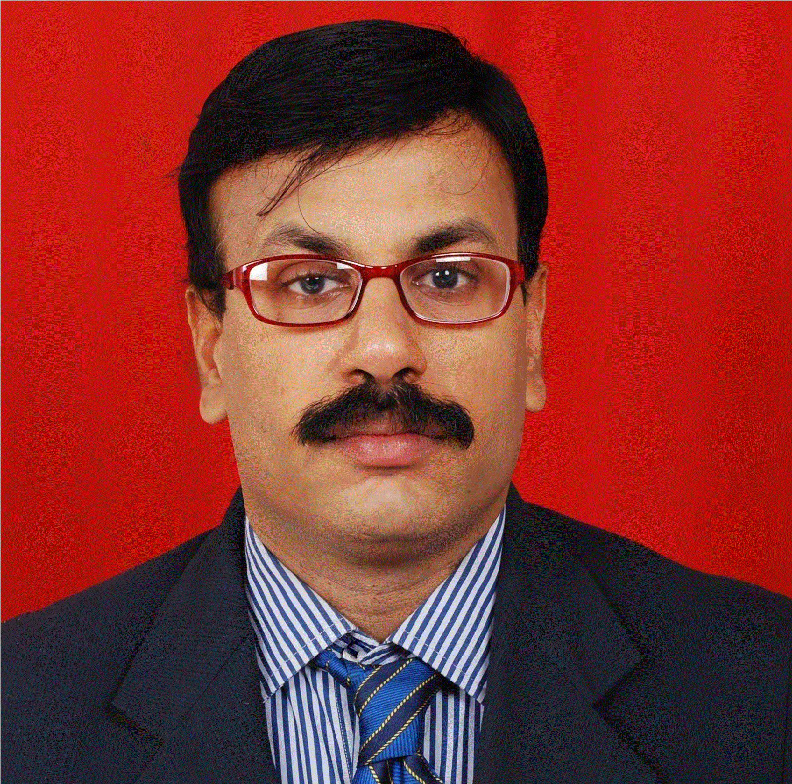

CURRICULUM VITAE
Gulfjobseeker CV No: 1338198
To interview this candidate call 971505797566
Or email us back filled up Vacancy Form
http://www.gulfjobseeker.com/Free_Job_Posting_Form.doc

CAREER OBJECTIVES
Aim to associate with progressive organization that gives me scope to update my knowledge and skill, further in accordance with the latest trend and be a part of the team that dynamically works towards growth of organization thereof.

PROFESSIONAL SUMMERY

- Finalization of accounts.
- Monthly MIS & profitability report, Branch Accounting and reconciliations.
- Diagnosing financial issues, finding problems and leading projects to streamlined solutions.
- Prepare departmental budgets and financial forecasts, ensuring that each division attains goals.
- Prepare tax schedules and work with teams to complete supporting spreadsheets.
- Manage accounting and administrative operations.

PROFESSIONAL & ACADEMIC QUALIFICATIONS

Examination | Institute / University | Year and Status
M.B.A (Finance) | Sikkim Manipal University | Completed 3rd Semester in Feb 2015
B.COM (Cost Accounting) | Calicut University, Kerala | Passed in 1996
Pre Degree (Commerce) | Calicut University, Kerala | Passed in 1991
S.S.L.C | Kerala Board of Examinations | Passed in 1989

WORK – EXPERIENCE

Presently working as Manager – Accounts and Administration from April 2005

Cont. Pg No.2
-2-

JOB PROFILE OF ABOVE

- Finalization of Accounts
- Monitoring day to day accounts, cash flow and monitoring investment portfolios.
- Scrutiny of ledger and reconciliation with parties.
- Analyse Job wise profitability and comment on irregularities if any.
- Maintaining Branch Accounts.
- Preparing Bank Reconciliation Statements
- Preparing of quarterly, half yearly and yearly cash flow statements and financial reports (Profit and Loss Account and Balance Sheet)
- Review credit control by preparing monthly and annual expense forecasts, including any necessary recommended action required to manage costs to achieve budget.
- Preparation of commission statements and sales reports for the sales team on weekly and monthly basis.
- Listening with various Government Authorities.
- Filing Sales Tax (VAT), Service Tax, TDS periodic returns.
- Asset/Investment Management.

WORK – EXPERIENCE

Worked as Sr. Accountant with M/s. Systematic Steel Industries Ltd., Mulund (W), Mumbai, India from April 2000 to March 2005.

JOB PROFILE OF ABOVE

- Preparation of monthly Stock Statements
- Preparation of bill of exchange, Hundies and documentation of discounting from Bank.
- Preparation of Cash flow statements and financial reports.
- Preparation of Branch Accounts and Reconciliation of branch transfers.
- Scrutiny of ledgers and reconciliation with creditors/debtors, preparation of monthly Bank Reconciliation Statements.
- Filing of Returns to Sales Tax and Excise Departments.
- Independently handling Purchase (Enquiries, Quotations, issue of Purchase orders bill passing, negotiation with parties and issue of payments)
- Employee’s reimbursements, Manage Payroll and employee welfare.

WORK – EXPERIENCE

Worked as Jr. Accountant with “M/s. Sriram Fabricators Pvt. Ltd. from February 1997 to March 2000

JOB PROFILE OF ABOVE

- Preparing of Challans and Invoices, handling Petty Cash
- Maintaining Salary Registers and preparation of Salary statements.
- Handling Central Excise matters and maintaining Excise Records.
- Submitting of Sales, Purchase abstracts to Tax consultant.
- Data entry & verification of Sales / Purchase Invoices & Petty Cash Vouchers.
- Preparing Bank Reconciliation, Debit Notes/Credit Notes.

Cont. Pg No.3

..3..

PERSONAL DETAILS

Date of Birth : 25th February 1974
Nationality : Indian
Interest : Painting, Creative Arts, eager to learn new technologies
Languages Known : English, Hindi & Malayalam
Marital Status : Married
Key Skills & Competencies : Comfortable with numbers with good analytical skills. Able to prioritize,
workloads according to deadlines. Confident attitude with a proactive
approach towards work. Ability to manage multiple tasks simultaneously.
Able to work as part of a team or alone. Strong Excel, verbal & written
skills. Quality & Improvement oriented.

DECLARATION

I hereby declare that the facts given in resume are correct to best of my knowledge and belief.

