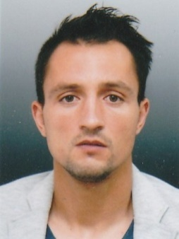

Gheorghe
Gheorghe.223679@2freemail.com

Personnel Information

gender : Male

Martial status : married

Date of birth : 12 dec 1979

Languages Known : English
romanian

Nationality : Romanian

Driver licence : B from year 2000

Objective

Intend to work and build a career with leading corporate of spa and body care, phisical and mental with committed and dedicated people, which will help me to explore myself fully and realize my potential. Willing to work as a key player in challenging and creative environment.
Area of Interest: spa and bodycare, sports team, therapist massage, and medical massage
Total Experience: 5+

Professional Experience

Summary

I was a former athlete who played football at the age of eight years until age 29 years and has dedicated all these years . I love sport and work activity and now that I chose to be a therapist masseur in a football team
I am specialists in sports massage, lymphatic drainage, relaxation massage (Swedish massage), reflexogen massage, cellulite massage, therapeutic massage,medical massage,the regions, segments and joints, ice massage, deep transverse massage and others

CAREER ACCOMPLISHMENTS

1. Football player (1988-2009) at many footbal teams from Romania (Fc Dinamo Bucharest, Foresta Falticeni, Dunarea Giurgiu, Astra Ploiesti, Astra Giurgiu)

2 . Therapist massage (from 2009-present)
I am therapist massage to a professional football team (Astra Ploiesti, Asta Giurgiu, Afc Fortuna)

Responsibility: therapeutic massage, reflexology, relax, lymphatic, and sport massage, medical massage.

Academic Qualifications

- therapist massage, medical massage (school of Dragomir from Bucharest)
- computer troubleshooter (at scool from bucharest)
- footbal coach UEFA Grassroots Charter C Licence
- driver Licence B from year 2000

Other Qualities and Hobbies:

- Carefully, full involvement in activities, tenacity, resistance to stress
- Team player, availability for overtime
- Leadership, strife to strive and professional
- Sociable, physically large, extended

I like football ,music, nature ,geography, evolution of universe and pc.

